

Sales and Inventory System for Mi-Gail Water Refilling Station

In Partial Fulfillment of the
Requirements in IT12/L – System
Integration and Architecture

Presented by:

Cristoria, Chris John BSIT 3rd
Atillo, Cyril John BSIT 3rd

Presented to:

Prof. Fe B. Yara
MSIS IT 12 (10781)
Adviser

May 2025

Acknowledgment

I would like to express my sincere gratitude to Prof. Fe B. Yara for her invaluable support and guidance throughout this project. Their expertise, encouragement, and dedication were instrumental in the successful completion of this work.

We would also like to thank Mi-Gail Water Refilling Station for allowing us to conduct this study and for their cooperation throughout the system development process.

Finally, we extend our appreciation to anyone who lend us their assistance. Thank you so much.

Thank you.

Table of Contents
Chapter 1: The Company
1. Company Profile ................................................................ 1
a. Organizational Chart .................................................. 2
b. Business Environment ............................................... 2
2. Description of the Existing System .................................... 4
3. Data Flow Diagram ............................................................ 6
a. Context Flow Diagram ................................................ 6
b. Level 0 DFD ............................................................... 7
4. Document Analysis .......................................................... 8
5. Definition of Terms ............................................................ 8
Chapter 2: The Problem
1. Statement of the Problem ................................................ 10
2. Feasibility of the Study ..................................................... 11
3. Objectives of the System ................................................. 12
Chapter 3: The Solution
1. Functional Requirements ................................................. 15
2. Solution ............................................................................ 18
3. Entity-Relationship Diagram ............................................ 19
4. Use Case Diagram .......................................................... 20
5. Data Dictionary ................................................................ 21
6. Network/Architecture Design ........................................... 26
7. Prototypes ........................................................................ 27
Chapter 4: The Implementation
- User Acceptance Testing................................................. 41
- User Training.…………….………………………………… 41
- User Manual…………………………………………………42
Chapter 5: The Source Code……………………..………………53

Chapter 1

THE COMPANY

Company Profile

Mi-Gail Water Refilling Station is a small water refilling business that provides purified drinking water to residents of Purok 9-B Tacunan, Tugbok District, Davao City. The company caters to walk-in customers and offers delivery services to nearby households within the community.
The business was established in July 2023 by Mary Jane Orpeza. It was named "Mi-Gail" as a combination of the names of the owner's children, "Miguel" and "Abigail." The business operates from a small 100-square-meter space located in Phase 1 of Purok 9-B, while the family residence is in Phase 2 of the same area.
The business was started as a means of livelihood while Ms. Orpeza's husband works as a seaman. Starting with basic filtration equipment and a family tricycle for deliveries, the business currently serves around 10-20 customers daily within the immediate vicinity. The current owner and manager of the company is Ms. Mary Jane Orpeza.

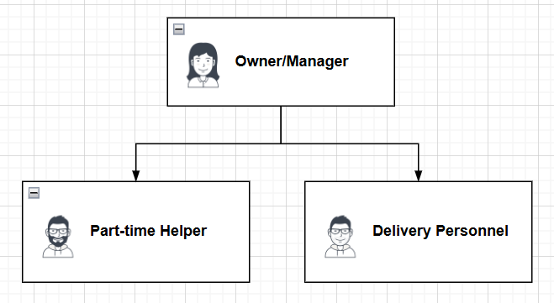
Figure 1: Organizational Chart

Business Environment
Mi-Gail Water Refilling Station operates in a small, 100-square-meter facility located in Phase 1 of Purok 9-B Tacunan, Tugbok District, Davao City. The water station is equipped with a single filtration system from ECT Water Treatment, capable of processing 50 to 150 gallons of water daily, depending on customer demand.
The business is open from Monday to Saturday, between 7:00 AM and 6:00 PM, providing convenient hours for customers. The station is closed on Sundays to allow the owners time for church and family activities.
The station is strategically positioned within the residential area of Purok 9-B, making it easily accessible to the local community, which is its main customer base. Its close proximity allows for fast service, catering to both walk-in customers and delivery orders. With the nearest competitor situated about 2 kilometers away, Mi-Gail Water Refilling Station benefits from a significant advantage in serving the immediate community.
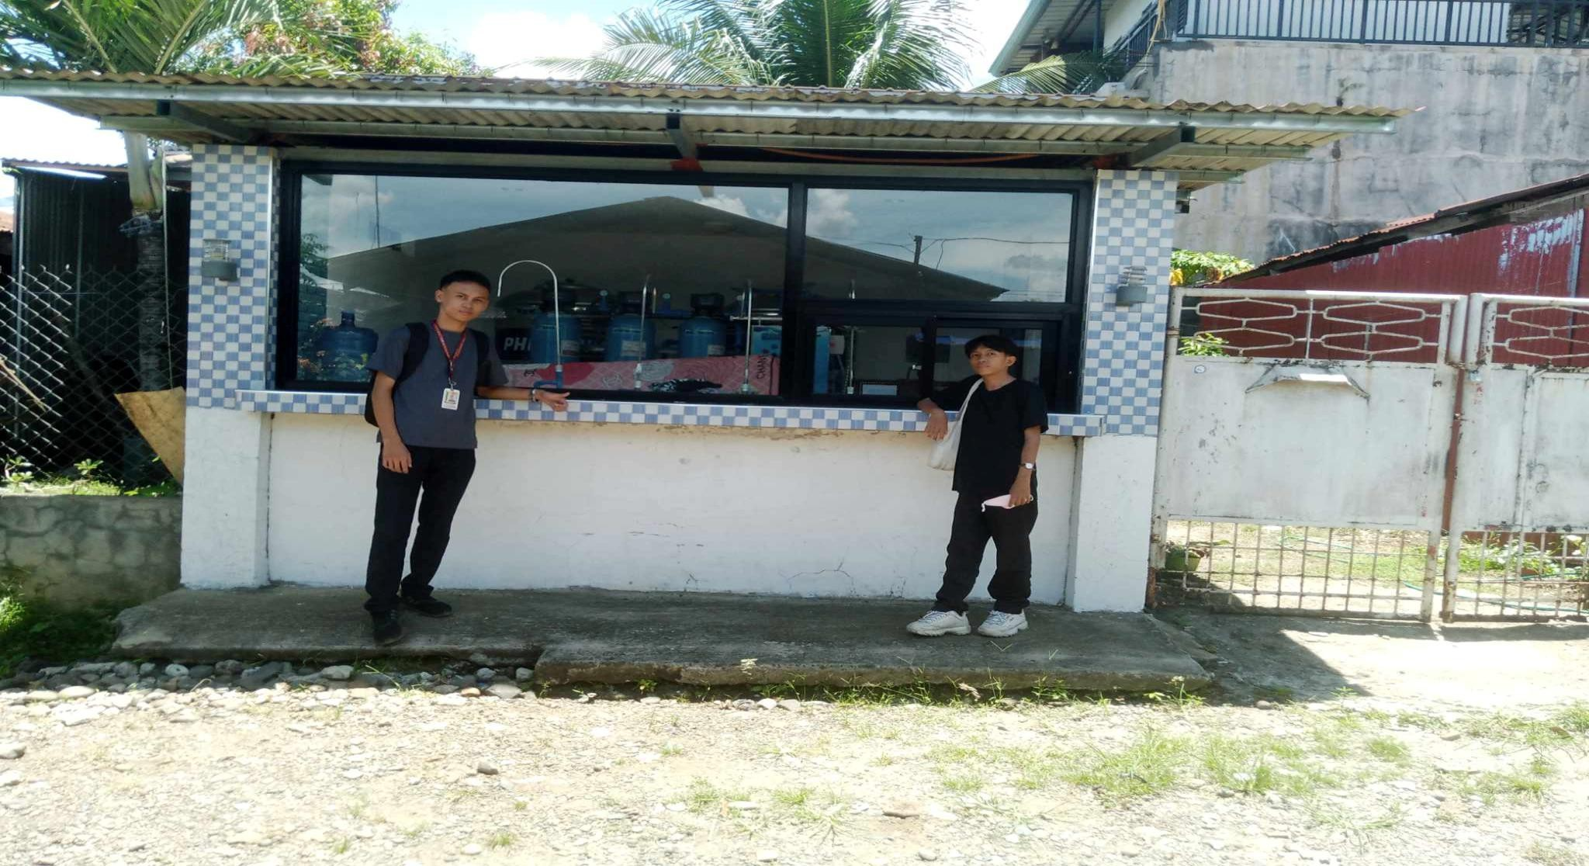
Figure 2: Picture outside the Company
This is the place where they do their transaction with the customer.

Description of the Existing System
Sales Transactions
Mi-Gail Water Refilling Station conducts two types of sales transactions: Walk-in and Delivery Sales. Below is a detailed description of each type of transaction.

Walk-in Sales - the process begins when customers arrive at the station with their empty containers. The Owner/Manager greets the customer and verifies the number of containers brought. The Helper then cleans the containers, if necessary, refills them using the water filtration system, and seals them. Once the containers are ready, the Owner/Manager collects a payment of 25 pesos per container from the customer. The transaction details, including the customer’s name (if provided), the date, the number of containers refilled, the payment amount, and any outstanding balance, are recorded in the sales notebook. After the transaction is recorded, the filled containers are handed back to the customer, completing the process.
Delivery Sales - the process starts when regular customers place their orders by texting or calling the Owner/Manager’s personal mobile phone, setting a fixed delivery schedule, or visiting the store in person. The Owner/Manager records the order details in the sales notebook, including the customer’s name, delivery address, contact number, the number of containers requested, and the delivery schedule. The Helper prepares the required number of containers, cleans them, if necessary, refills them, seals them, and assists in loading them onto the family tricycle. The Delivery Personnel (son) then delivers the filled containers to the customer’s home, relying on their familiarity with the local area to ensure timely delivery. Upon delivery, the Delivery Personnel collects payments from the customer, which include 25 pesos per container and a 5-peso delivery fee per transaction. Once all deliveries are completed, the Delivery Personnel returns to the station and reports the completed orders to the Owner/Manager, providing details on the payments collected, the number of containers delivered, and any issues encountered during the delivery. The Owner/Manager then records the delivery transaction details in the sales notebook, ensuring that all sales and payments are accurately documented. This process ensures that both walk-in and delivery sales transactions are managed systematically and efficiently.

Sales Report
The business maintains all records in a notebook. Daily sales are recorded in a dedicated notebook by the Owner/Manager, including date of sale, customer information, number of containers, payment method, amount, and any outstanding balances. At the end of each day, the Owner/Manager tallies total sales, containers sold, and deliveries completed. Weekly and monthly summaries are created from these daily records.
Business hours are 7:00 AM to 6:00 PM Monday through Saturday. The business is closed on Sundays for church.
The nearest competing water station is approximately 2 kilometers away, giving Mi-Gail a significant competitive advantage in serving the immediate Purok 9-B community.
Inventory Transaction
The Owner/Manager will check the count of the resources in the inventory, with the assistance of the Part-time Helper. They will deduct the count of used materials such as empty containers, caps, seals, and raw materials after production. The filled containers from production will be added back to the inventory, and the Owner/Manager will ensure the count is accurate. If damaged containers or materials are found, they will be deducted from the inventory count. If there are insufficient stocks of critical materials (e.g., caps, containers, seals, raw water), the Owner/Manager will create a purchase order for the supplier. When the delivery from the supplier arrives, the Owner/Manager will verify the items, pay the supplier, and receive an official receipt. The delivered supplies will then be logged and added to the inventory.

Data Flow Diagram
Context Flow Diagram
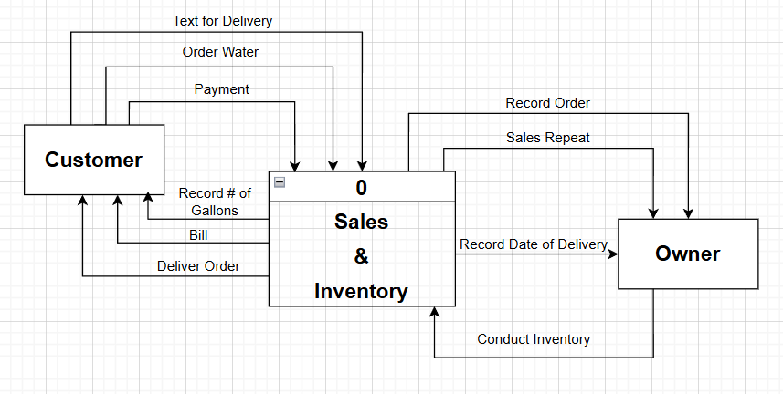
Figure 3: Context Flow Diagram
A diagram showing information exchange in the existing system.

Level 0 Diagram
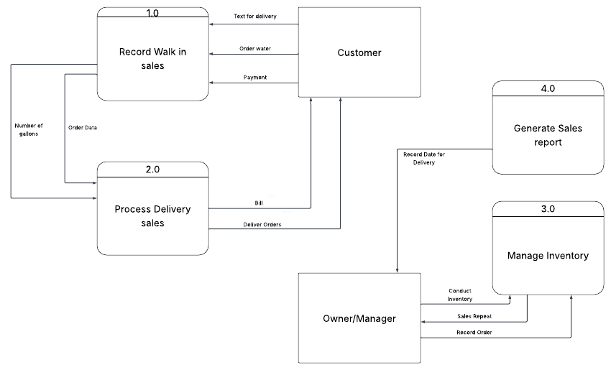

Figure 4: Level 0 Diagram
System overview showing order processing, delivery, and reporting workflows.

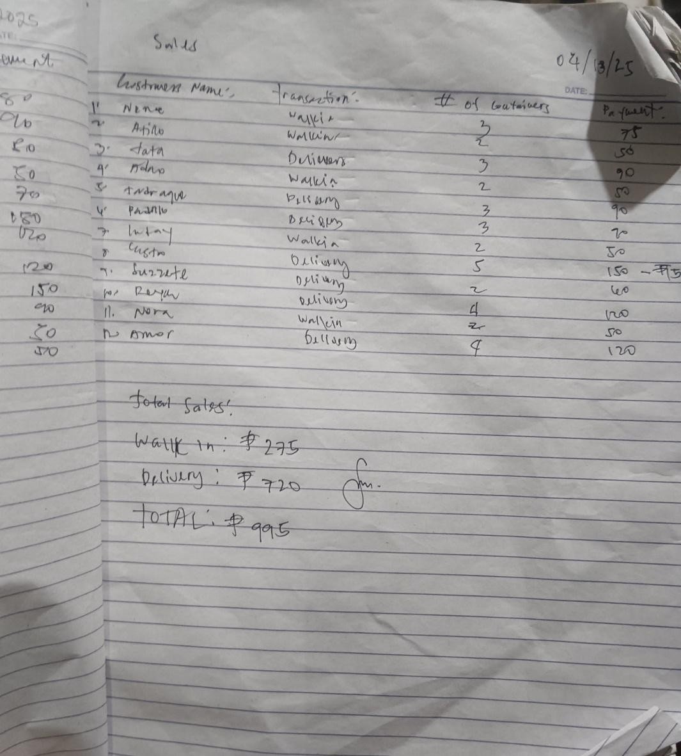
Document Analysis
Figure 5: Sales Notebook
Picture of a sales logbook written in a big notebook

Definition of Terms

Walk-in sales - Sales transactions are conducted at the water refilling station when customers visit in person.
Delivery sales - Sales transactions that involve delivering water containers to customers' homes within Purok 9-B.
Regular customers - Customers who order water regularly through calls, texts, or set delivery schedules.
Container - The standard water container used by the business for selling purified water.

Delivery fee - An additional 5 pesos is charged for home delivery service.
Sales notebook – The record-keeping document where all transaction details are recorded.
Delivery list - A simple document listing customers requiring delivery services on a particular day.
Delivery Personnel - The person responsible for delivering water containers to customers' homes.
Helper - The person who assists with water container preparation and loading for delivery.
Owner/Manager - The person who oversees all business operations, including sales, payments, and record-keeping.

Chapter 2

THE PROBLEM

Statement of the Problem
Time-Consuming Record-Keeping
Recording sales transactions in a notebook is time-consuming. For every transaction, the Owner/Manager must write down all details, including customer information and payment amounts, for walk-in and delivery sales. This becomes tedious, especially during peak hours or when handling bulk orders, causing delays in serving other customers.
Time-consuming in recording Sales from Walk-in and Delivery transactions
All transactions are meticulously written in the logbook for both walk-in and delivery sales. The delivery process requires twice the recording effort as staff must first document the incoming text message from the customer, then note the scheduled delivery date, and finally record the actual sales transaction when completed. This multiple recording process creates significant inefficiencies and introduces numerous opportunities for error during data entry.
Time-consuming to generate the sales report
All sales transactions are maintained exclusively in the physical logbook, requiring compilation for reporting. Staff members must individually check and validate each customer's sales transaction against corresponding GCash transaction records to ensure accuracy. For every transaction, they must write down both the reference number and the amount paid by customers to maintain proper records. This labor-intensive validation and record-keeping process significantly delays the generation of sales reports, making timely business analysis challenging.
Delays in Inventory Management
Inventory management is also conducted through physical means, which delays the tracking of stock levels. Counting, updating, and verifying inventory after every transaction is time-intensive, leading to potential stock shortages or overstocking if not done accurately.

Feasibility Study
Technical Feasibility
The owner is willing to invest for a computer for her business. Additionally,
The owner is willing to provide software and hardware components to support the business and make the transactions easier. Therefore, it is technically feasible.

Economic Feasibility
The proposed system is economically feasible because the hardware that is required for the system is not expensive and would be able to run the proposed system. Additionally, the system is user-friendly. Therefore, it is economically feasible.

Table 1. Hardware Cost
Hardware Minimum Requirements | Amount
Desktop Computer (Intel i3/i5, 8GB RAM, 256GB SSD) | PHP 25,000
Monitor | PHP 4,000
Keyboard/Mouse | PHP 450
UPS (Uninterruptible Power Supply) | PHP 2,500
Total | PHP 31,950
Source: Pcpartpicker

Table 2. Software Cost
Software | Amount
Operating System (Windows 10) | Free
Sales and Inventory System | Free
Web Development Technologies (PHP, Bootstrap, CSS, HTML) | Free
Database (MySql, phpMyAdmin) | Free
Hosting (GoDaddy) | PHP 399
Total | PHP 4,788/Year
Source: GoDaddy
Table 3. Personnel Cost
Job Role | Payment/Salary (Daily)
Part-time helper | PHP 300
Delivery Personnel | None
Total | PHP 300

Table 4. Total System Cost
System | Amount
Hardware Cost | PHP 31,950
System Cost | PHP 4,788
Personnel Cost | PHP 300
Total | PHP 37,038

Operational Feasibility
The proposed system is operationally feasible because aside from being free, it is also user-friendly. The system can be installed on any computer that meets the minimum requirements. Additionally, the owner is knowledgeable about using the computer. Therefore, the system is operationally feasible.

System Objectives
Automate Sales Transaction
The system will allow the owner to input all sales details, whether walk-in or delivery, under one customer name. It will automatically calculate the total payment and record the transaction in the system, reducing manual entry time.

Simplify Inventory Management
After each transaction, the system will automatically update the inventory by deducting used materials and adding refilled containers, making stock tracking easier and more accurate.

Manage Customer Records
The system will store customer names, contact details, and order history, allowing quick access to repeat orders and better tracking of balances and delivery schedules.

Generate Sales Report
It will automatically compile sales data into daily, weekly, and monthly reports, making it easier for the owner to monitor business performance without manual tallying.

Provide Secure Access
The system will be installed on a single computer with login credentials, ensuring only authorized users can access sensitive sales and inventory data.

Chapter 3
THE SOLUTION
Functional Requirements
Administration Module
This module is for managing the system itself and its users. It includes user management features to create accounts, assign roles, reset passwords, and track activity. It also provides system configuration options to update pricing, set delivery fees, configure business hours, manage inventory alerts, and handle data backups.

Dashboard Module
The dashboard provides a visual overview of key performance metrics. Admins and employees can view summaries of daily, weekly, and monthly sales, the number of pending deliveries, and the status of recent orders. It also displays any low stock alerts and offers quick access to initiate new sales, walk-in transactions, adding customers, and navigating to the inventory. Additionally, the current date is displayed for context.

Sales Module
This module encompasses all sales-related activities, from managing customer information to processing various types of sales transactions. It enables the creation and maintenance of customer records, including their purchase history. The module facilitates walk-in sales by recording container quantities, calculating payments, generating receipts, and updating inventory. It also handles delivery sales, allowing for the management of delivery details, scheduling, fees, status tracking, and payment processing. Furthermore, the module supports different payment methods like cash and GCash. The “Orders" view provides a central location to see and manage these sales transactions, with quick actions available for initiating new orders and walk-in sales.

Delivery Module
This module manages the delivery operations of the system. It provides a view to track deliveries, categorized as "Pending," "Completed," and "All Deliveries." Currently, the system indicates that there are no pending deliveries. This module serves as a central place to monitor the status of deliveries and likely includes functionalities for scheduling, assigning, and updating the progress of orders being delivered to customers.

Inventory Module
The inventory module is responsible for managing the stock of various items, including purified water, gallon containers, bottle caps, and seals. It allows users to view the current quantity, defined threshold, and stock status of each item. The module provides options to filter the inventory by type and stock level. Users can also add new items and view items that are low in stock. Additionally, there's a function to export the inventory data. This module serves as the central point for monitoring and managing the product and supply levels within the system.

Customer Module
The customer module manages all aspects of customer interaction and information within the system. It enables users to create and manage detailed customer records, including their name, address, and contact number. The module allows for viewing a customer's purchase history and updating their information as needed. It also supports categorizing customers as regular or one-time. Users can search for specific customers using their name or contact number, and the system provides options to filter and sort the customer list. The primary function is to serve as a central repository for all customer-related data, facilitating better customer relationship management and sales tracking.

Reporting Module
Sales Report Module
The sales report module lets users create different kinds of sales reports to understand how the business is doing. Users can pick a time period for the report, like today, this week, this month, or choose specific dates. Users can also choose to see reports for all orders or only some. The reports show important numbers like the total money made, how much was paid, how much is still owed, and how many water containers were sold. It also shows sales trends using charts. There's also a button to print the report.
Delivery Report Module
The delivery report module helps the user see how the deliveries are going. You can choose a time period for the report, like today, this week, this month, or pick your own dates. User can also filter by the status of the delivery, like if it's pending. The report shows how many total deliveries there were, how many were finished, how many are still waiting, and how much water was delivered. It also looks at how the delivery people are doing. You can also print this report.

Customer Report Module
This module is designed to help users analyze information about their customers. It allows you to choose a specific time period to review customer activity. You can also filter the reports to focus on certain types of customers, like top buyers. The module shows key details such as the total number of customers, how many orders they've placed, the average amount they spend, and how often they reorder. It also helps identify your most valuable customers based on their spending. This module serves as a tool to gain insights into your customer base for better business decisions.

Inventory Report Module
The inventory module provides tools to understand and track the stock levels of different items. Users can select a time period to review inventory, such as today, this week, this month, or a custom range. It allows filtering by the type of item. The report shows the current quantity of items like water, containers, caps, and seals, along with when they were last updated. It also indicates how much stock has come in and gone out during the chosen period. A section displays the current inventory levels for each item. This module helps in monitoring the movement and current status of all inventory.

Solution
Automating Sales transactions
The system simplifies the entire sales process, from order taking to payment recording. When a sale occurs (whether walk-in or delivery), the user can input all relevant details under a single customer record. The system will then automatically compute the total amount due, reducing the need for manual calculations and potential errors. Once the transaction is finalized, the system records it, providing a clear and auditable history of all sales. This automation saves time and ensures accuracy in tracking financial transactions.

Simplifying Inventory Management
After each sales transaction is processed, the system will automatically adjust the inventory levels. For items sold, the corresponding materials (like water, containers, etc.) will be deducted from the stock count. Additionally, the system will allow for the input of refilled containers, ensuring that the inventory records are always up-to-date. This automatic updating simplifies the process of tracking stock and provides a more accurate view of available resources, making inventory management more efficient.
Managing Customer Recorders
The system provides a centralized location to store and manage all customer-related information. For each customer, their name, contact details, and a history of their orders are recorded. This allows for quick retrieval of information for repeat orders, facilitating a faster service for returning customers. Furthermore, the stored data enables better tracking of customer balances (if applicable) and the scheduling of deliveries, improving overall customer relationship management.

Generating Sales Reports
For business performance monitoring, the system automatically compiles sales data into various report formats. Users can generate reports on a daily, weekly, or monthly basis. These reports provide key financial information, making it easier for the owner to monitor the business's performance without the need for manual data aggregation and calculations. This feature enables data-driven decision-making for business growth.

Providing Secure Access
The system's security is maintained by its installation on a single computer with a login credential system. This ensures that only authorized individuals with the correct credentials can access the sensitive sales and inventory data stored within the system. This controlled access helps protect business information and maintain data integrity.

Entity-Relational Diagram (UML)

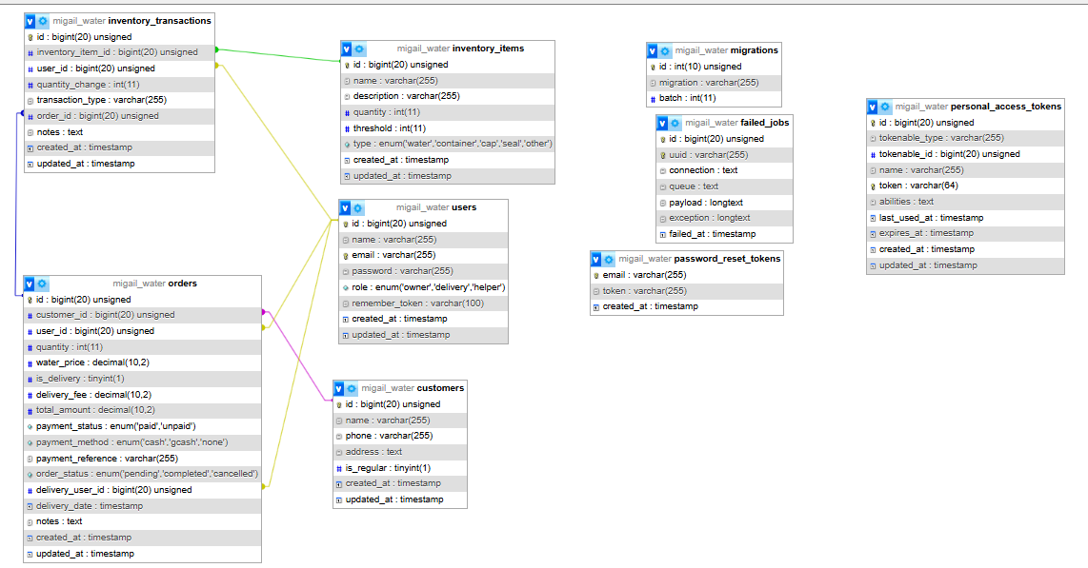
Figure 6: ERD

Use Case Diagram

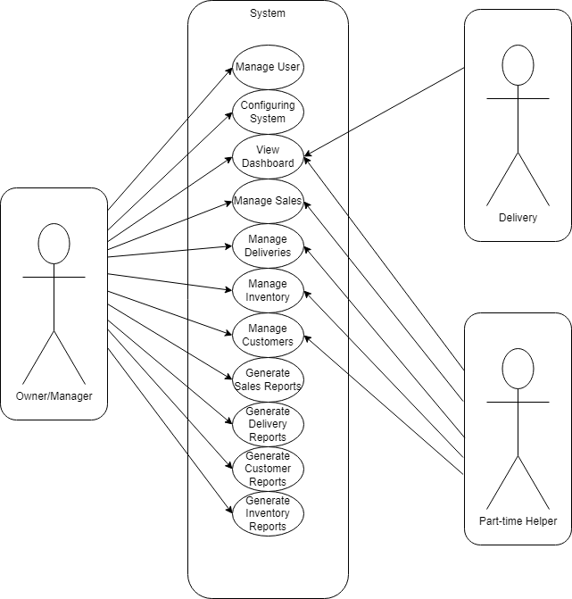

Figure 7: Use Case Diagram

Data Dictionary
Table 5: users
Field Name | Data Type | Length | Constraints | Description | Default
id | INT | - | PK,  AUTO_INCREMENT | Unique identifier for users | -
name | VARCHAR | 50 | NOT NULL | Full name of user | -
email | VARCHAR | 50 | UNIQUE | Email address for login | -
password | VARCHAR | 50 | NOT NULL | Encrypted password | -
role | VARCHAR | 15 | NOT NULL | User role (owner, delivery, helper) | -
phone | VARCHAR | 15 | NULL | Contact phone number | NULL
is_active | BOOLEAN | - | NOT NULL | Account status | TRUE
created_at | TIMESTAMP | - | NOT NULL | Account creation date | CURRENT_TIMESTAMP
updated_at | TIMESTAMP | - | NOT NULL | Last account update | CURRENT_TIMESTAMP

Table 6: customers
Field Name | Data Type | Length | Constraints | Description | Default
id | INT | - | PK,  AUTO_INCREMENT | Unique identifier for customers | -
name | VARCHAR | 50 | NOT NULL | Customer full name | -
phone | VARCHAR | 15 | NULL | Customer contact number | NULL
address | TEXT | - | NULL | Customer delivery address | NULL
Is_regular | BOOLEAN | - | NOT NULL | Whether customer is a regular | FALSE
notes | text | 50 | NULL | Additional customer notes | NULL
created_at | TIMESTAMP | - | NOT NULL | Record creation date | CURRENT_TIMESTAMP
updated_at | TIMESTAMP | - | NOT NULL | Last record update | CURRENT_TIMESTAMP

Table 7: orders
Field Name | Data Type | Length | Constraints | Description | Default
id | INT | - | PK,  AUTO_INCREMENT | Unique order identifier | -
customers_id | INT | 50 | FK (customers.id) | Customer who placed the order | -
user_id | INT | - | FK (users.id) | User who recorded the order | -
quantity | INT | - | NOT NULL | Number of water containers | NULL
water_  price | DECIMAL | 10, 2 | NOT NULL | Price per container | 25.00
is_delivery | BOOLEAN | - | NOT NULL | Whether order is for delivery | FALSE
delivery_fee | DECIMAL | 10, 2 | NULL | Delivery fee charged | 5.00
total_  amount | DECIMAL | 10, 2 | NOT NULL | Total order amount | -
payment_status | VARCHAR | 20 | NOT NULL | Status (paid, unpaid) | ‘unpaid’
payment_method | VARCHAR | 20 | NULL | Method (cash, GCash, none) | ‘none’
payment_reference | VARCHAR | 50 | NULL | GCash reference number | NULL
order_status | VARCHAR | 20 | NOT NULL | Status (pending, completed, cancelled) | ‘pending’
delivery_user_id | INT | - | FK (users.id), NULL | Delivery personnel assigned | NULL
delivery_date | DATETIME | - | NULL | Date/time of delivery | NULL
notes | TEXT | - | NULL | Order notes | NULL
created_at | TIMESTAMP | - | NOT NULL | Order creation date | CURRENT_TIMESTAMP
updated_at | TIMESTAMP | - | NOT NULL | Last order date | CURRENT_TIMESTAMP

Table 8: inventory_items
Field Name | Data Type | Length | Constraints | Description | Default
id | INT | - | PK,  AUTO_INCREMENT | Unique transaction ID | -
type | VARCHAR | 50 | NOT NULL | Item type (water, empty, cap, seal) | -
name | VARCHAR | 50 | NOT NULL | Item name | -
description | TEXT | - | NULL | Item description | NULL
quantity | INT | - | NOT NULL | Current quantity in stock | -
min_stock_level | INT | - | NOT NULL | Minimum stock threshold | 10
created_at | TIMESTAMP | - | NOT NULL | Record creation date | CURRENT_TIMESTAMP
updated_at | TIMESTAMP | - | NOT NULL | Last record update | CURRENT_TIMESTAMP

Table 9: inventory_transactions
Field Name | Data Type | Length | Constraints | Description | Default
id | INT | - | PK,  AUTO_INCREMENT | Unique transaction ID | -
inventory_item_id | INT | - | FK (inventory_items.id) | Related inventory item | -
user_id | INT | - | FK (users.id) | User who made the transaction | -
quantity_change | INT | - | NOT NULL | Amount added/removed/positive/negative) | -
transaction_type | VARCHAR | 50 | NOT NULL | Type (order, refill, adjustment) | -
order_id | INT | - | FK (orders.id) | Related order if applicable | NULL
notes | TEXT | NULL | NULL | Transaction notes | NULL
created_at | TIMESTAMP | - | NOT NULL | Transaction date | CURRENT_TIMESTAMP

Network/Architecture Design
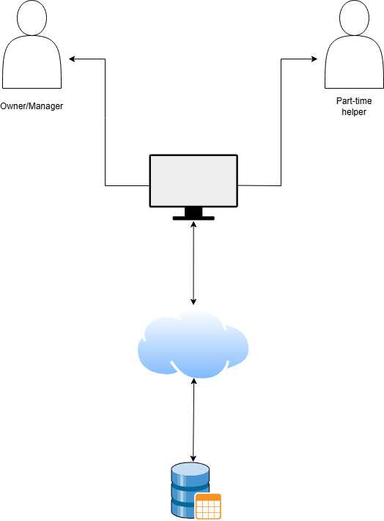

Figure 8: Network/Architecture Design

Prototypes (Input/Output)

The purpose of the Sales and Inventory model is to demonstrate all the modules and capture reports implemented in our system for the Mi-gail Water Refilling Station. It is designed for daily use, making transaction easier, more convenient, and faster.
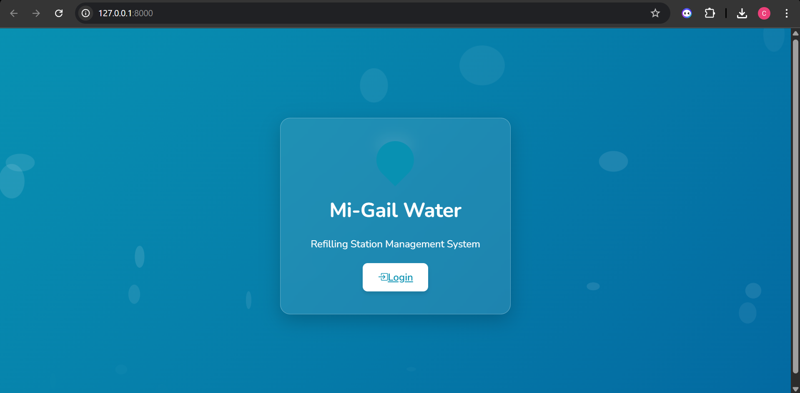
Figure 9: Landing Page
The landing page is the module where you go when you run the system before logging in. The login button is the navigation for logging in.

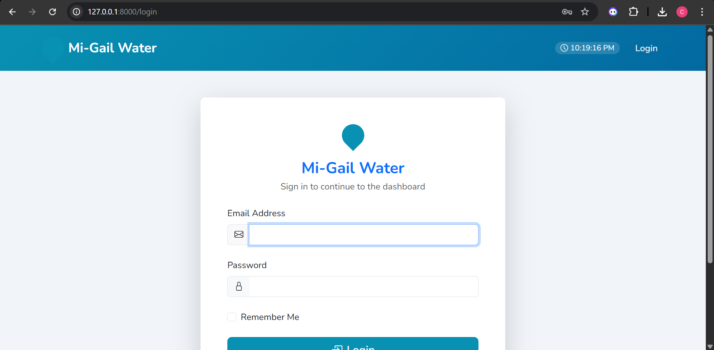
Figure 10: Login Form
The login page where the admin or the employees can only access. The user can only access the forms that they can access through logging in the right username and password.
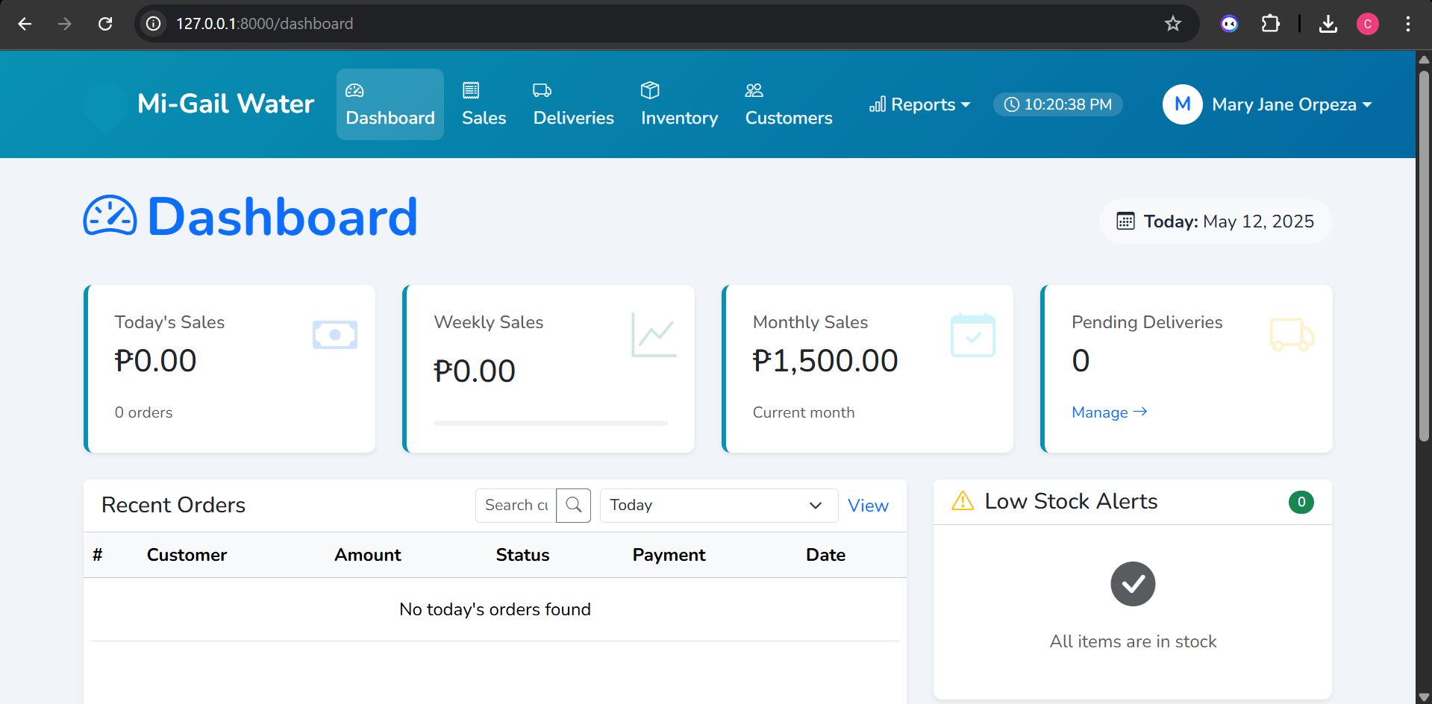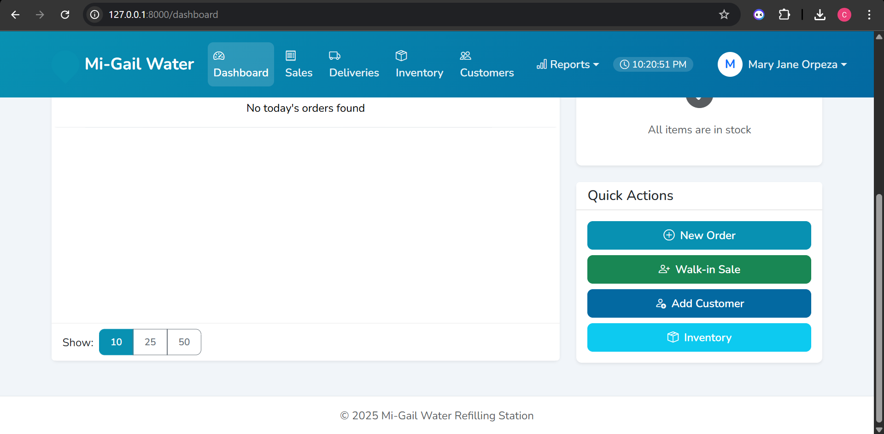
Figure 11: Dashboard Form
The dashboard provides a concise overview of the Mi-Gail Water business operations. It centralizes key information like sales figures (today, this week, this month), the number of pending deliveries, and the status of low stock alerts. Additionally, it offers quick access to common actions such as creating new orders or managing inventory, making it a central point for monitoring and managing the system's core functions at a glance.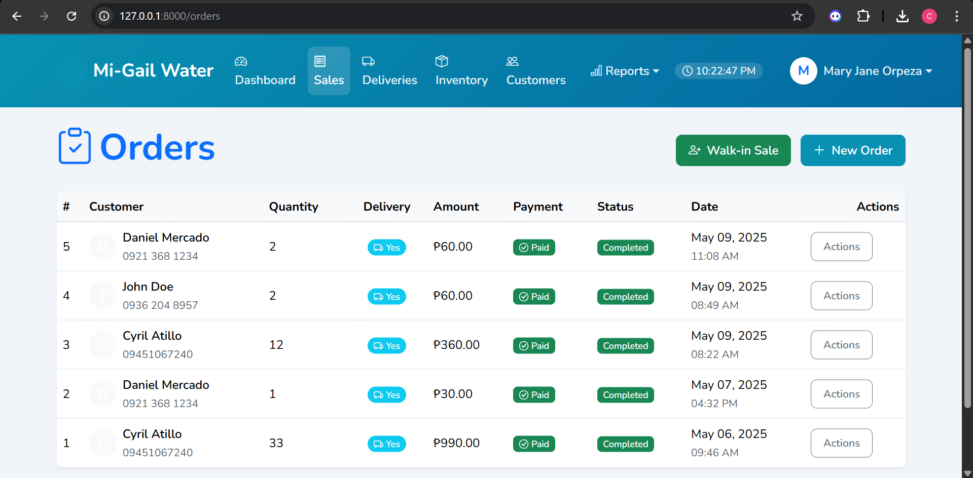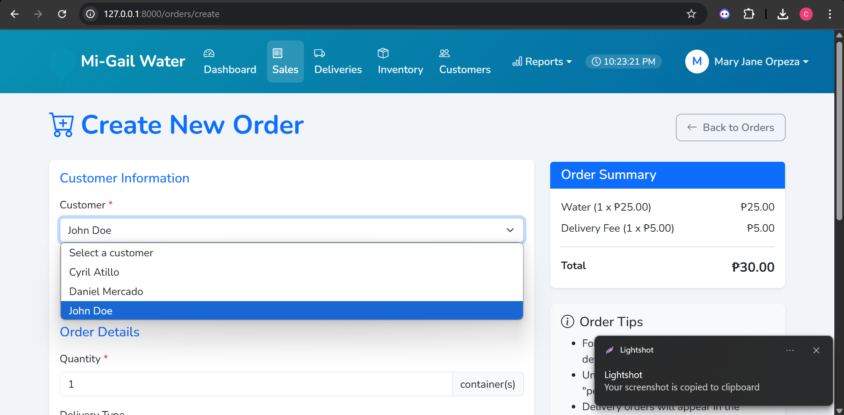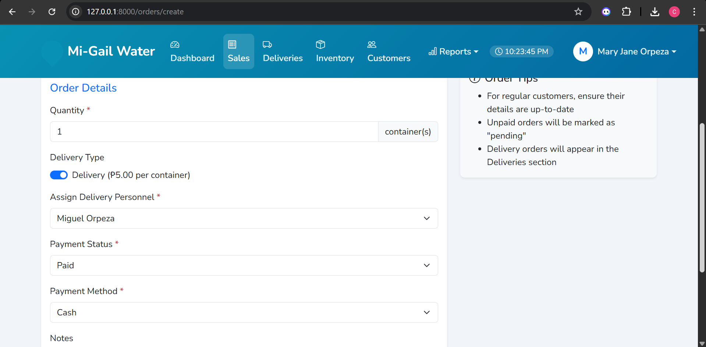
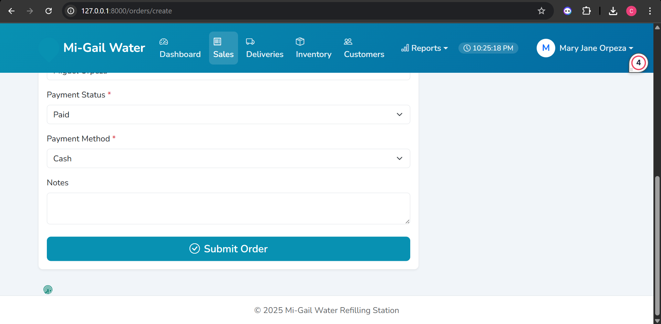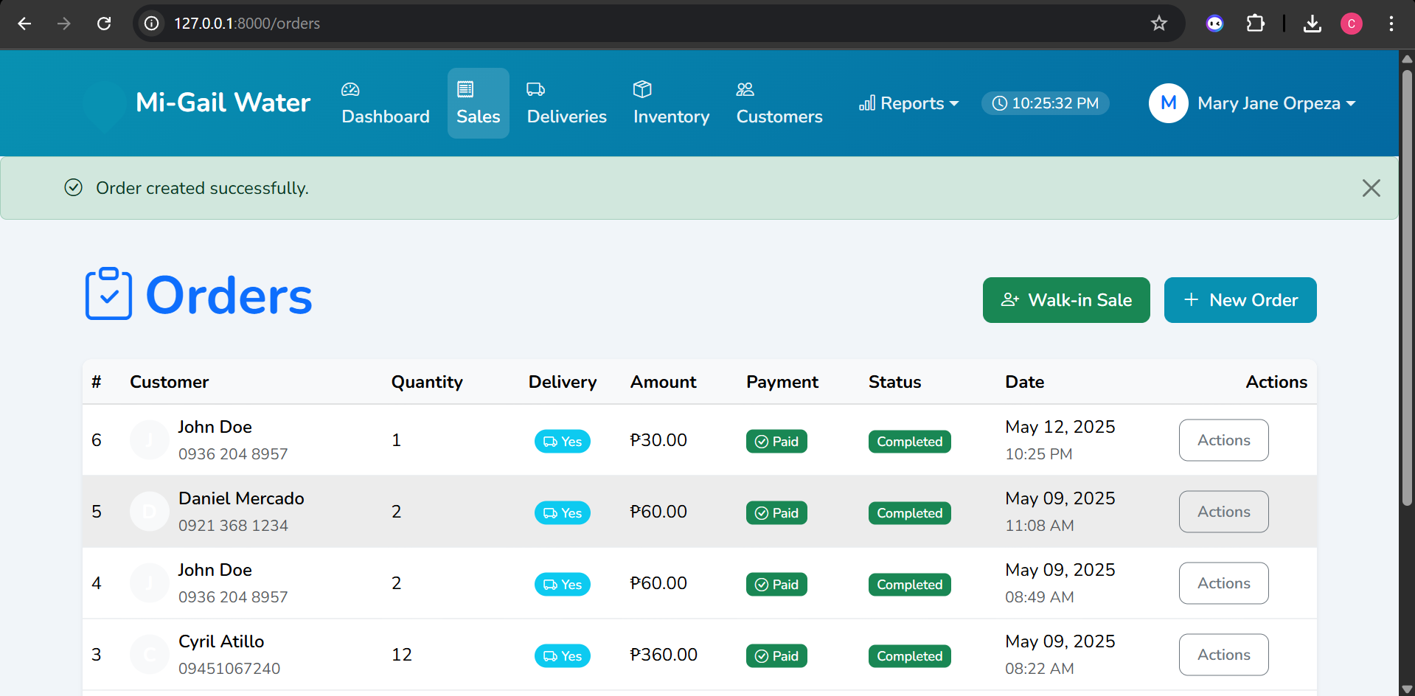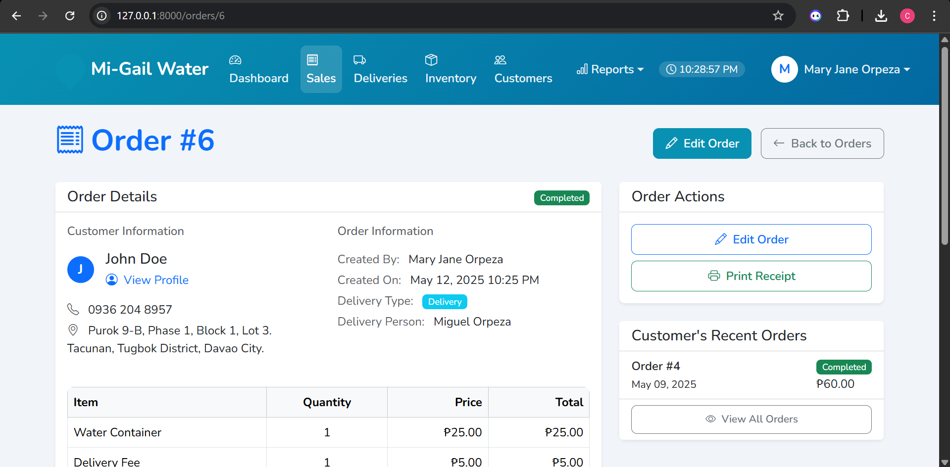
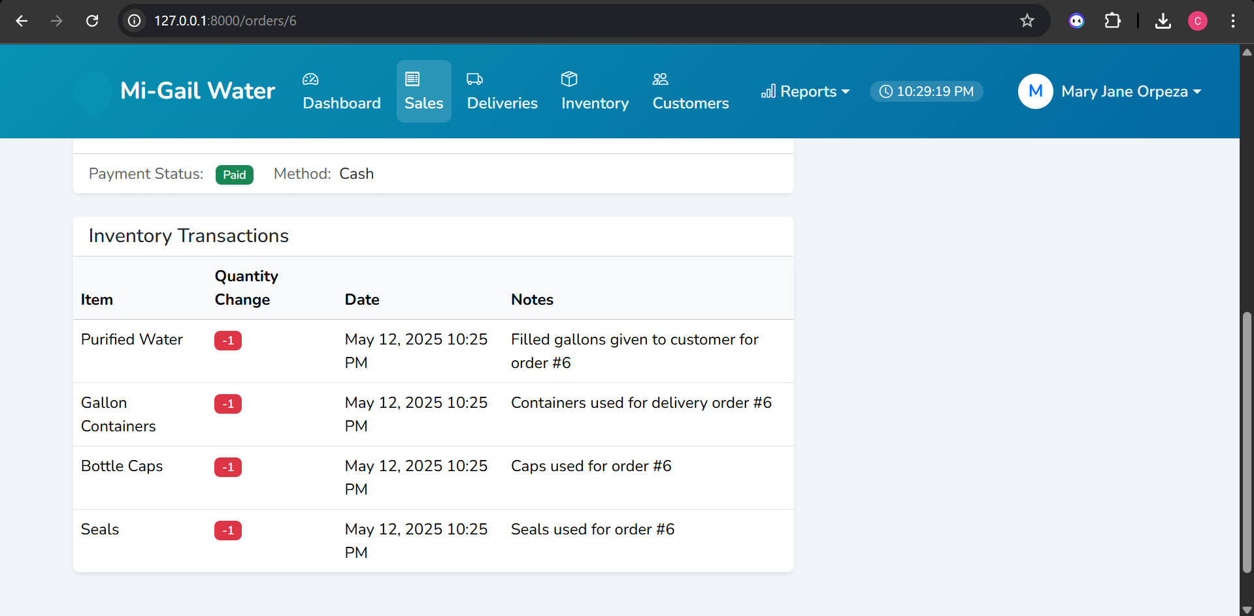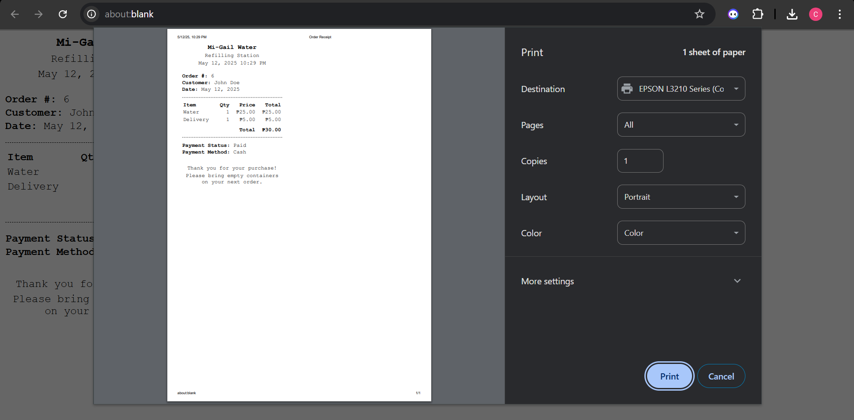
Figure 12: Sales Form
The sales form illustrates the workflow for managing customer orders within the system. It includes the initial order creation form, a list view for tracking all orders and their statuses, and a detailed view for individual orders, providing comprehensive information and actions related to each transaction.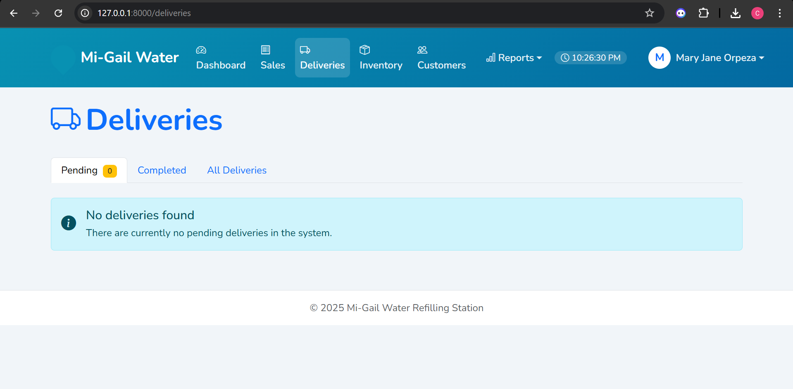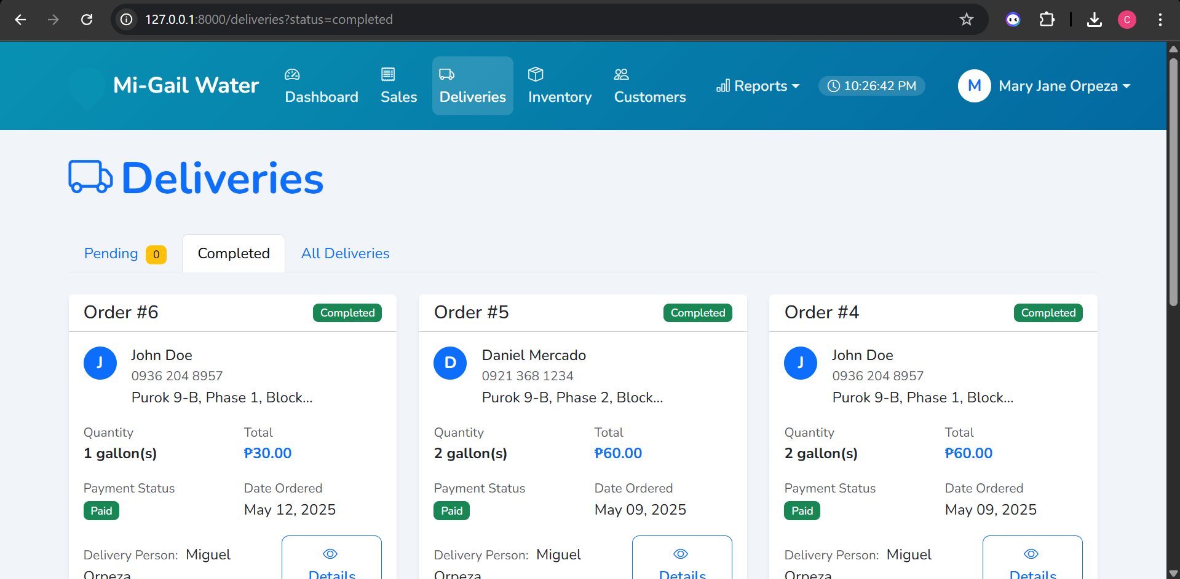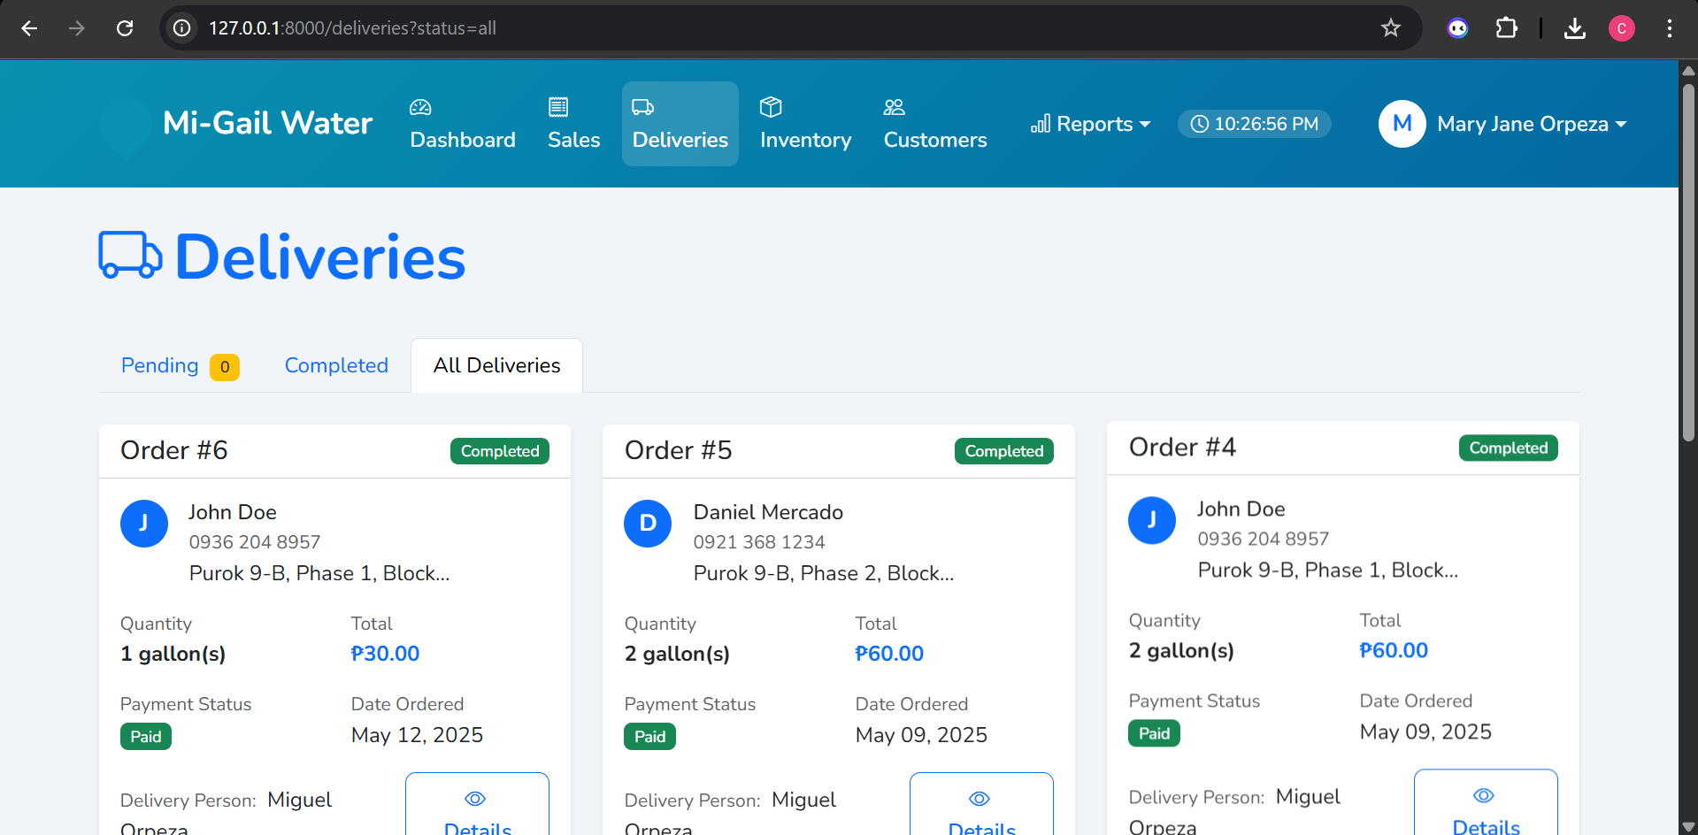
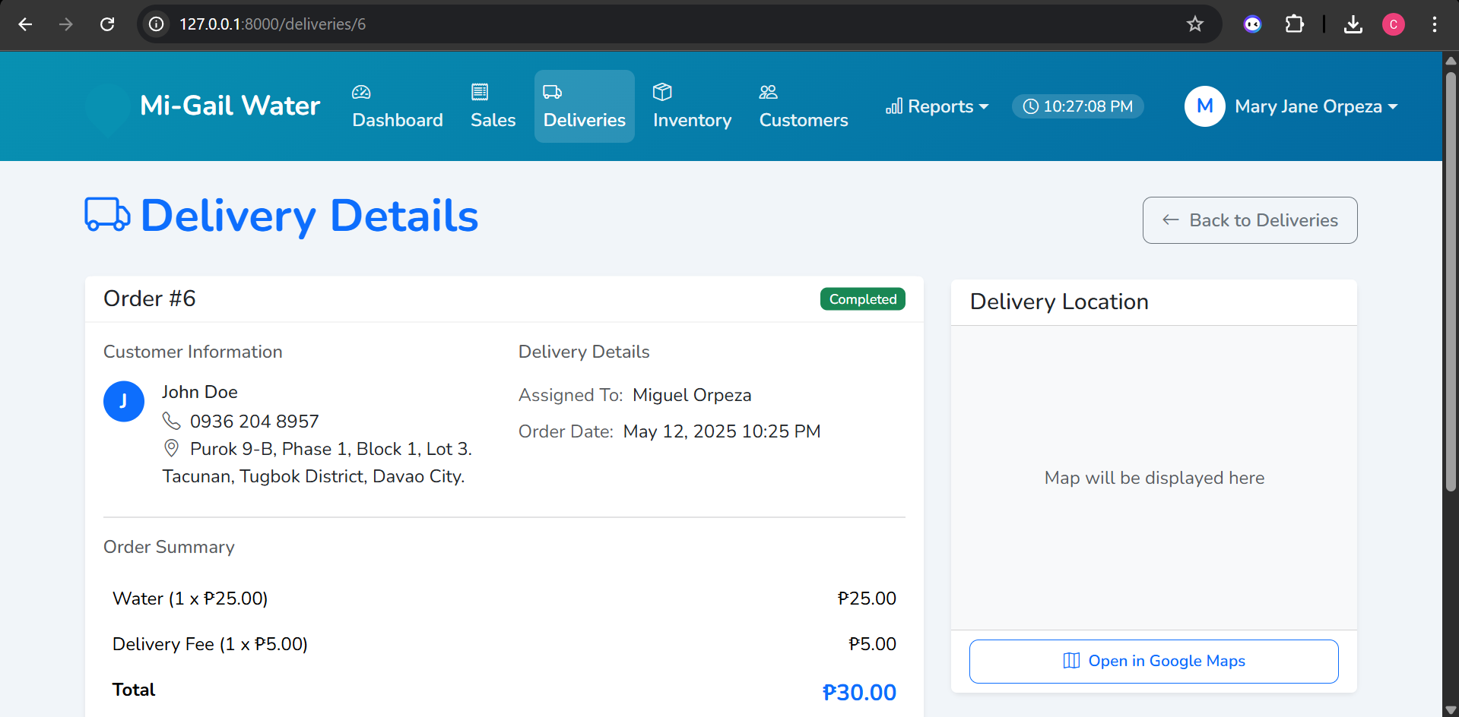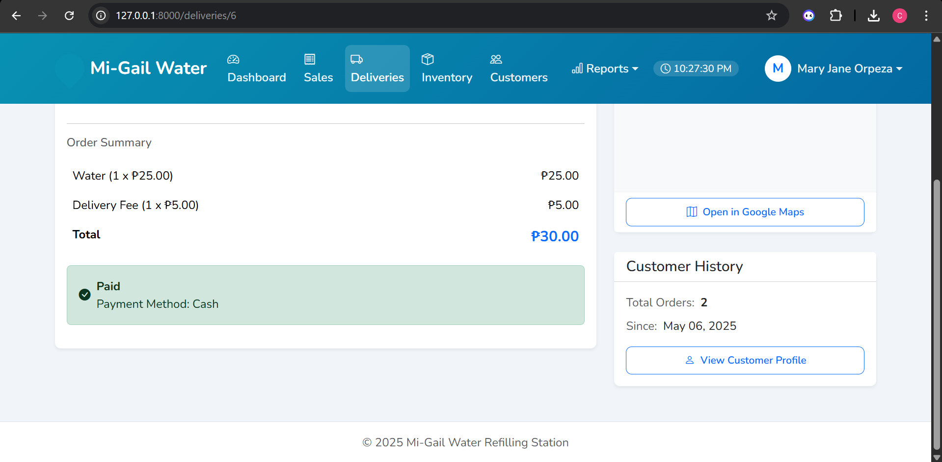
Figure 13: Delivery Form
The delivery form serves as the central tool for managing and tracking the delivery aspect of the business. It provides real-time information on pending deliveries and a historical record of completed deliveries. This allows users to monitor the efficiency of their delivery operations, review past delivery details, and potentially identify areas for improvement in their service.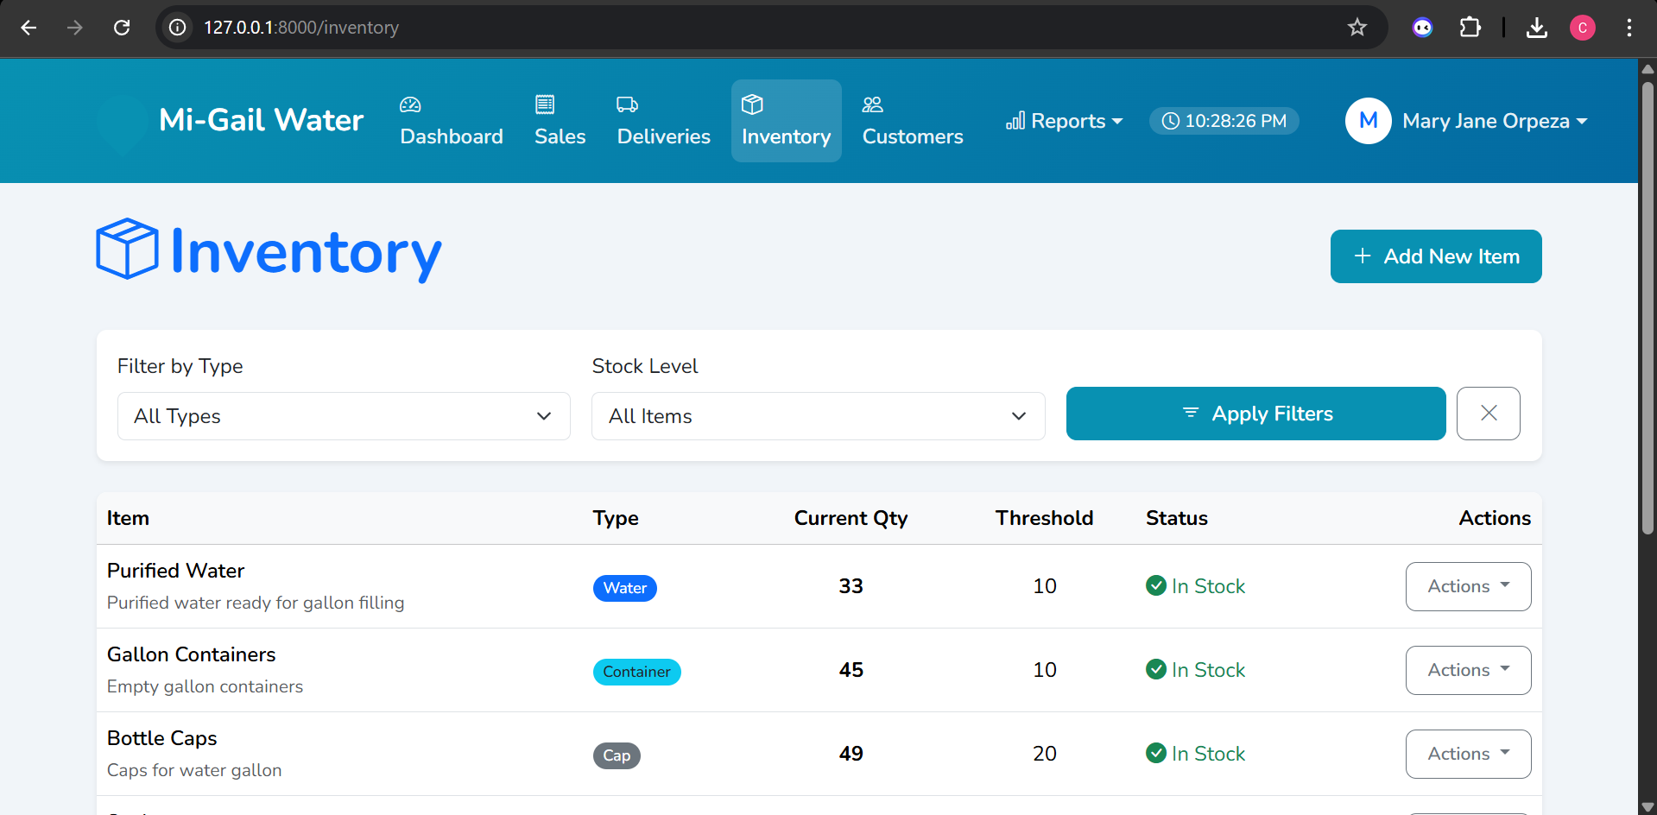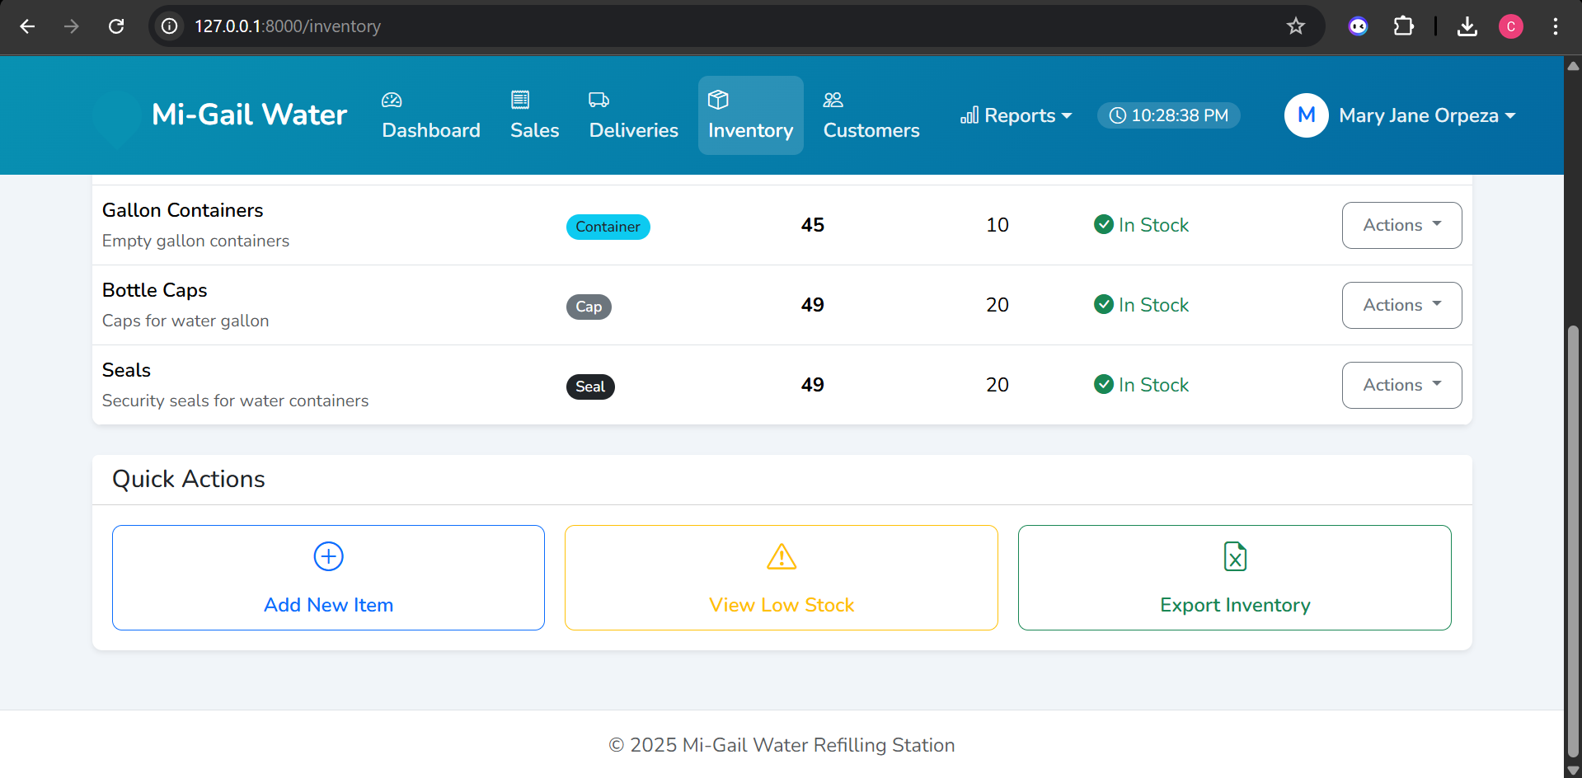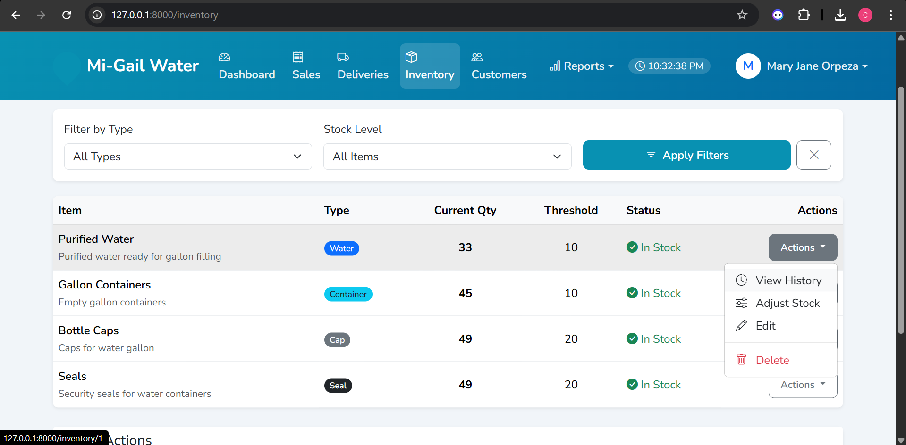
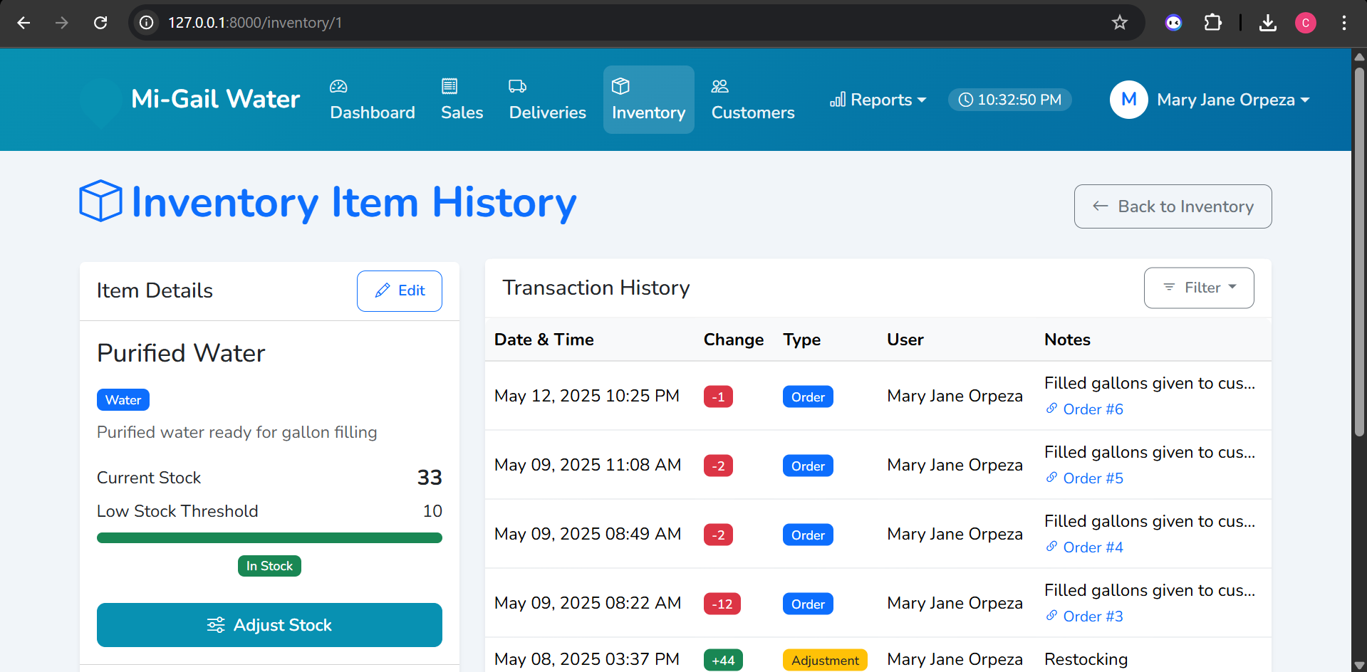
Figure 14: Inventory Form
The inventory form allows users to track the current stock levels of all items. It displays the quantity on hand, a set threshold for each item, and their current stock status. This enables efficient monitoring of supplies and facilitates timely restocking to avoid shortages.

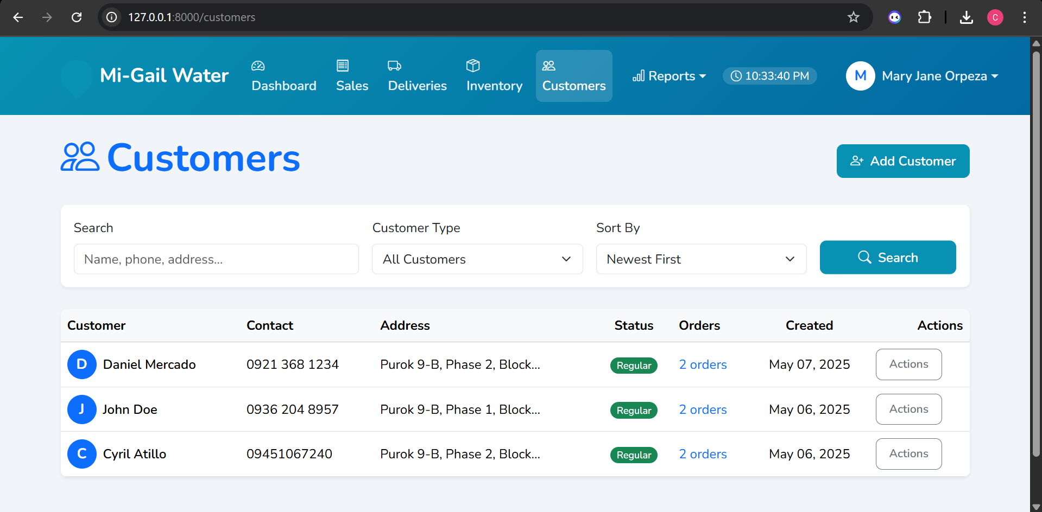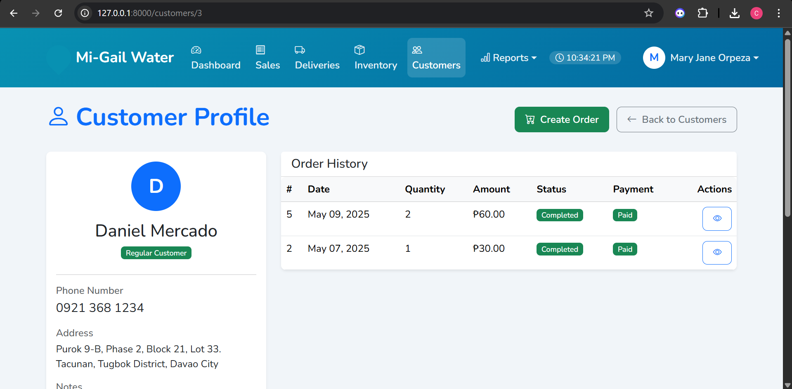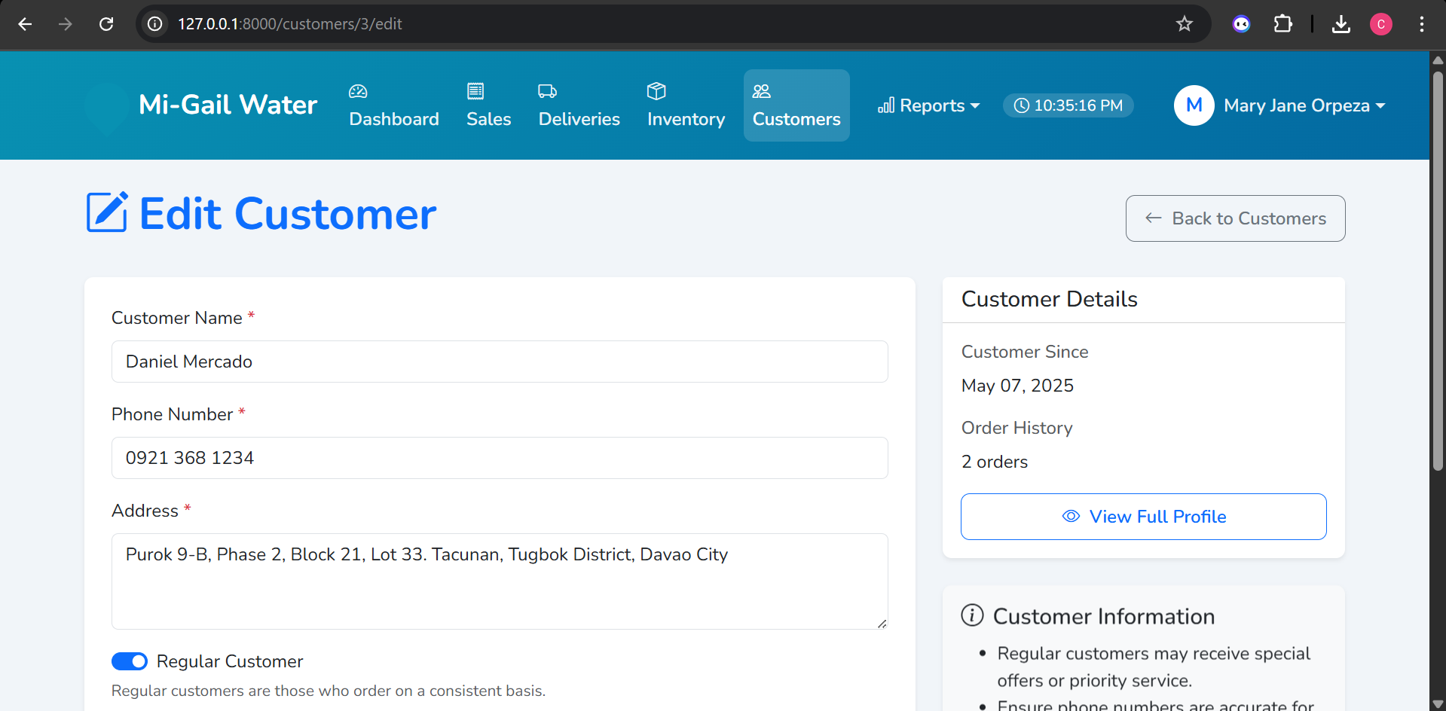
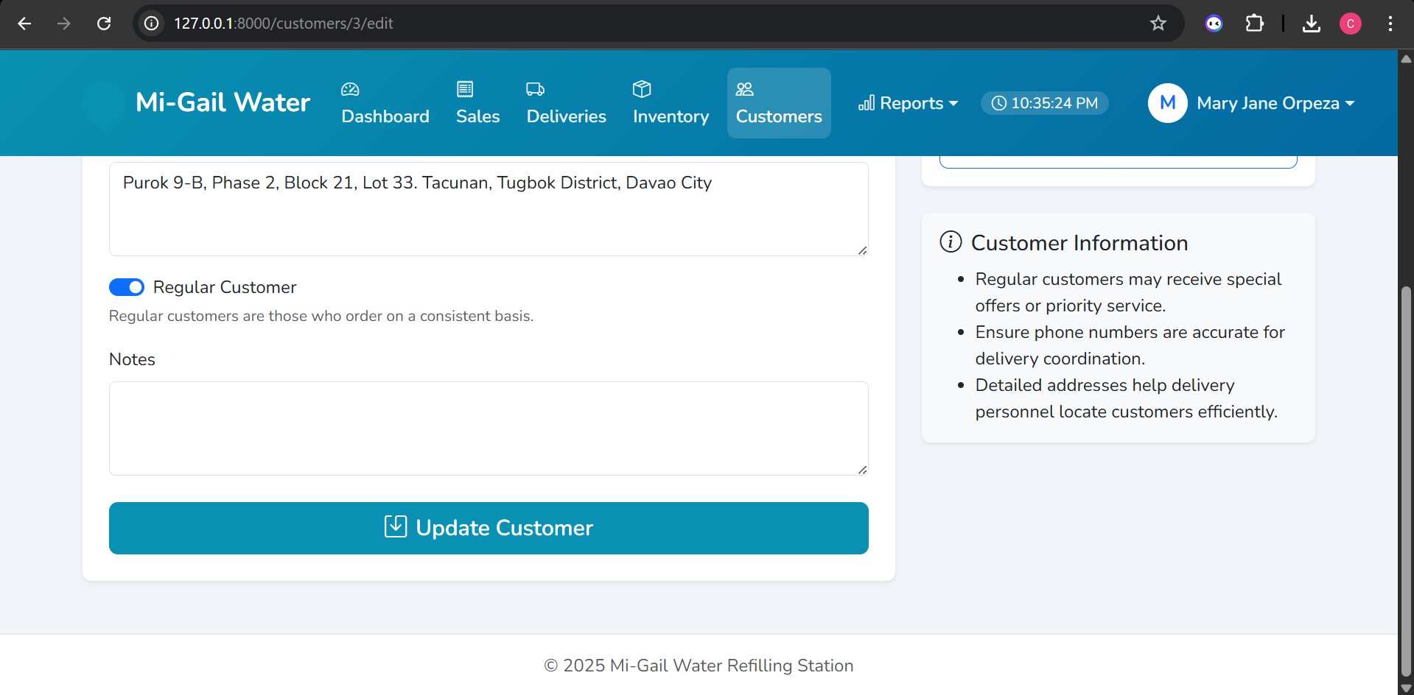
Figure 15: Customers Form
The customers form serves as a database for managing customer information. It allows users to view a list of customers, their contact details, addresses, order status, and the date they were added. Additionally, it provides functionalities to add new customers, view individual customer profiles with their order history, and edit customer details, facilitating effective customer relationship management.
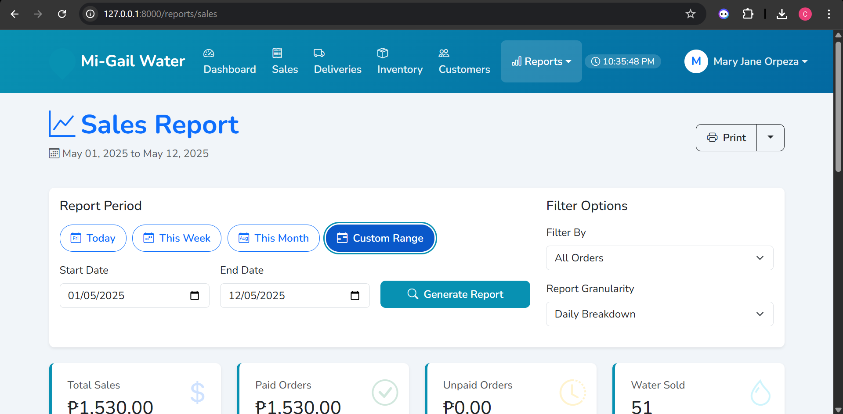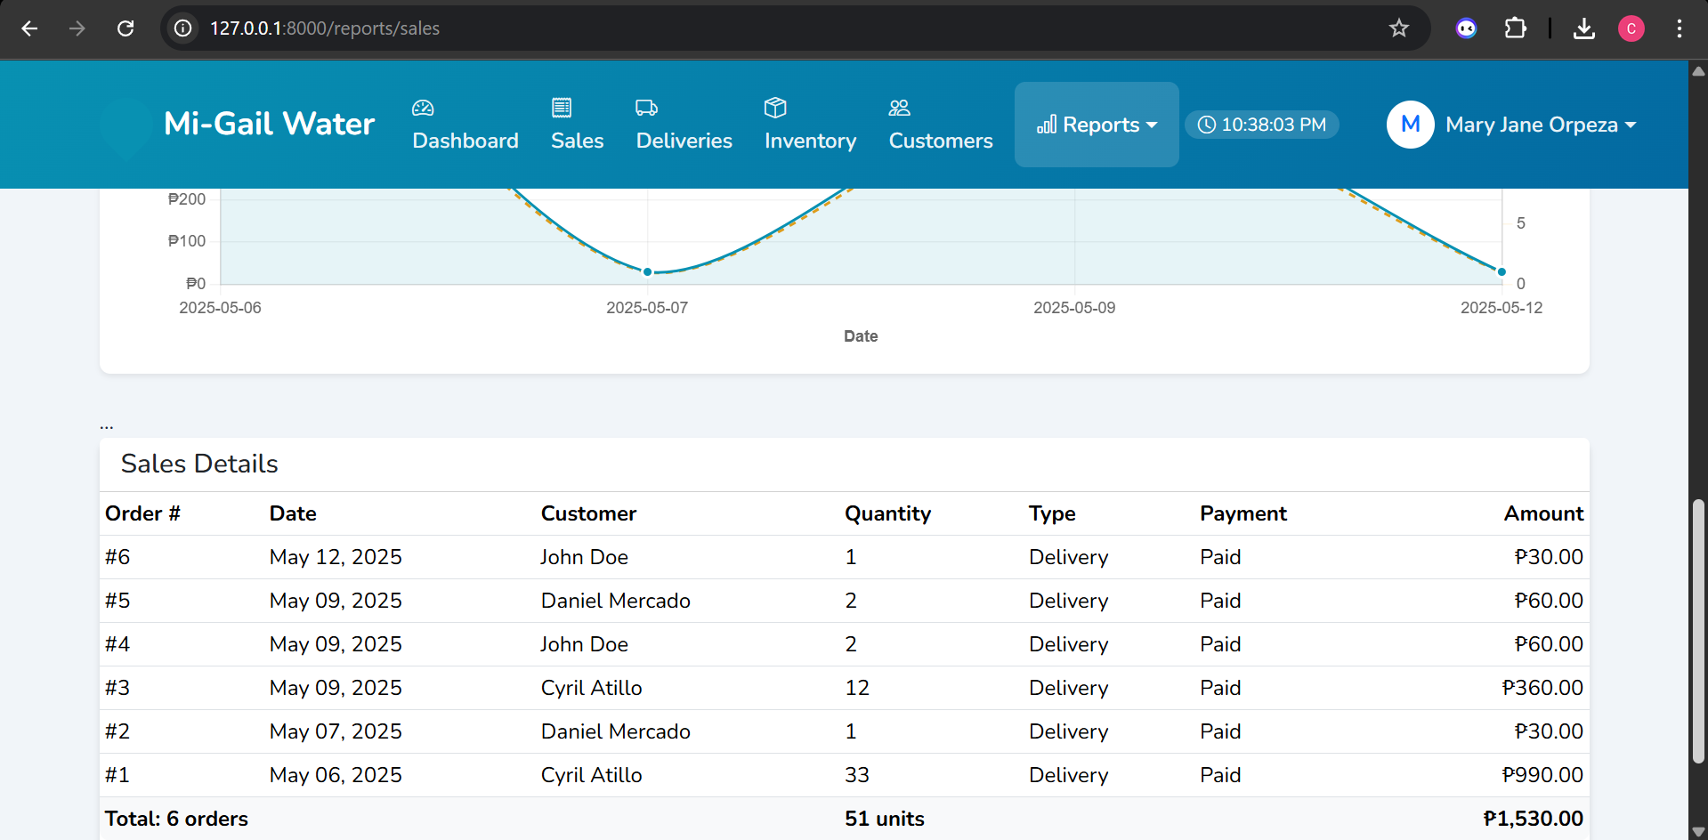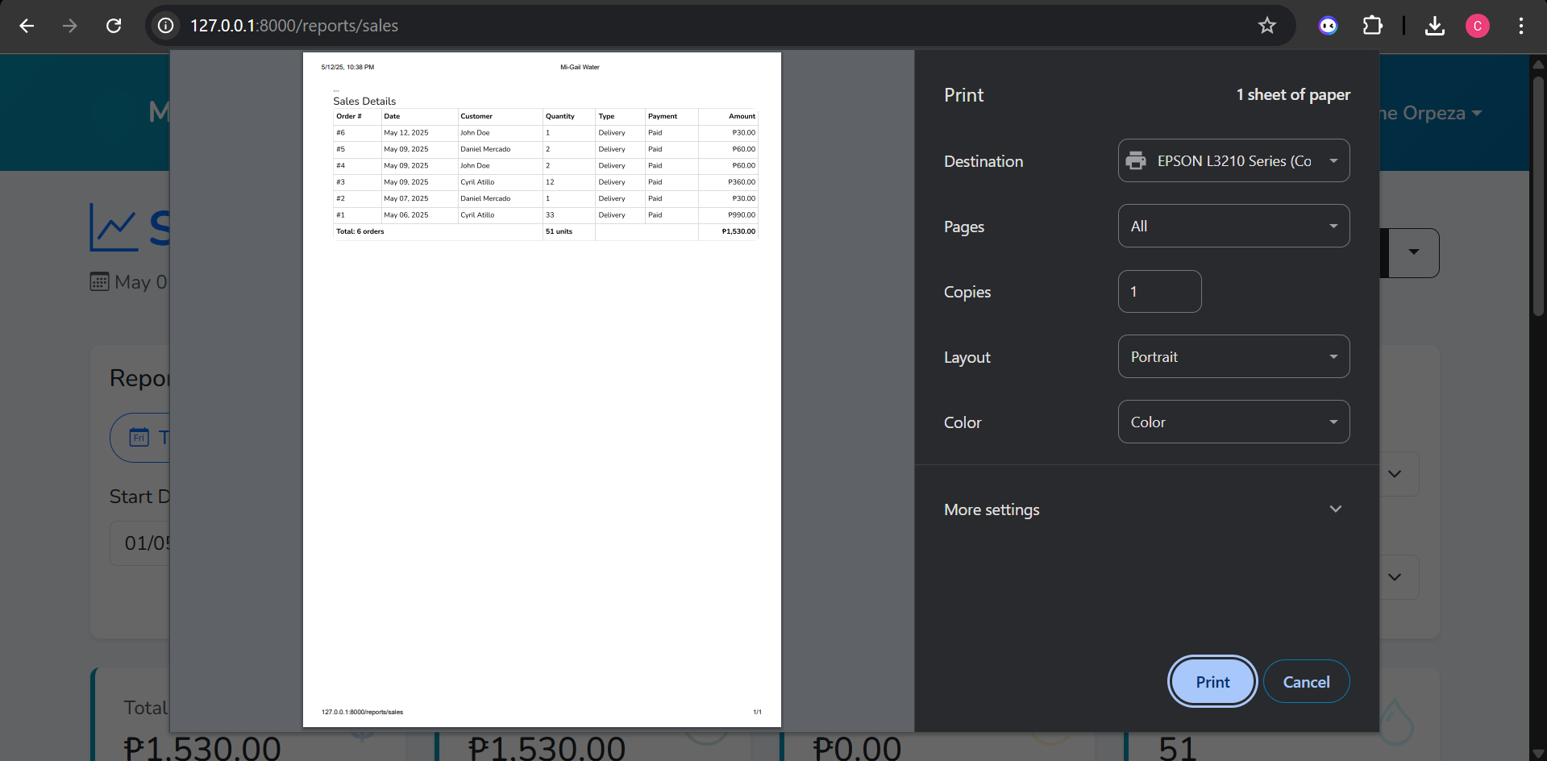
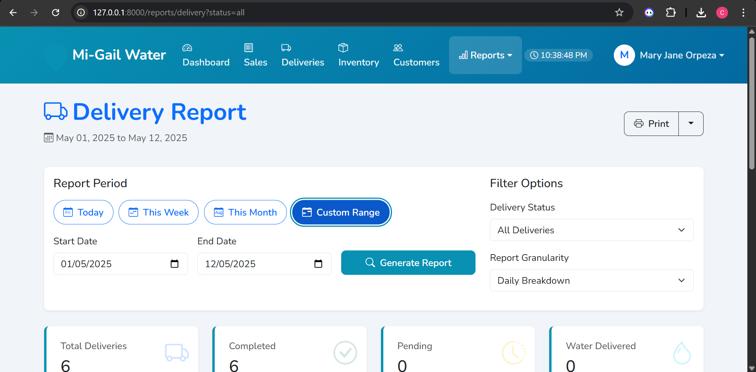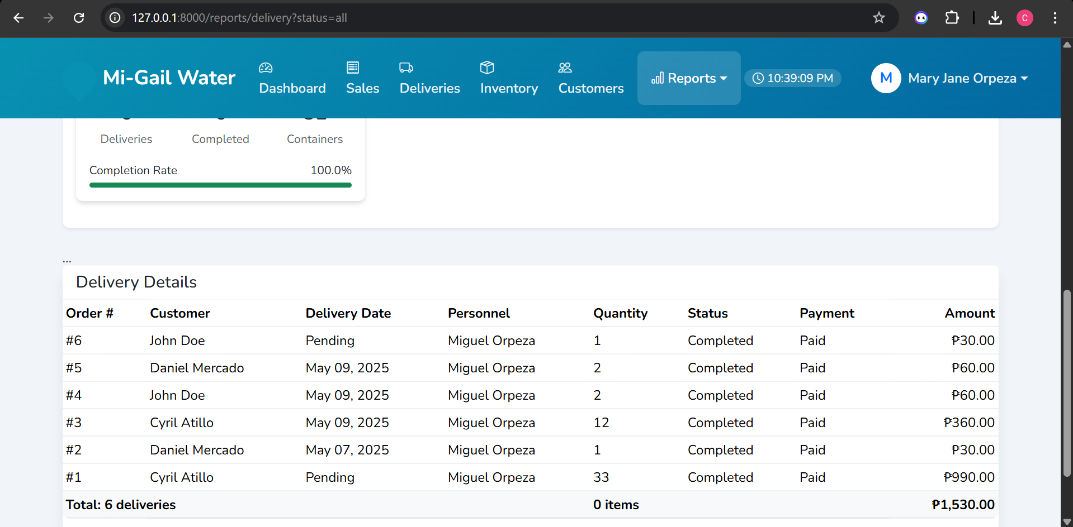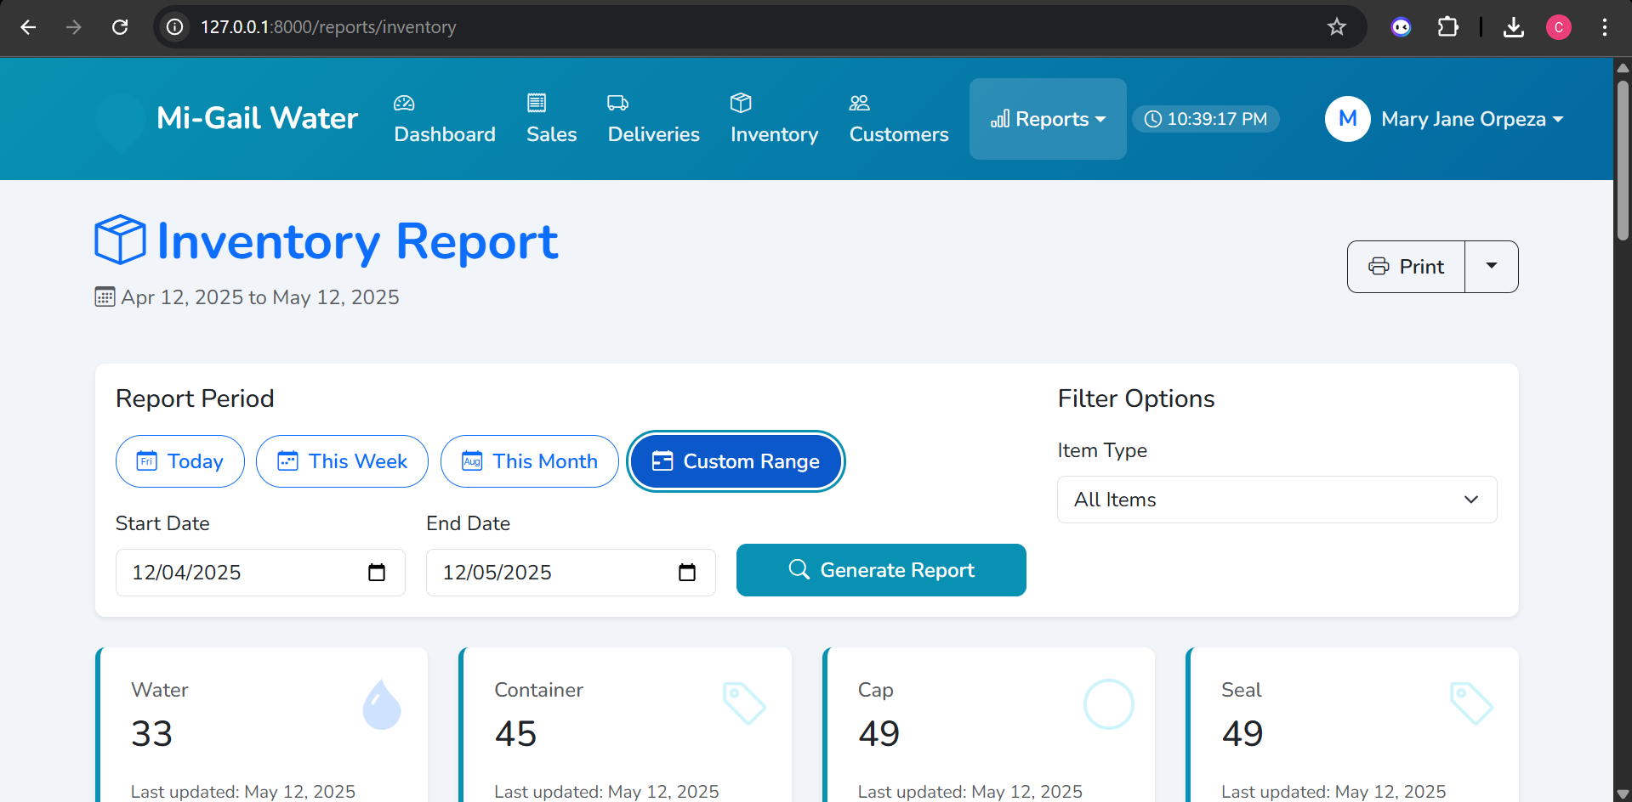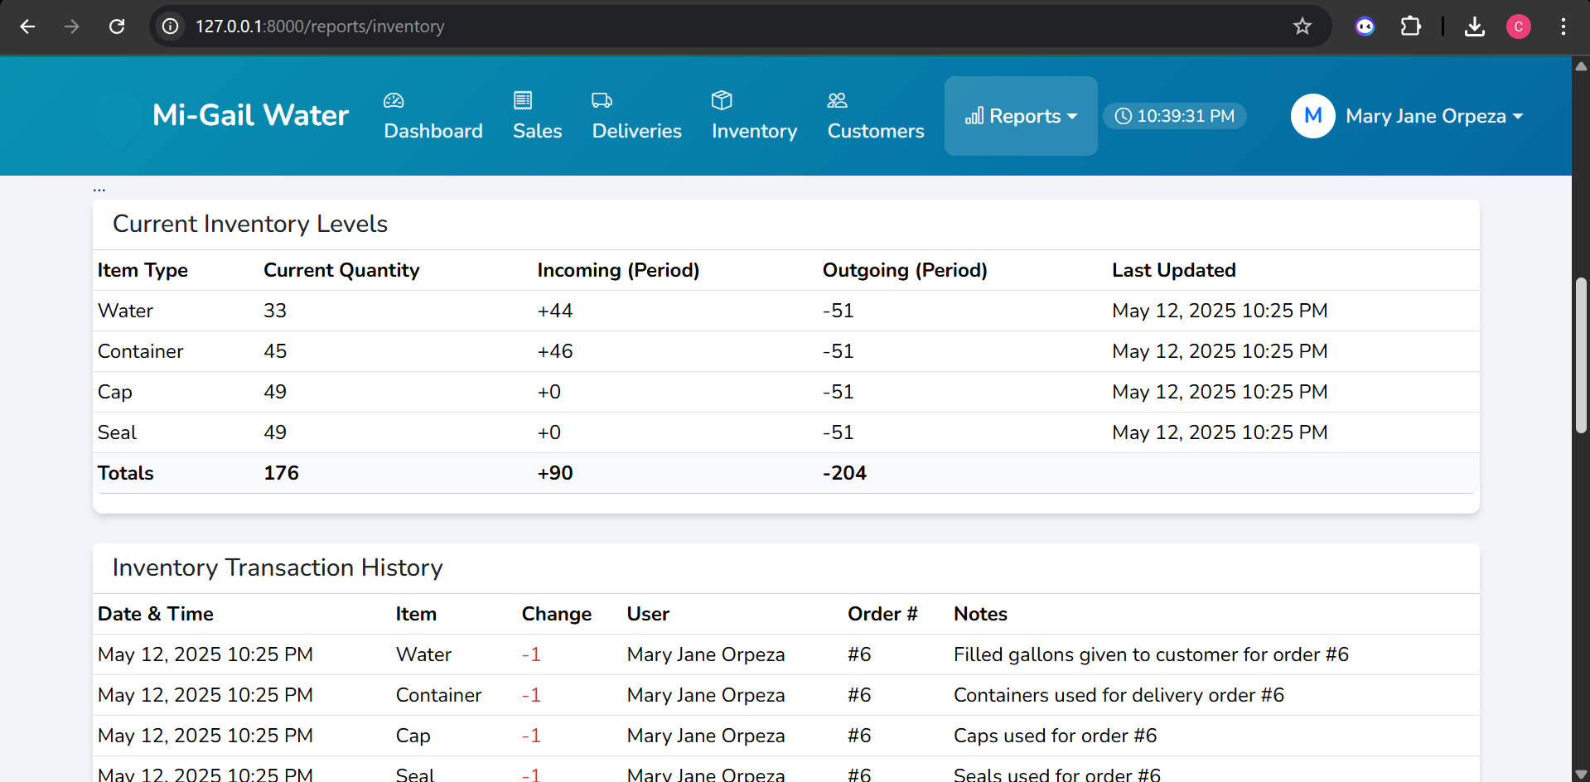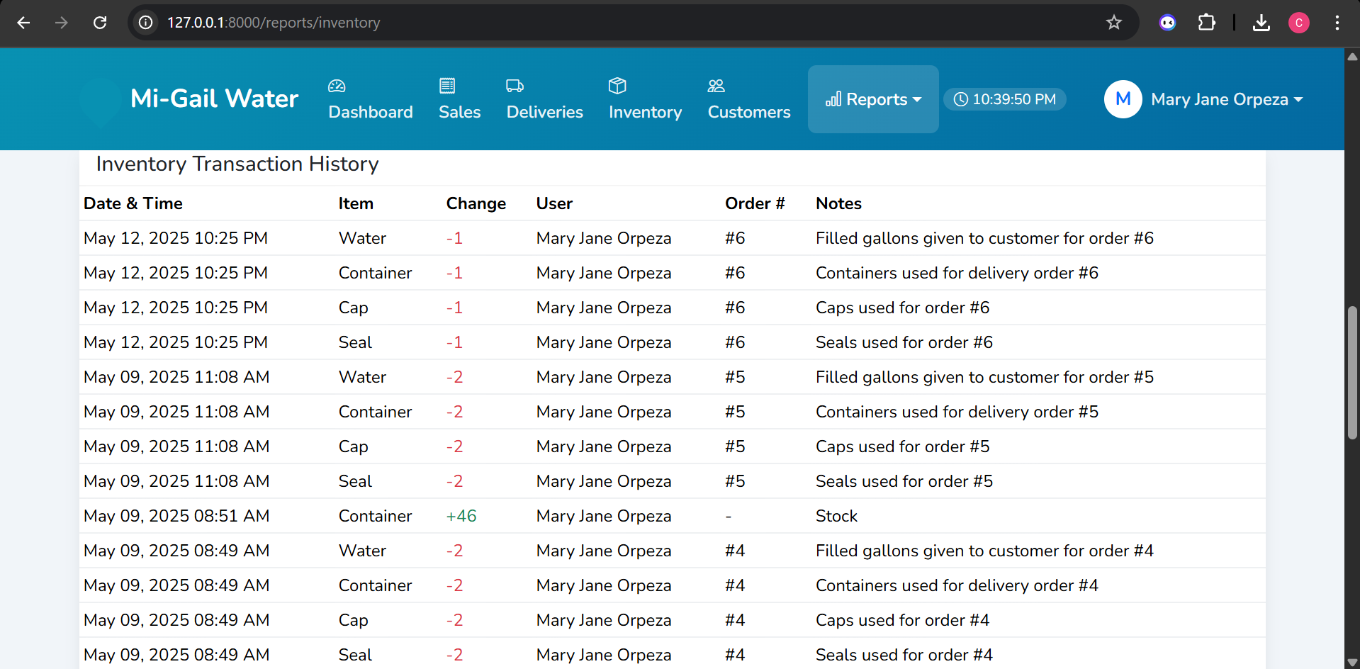
Figure 16: Reports Form
The reports form enables users to generate and view various business reports, such as sales, delivery, and inventory summaries. This functionality allows for performance monitoring and helps in making informed business decisions based on the presented data.

Chapter 4

THE IMPLEMENTATION

User Acceptance Testing
The researchers showed the owner the basic functions of every module in the system to conduct a training. The researchers demonstrated the system specifically the login, Orders, Inventory, Delivery, Customer’s form.

User Training
On May 17, 2025, the researchers conducted a training for the owner on how to use the system and understand its features. During the training, the researchers demonstrated the system step by step to ensure the owner could fully comprehend its functionality.

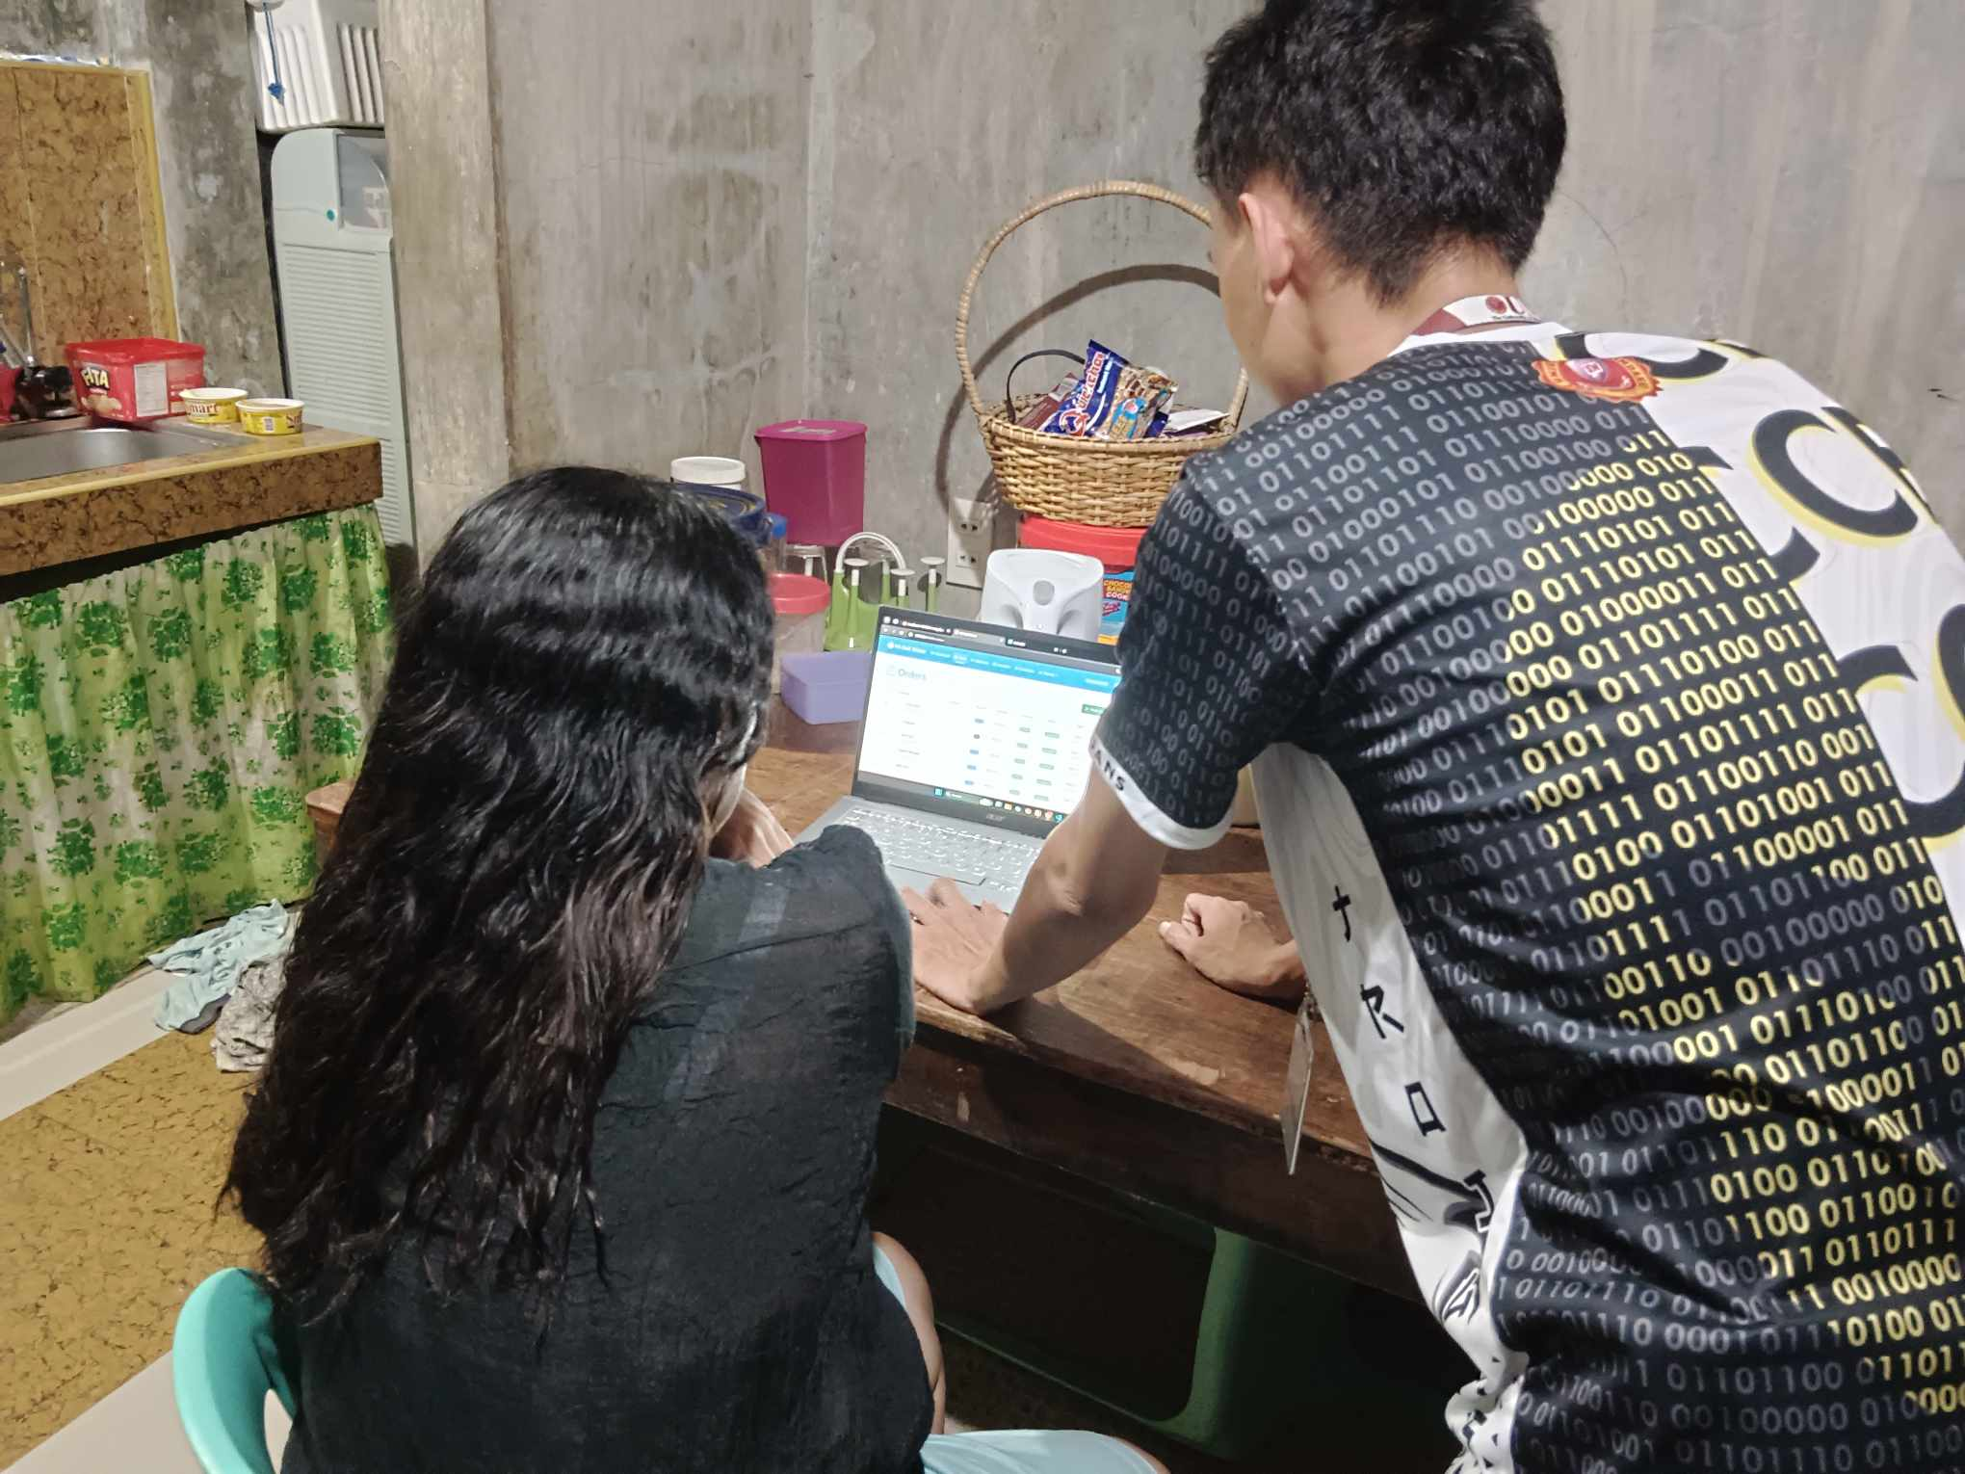
Figure 17: User Training

User Manual
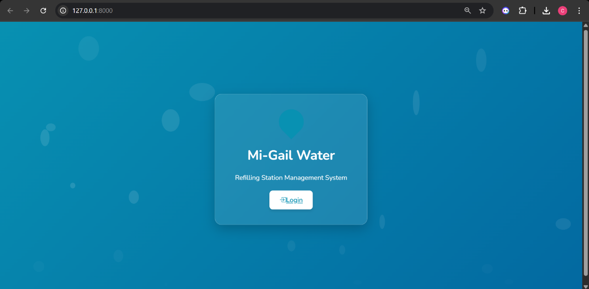
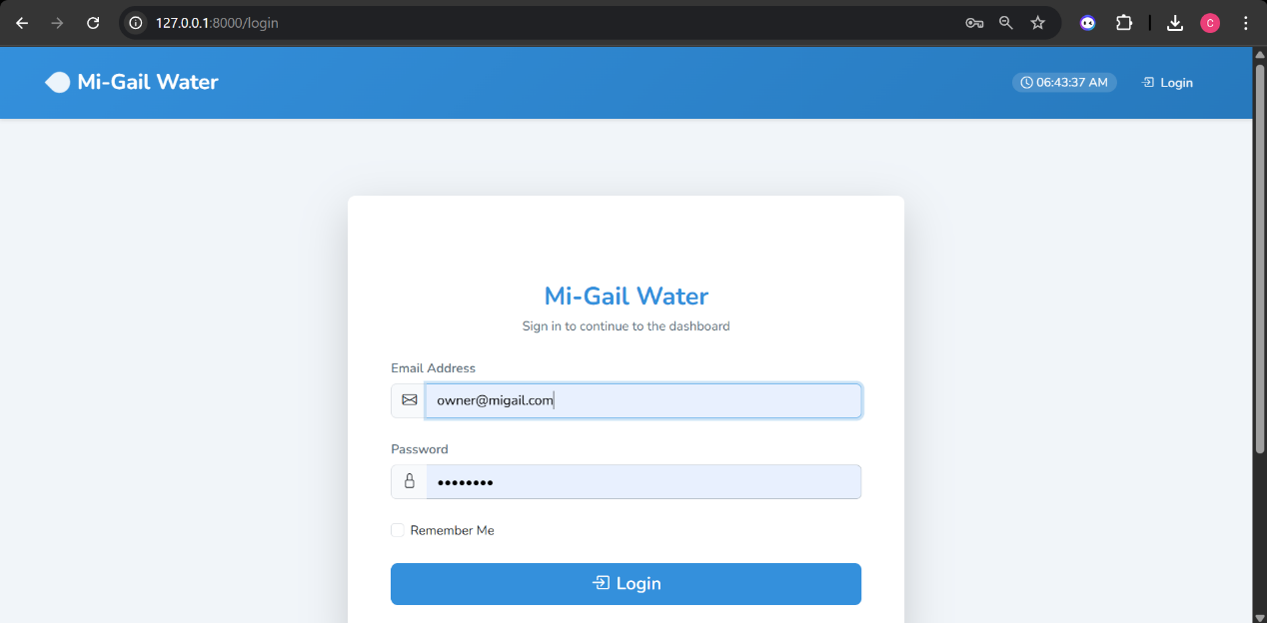
Figure 18: Login Form
The Login Form is the first page you encounter when accessing the Mi-Gail Water System.
Different user roles have different levels of access:
  - Owner: Has complete access to all system functions
  - Admin: Has access to most functions except some administrative settings
  - Helper: Has limited access to day-to-day operations
  - Delivery: Has access to delivery-related functions
To login:
- Type your username in the username field.
- Enter your password in the password field.
- Click the "LOGIN" button to proceed to the system dashboard.
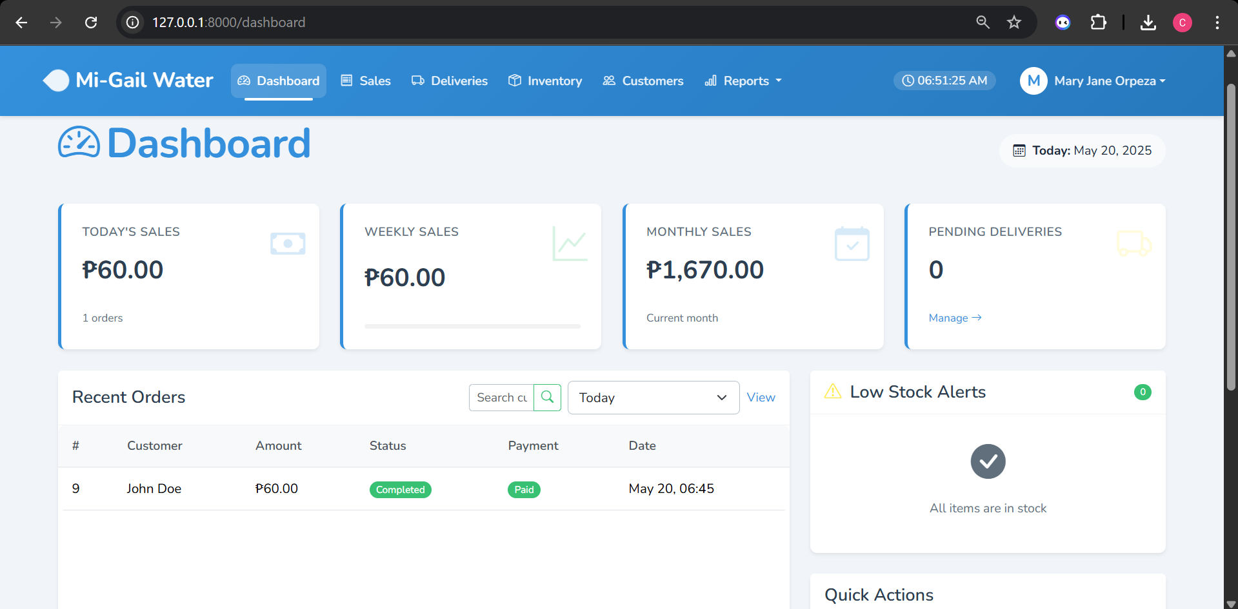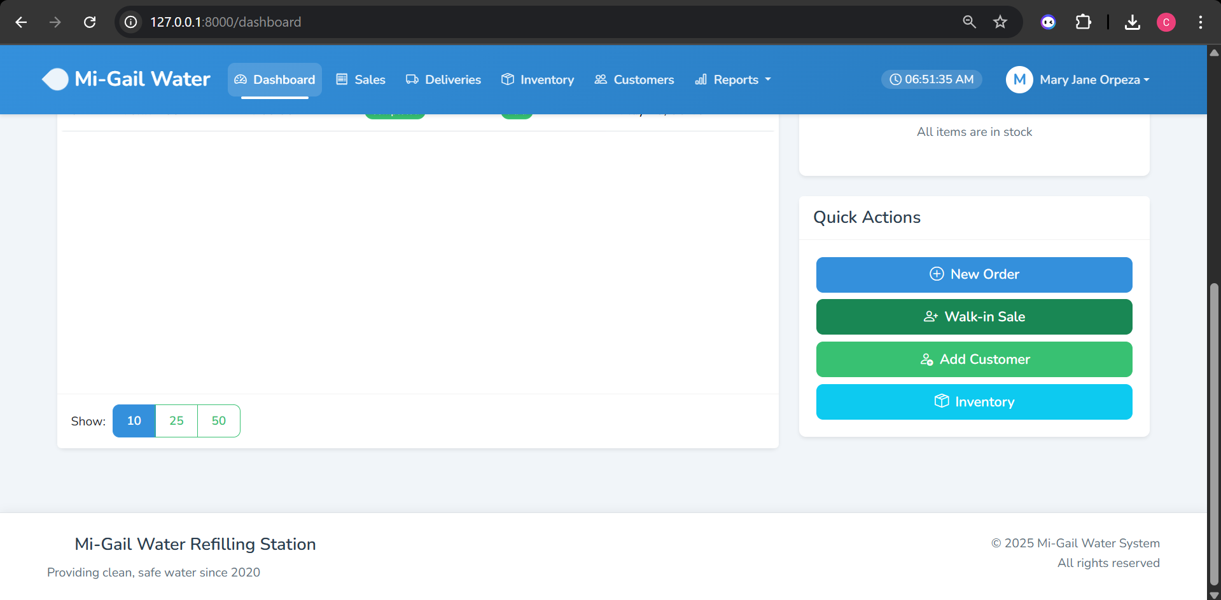
Figure 19: Dashboard
The dashboard provides an overview of your water refilling station's key metrics and quick access to all functions:
- Statistics Cards: View total sales, pending deliveries, inventory levels, and customers at a glance.
- Recent Orders: See the most recent orders placed in the system.
- Quick Action Buttons: Create new orders, add customers, manage inventory, and more.
- Navigation Menu: Access all system features through the top navigation bar.
- Navigation options include:
- Dashboard: Return to the main overview screen
- Sales: Manage orders and transactions
- Deliveries: Track and manage water deliveries
- Inventory: Monitor and update stock levels
- Customers: Manage customer information
- Reports: Generate various business reports
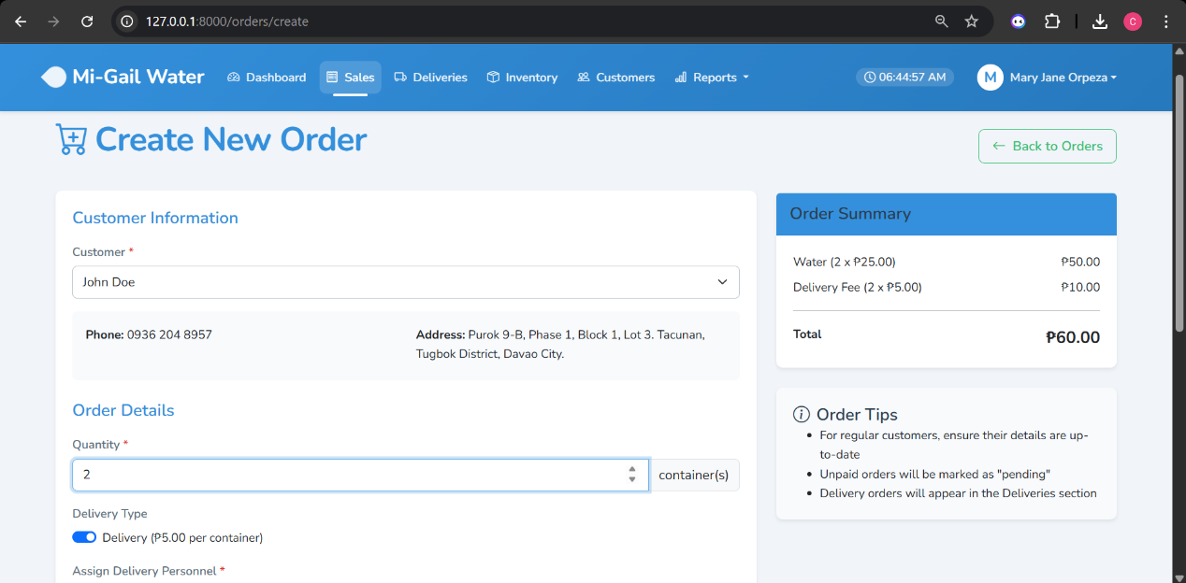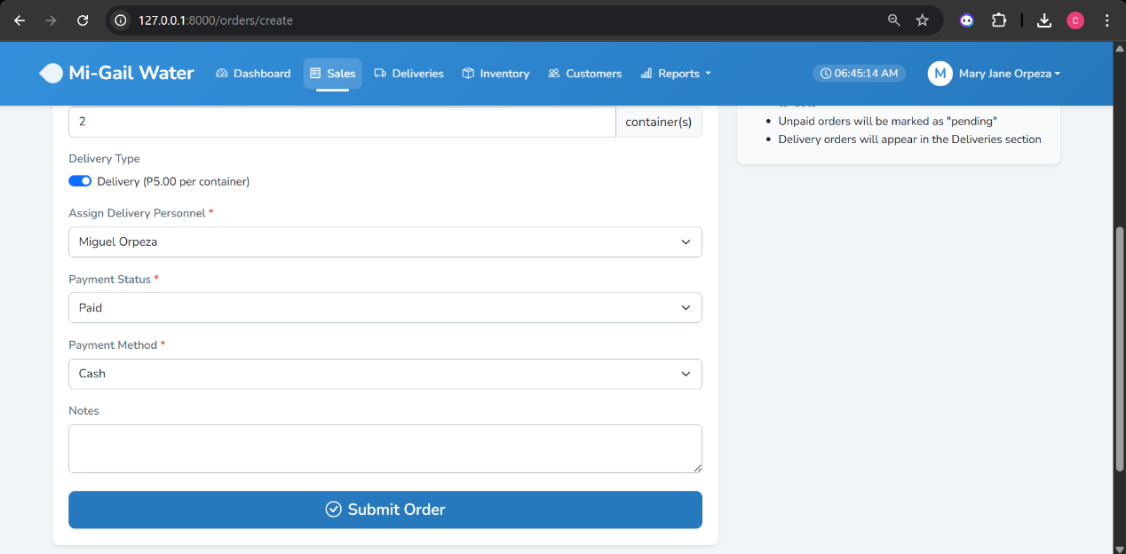
Figure 20: Create a new order for regular customer
To create a new order for an existing regular customer:
- Navigate to "Sales" in the top menu.
- Click on "Create New Order" button.
- Select "Regular Customer" option.
- Search for the customer by name or phone number.
- Fill in the order details:
  - Quantity of water containers
  - Select delivery option (if applicable)
  - Choose payment method
  - Enter total amount
- Click "Submit Order" to complete the transaction.

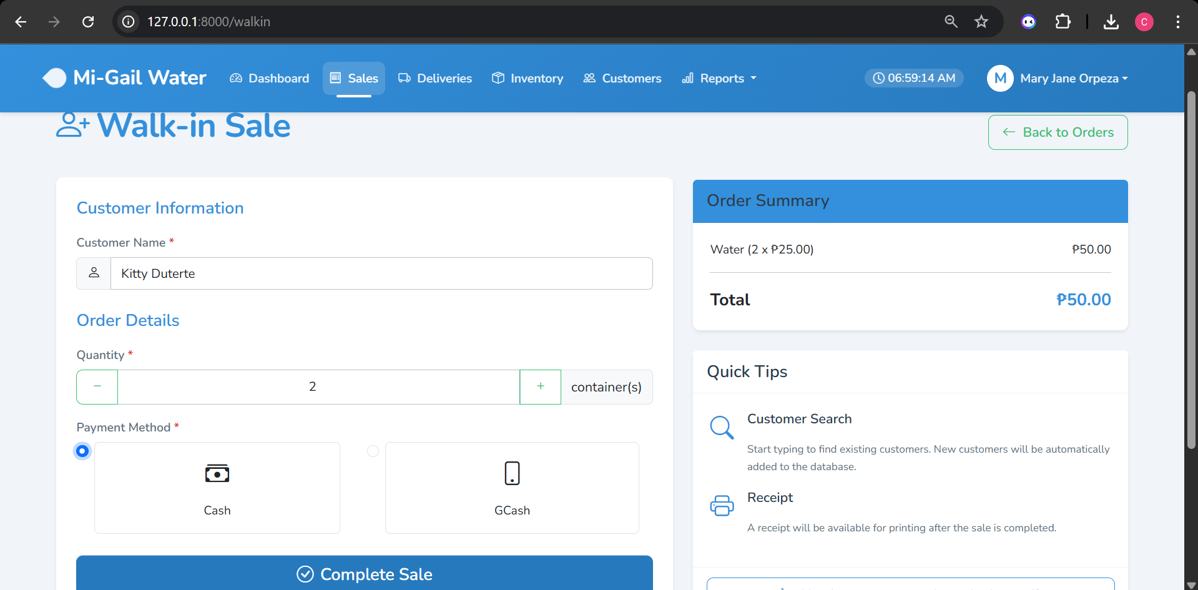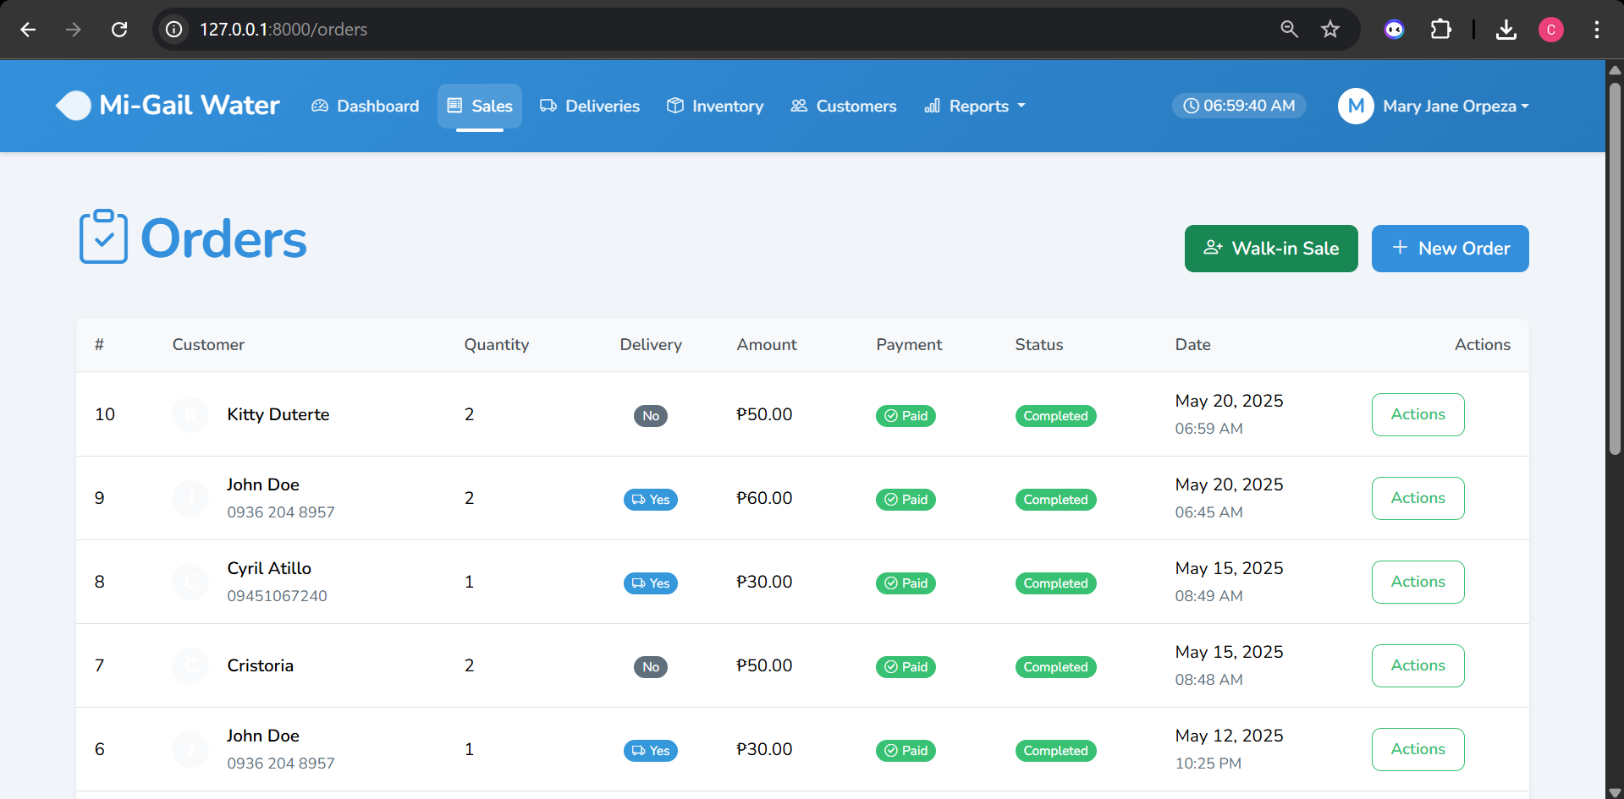
Figure 21: Create a new order for walk-in customer
For customers who don't have an account in the system:
- Navigate to "Sales" in the top menu.
- Click on "Create New Order" button.
- Select "Walk-in Customer" option.
- Fill in the basic customer information:
  - Customer name
  - Phone number (optional)
- Complete the order details:
  - Quantity of water containers
  - Select payment method
  - Enter total amount
- Click "Submit Order" to complete the transaction.
- All completed transactions will appear in the Sales list and will update the inventory automatically.

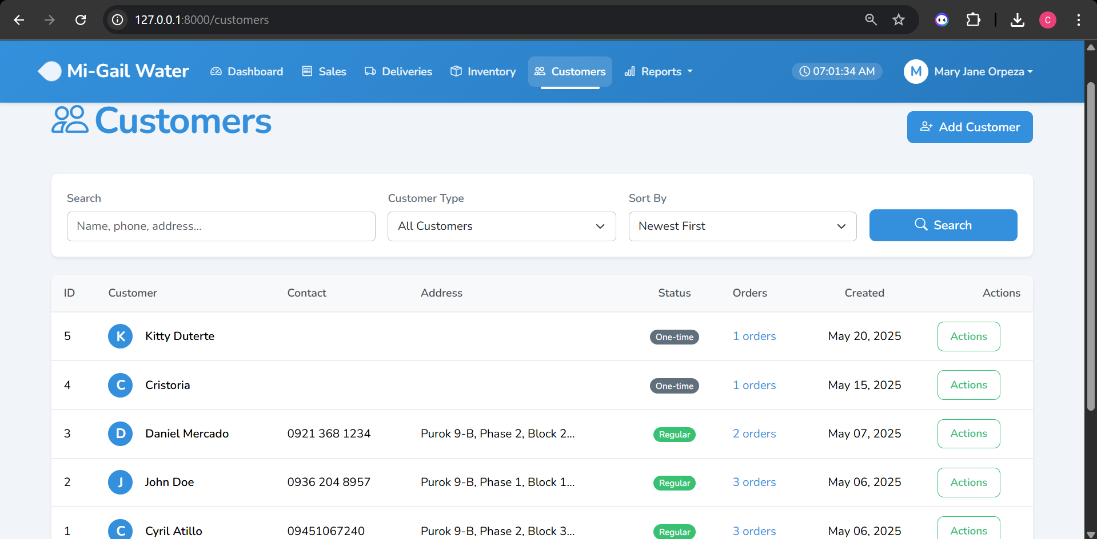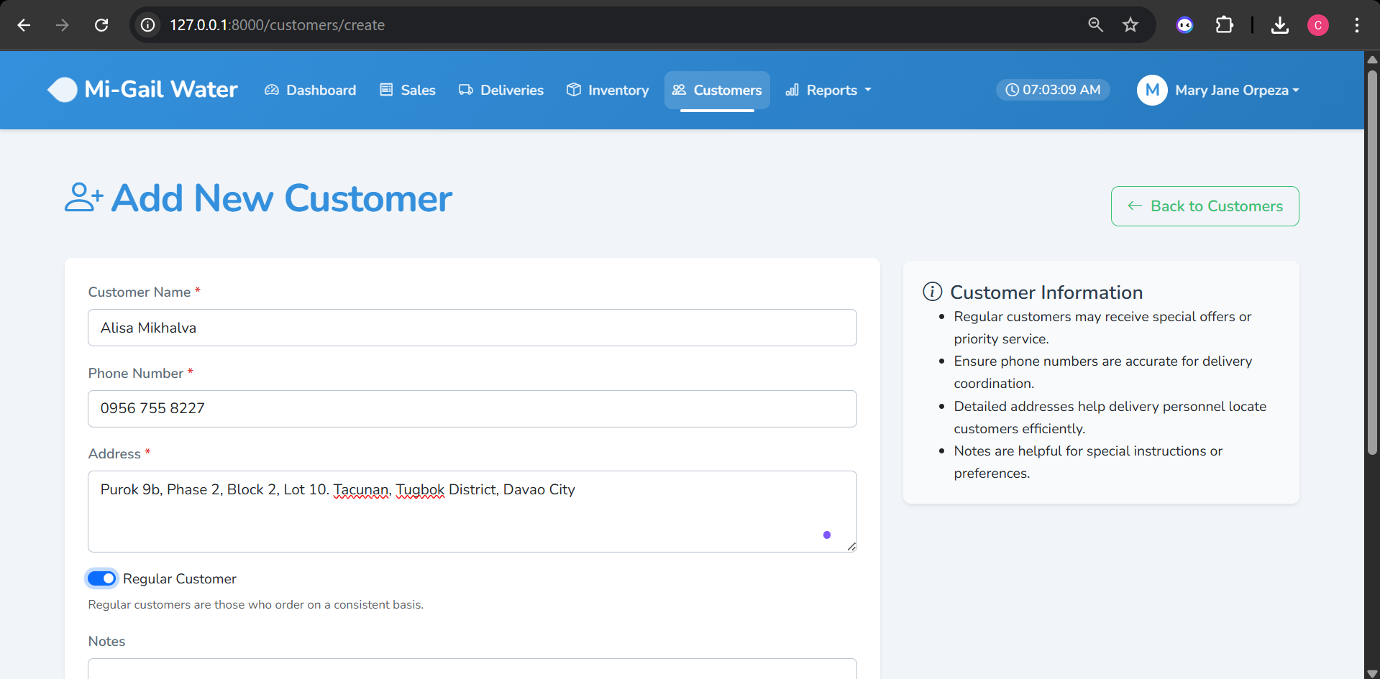
Figure 22: Create a record of a regular customer
Regular customers receive special pricing and delivery services. To add a regular customer:
- Navigate to "Customers" in the top menu.
- Click the "Add New Customer" button.
- Fill in the customer details:
  - Full name
  - Contact number
  - Complete address
  - Email (optional)
  - Mark "Regular Customer" checkbox
- Click "Save Customer" to add them to the system.
- Managing Customer Records
- The Customers page allows you to:
- View all registered customers
- Edit customer information
- Track customer purchase history
- Search for specific customers
- Filter customers by type (regular/one-time)
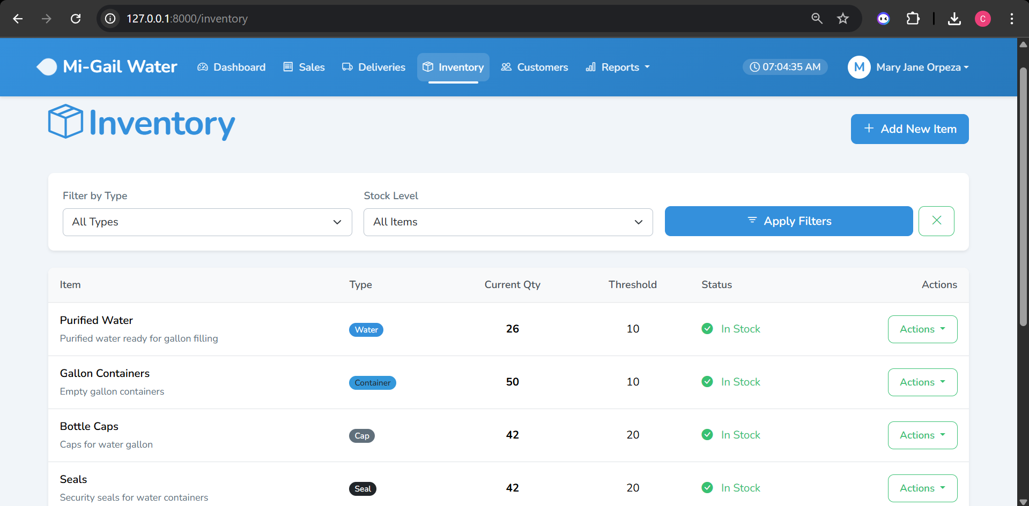
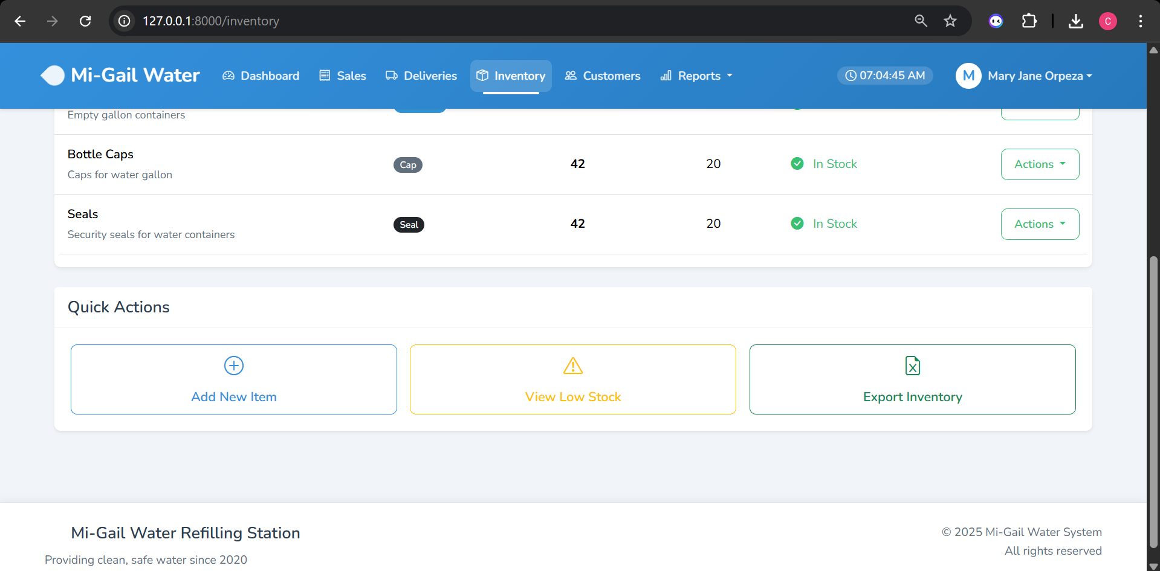
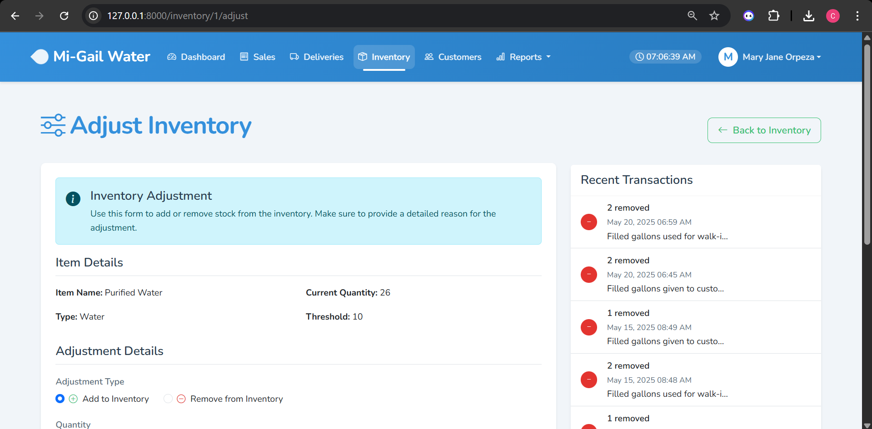
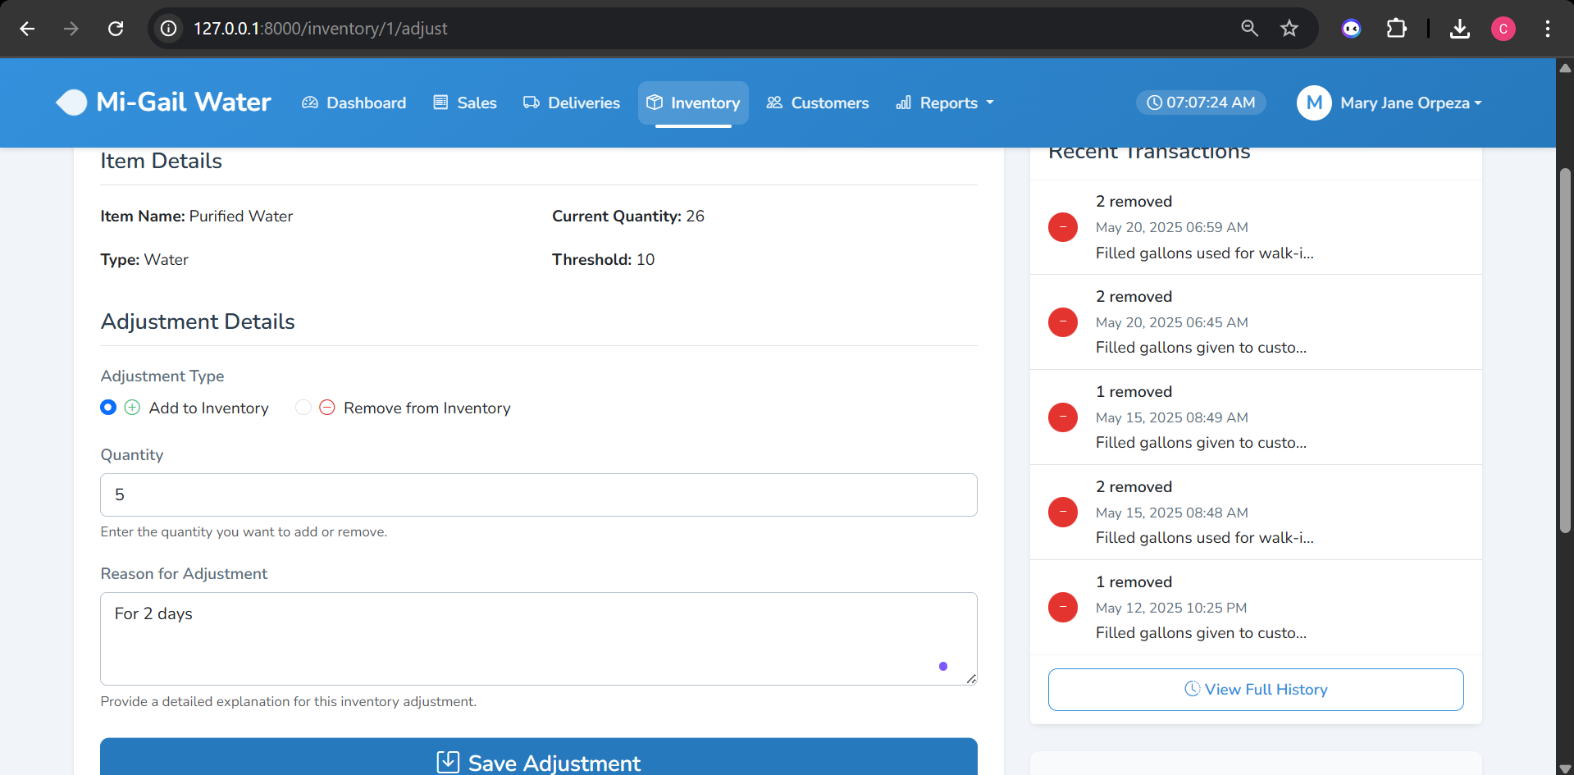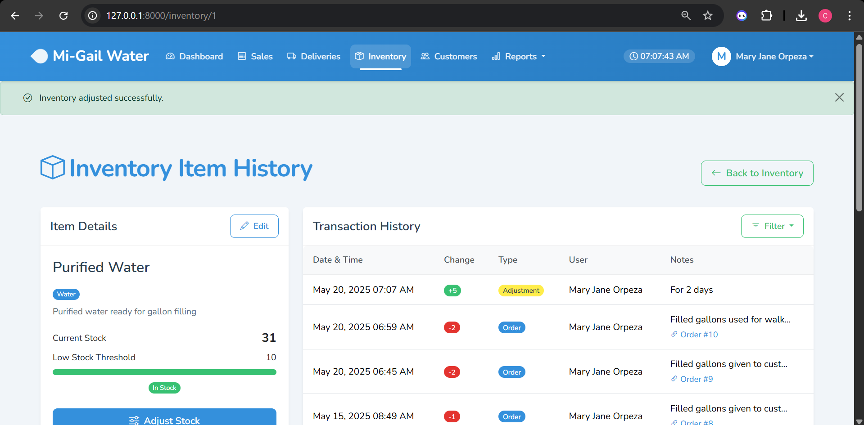
Figure 23: Inventory page and adding stock successfully
The inventory system helps you track water containers, empty bottles, and other inventory items.
- Managing Inventory
- Navigate to "Inventory" in the top menu.
- View current stock levels for all item types.
- To add or remove stock:
  - Click "Add Stock" or "Remove Stock" button
  - Select the item type (Water, Empty, Cap, etc.)
  - Enter the quantity
  - Add notes (optional)
  - Click "Submit" to update inventory
- The system automatically updates inventory when:
- New sales are recorded (reduces water inventory)
- Empty bottles are returned (increases empty inventory)
- Deliveries are marked as completed

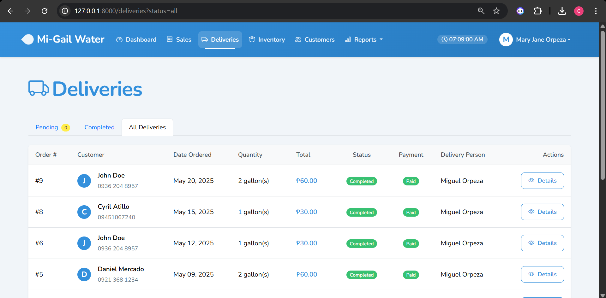
Figure 24: Viewing of all done deliveries
The delivery management system helps track and manage water deliveries to customers.
- Managing Deliveries
- Navigate to "Deliveries" in the top menu.
- View all pending, ongoing, and completed deliveries.
- To update delivery status:
  - Select a delivery from the list
  - Click "Update Status" button
  - Choose the appropriate status (Pending, Out for Delivery, Completed, Cancelled)
  - Add notes if necessary
  - Click "Save Changes"
- Assigning Delivery Personnel
- From the delivery details page, click "Assign Personnel"
- Select an available delivery person from the dropdown
- Set the estimated delivery time
- Click "Assign" to update the delivery record

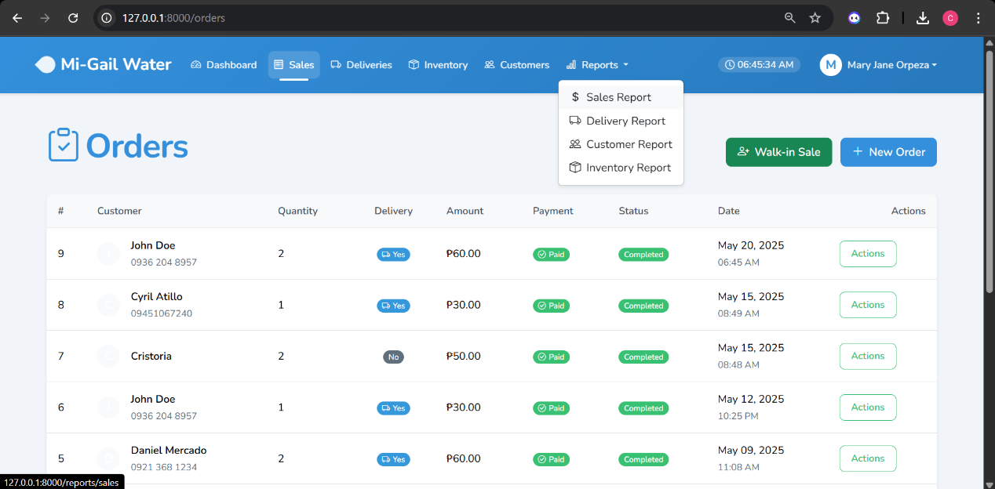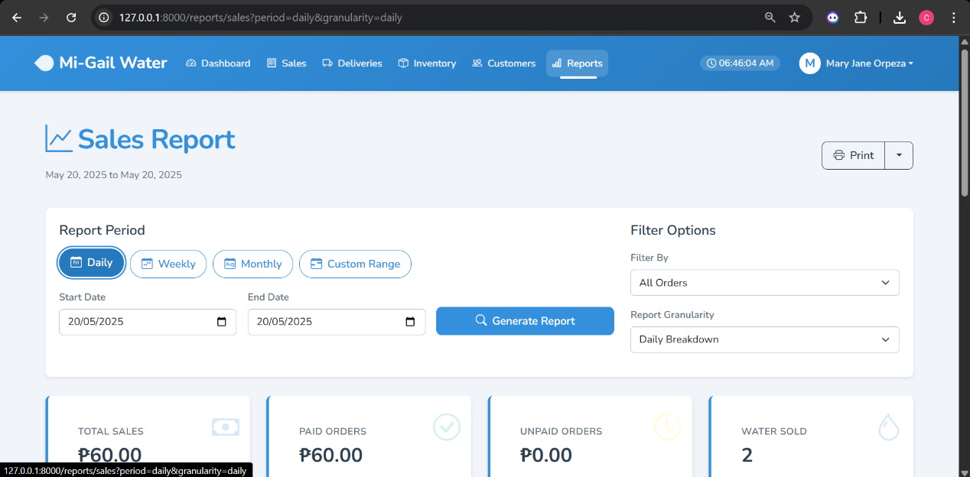
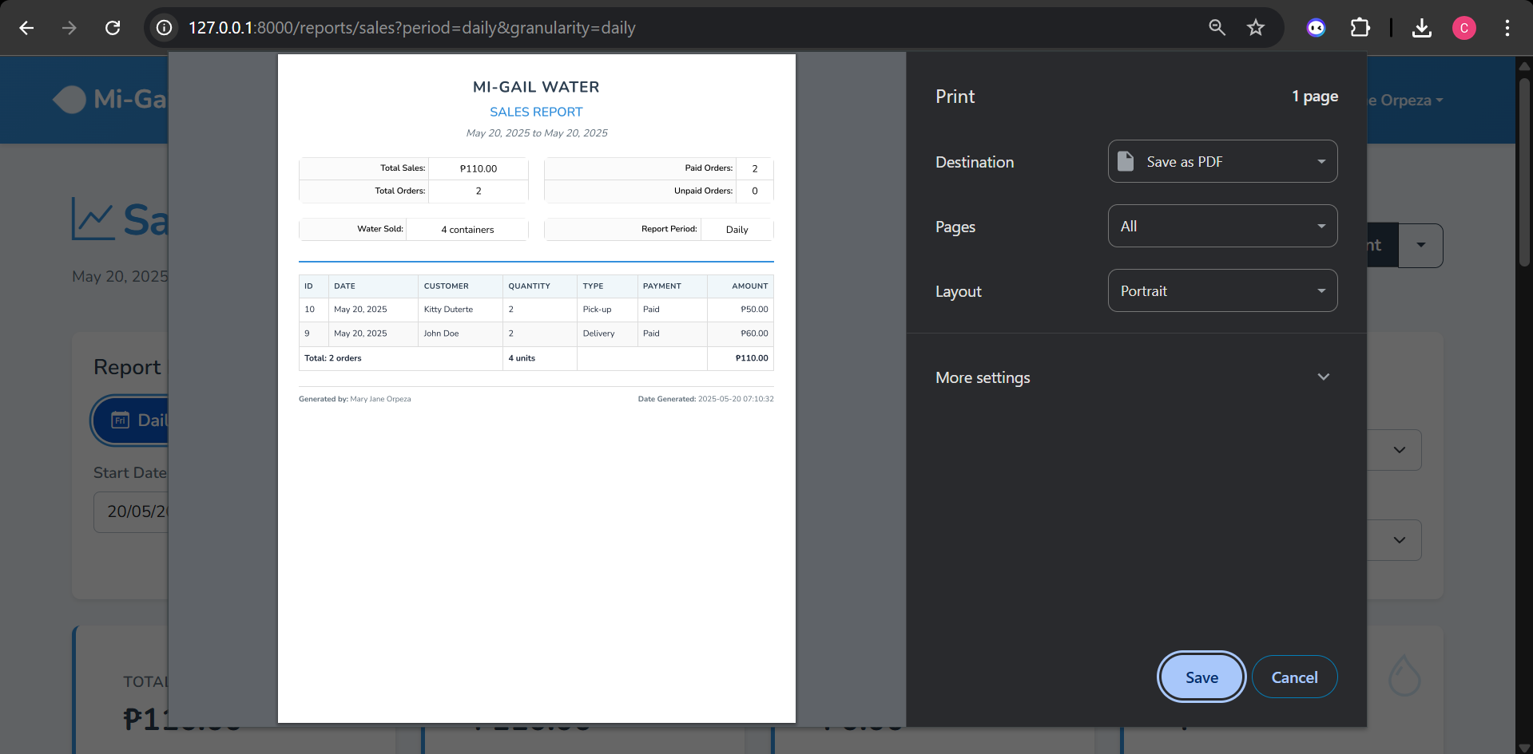
Figure 25: Sales report form
The reporting system provides insights into your business performance.
- Generating Reports
- Navigate to "Reports" in the top menu.
- Select the type of report:
  - Sales Report: Overview of all sales transactions
  - Delivery Report: Analysis of delivery operations
  - Customer Report: Customer purchase patterns
  - Inventory Report: Stock level changes and transactions
- Set filters as needed:
  - Date range (daily, weekly, monthly, or custom)
  - Payment status
  - Customer type
  - Item type
- Click "Generate Report" to view the results.
- Exporting Reports
- All reports can be:
- Printed directly from the browser
- Exported to Excel for further analysis
- Exported to PDF for sharing
- Exported to CSV for database imports
- To export a report:
- Generate the report with your desired filters
- Click the dropdown next to the "Print" button
- Select your preferred export format
- The report will download automatically

For additional assistance or to report issues with the Mi-Gail Water System,
please contact system support at support@migailwater.com or call our helpdesk at (123) 456-7890.

Chapter 5

THE SOURCE CODE
<?php
// database/migrations/2023_01_01_000001_create_users_table.php
use Illuminate\Database\Migrations\Migration;
use Illuminate\Database\Schema\Blueprint;
use Illuminate\Support\Facades\Schema;

class CreateUsersTable extends Migration
{
/**
* Run the migrations.
*
* @return void
*/
public function up()
{
Schema::create('users', function (Blueprint $table) {
$table->id();
$table->string('name');
$table->string('email')->unique();
$table->string('password');
$table->enum('role', ['owner', 'delivery', 'helper'])->default('helper');
$table->rememberToken();
$table->timestamps();
});
}

/**
* Reverse the migrations.
*
* @return void
*/
public function down()
{
Schema::dropIfExists('users');
}
}

<?php
// database/migrations/2023_01_01_000002_create_customers_table.php
use Illuminate\Database\Migrations\Migration;
use Illuminate\Database\Schema\Blueprint;
use Illuminate\Support\Facades\Schema;

class CreateCustomersTable extends Migration
{
/**
* Run the migrations.
*
* @return void
*/
public function up()
{
Schema::create('customers', function (Blueprint $table) {
$table->id();
$table->string('name');
$table->string('phone')->nullable();
$table->text('address')->nullable();
$table->boolean('is_regular')->default(false);
$table->timestamps();
});
}

/**
* Reverse the migrations.
*
* @return void
*/
public function down()
{
Schema::dropIfExists('customers');
}
}

<?php
// database/migrations/2023_01_01_000004_create_orders_table.php
use Illuminate\Database\Migrations\Migration;
use Illuminate\Database\Schema\Blueprint;
use Illuminate\Support\Facades\Schema;

class CreateOrdersTable extends Migration
{
/**
* Run the migrations.
*
* @return void
*/
public function up()
{
Schema::create('orders', function (Blueprint $table) {
$table->id();
$table->foreignId('customer_id')->constrained('customers');
$table->foreignId('user_id')->constrained('users'); // User who created the order
$table->integer('quantity');
$table->decimal('water_price', 10, 2)->default(25.00);
$table->boolean('is_delivery')->default(false);
$table->decimal('delivery_fee', 10, 2)->default(5.00);
$table->decimal('total_amount', 10, 2);
$table->enum('payment_status', ['paid', 'unpaid'])->default('unpaid');
$table->enum('payment_method', ['cash', 'gcash', 'none'])->default('none');
$table->string('payment_reference')->nullable(); // For GCash reference
$table->enum('order_status', ['pending', 'completed', 'cancelled'])->default('pending');
$table->foreignId('delivery_user_id')->nullable()->constrained('users'); // User who delivered
$table->timestamp('delivery_date')->nullable();
$table->text('notes')->nullable();
$table->timestamps();
});
}

/**
* Reverse the migrations.
*
* @return void
*/
public function down()
{
Schema::dropIfExists('orders');
}
}

<?php
// database/migrations/2023_01_01_000003_create_inventory_items_table.php
use Illuminate\Database\Migrations\Migration;
use Illuminate\Database\Schema\Blueprint;
use Illuminate\Support\Facades\Schema;

class CreateInventoryItemsTable extends Migration
{
/**
* Run the migrations.
*
* @return void
*/
public function up()
{
Schema::create('inventory_items', function (Blueprint $table) {
$table->id();
$table->string('name');
$table->string('description')->nullable();
$table->integer('quantity');
$table->integer('threshold')->default(10); // Alert threshold
$table->enum('type', ['water', 'container', 'cap', 'seal', 'other']);
$table->timestamps();
});
}

/**
* Reverse the migrations.
*
* @return void
*/
public function down()
{
Schema::dropIfExists('inventory_items');
}
}

<?php
// database/migrations/2023_01_01_000005_create_inventory_transactions_table.php
use Illuminate\Database\Migrations\Migration;
use Illuminate\Database\Schema\Blueprint;
use Illuminate\Support\Facades\Schema;

class CreateInventoryTransactionsTable extends Migration
{
/**
* Run the migrations.
*
* @return void
*/
public function up()
{
Schema::create('inventory_transactions', function (Blueprint $table) {
$table->id();
$table->foreignId('inventory_item_id')->constrained('inventory_items');
$table->foreignId('user_id')->constrained('users');
$table->integer('quantity_change'); // Positive for additions, negative for deductions
$table->string('transaction_type'); // 'order', 'restock', 'adjustment'
$table->foreignId('order_id')->nullable()->constrained('orders');
$table->text('notes')->nullable();
$table->timestamps();
});
}

/**
* Reverse the migrations.
*
* @return void
*/
public function down()
{
Schema::dropIfExists('inventory_transactions');
}
}

<?php
// database/migrations/2025_05_01_150853_fix_inventory_transactions_constraints.php
use Illuminate\Database\Migrations\Migration;
use Illuminate\Database\Schema\Blueprint;
use Illuminate\Support\Facades\Schema;
use Illuminate\Support\Facades\DB;

class FixInventoryTransactionsConstraints extends Migration
{
/**
* Run the migrations.
*
* @return void
*/
public function up()
{
// For MySQL, we need to check if the foreign key already exists
// First, get a list of all foreign keys on the table
$existingForeignKeys = $this->getForeignKeys('inventory_transactions');

// Only add the foreign key if it doesn't already exist
if (!in_array('inventory_transactions_order_id_foreign', $existingForeignKeys)) {
Schema::table('inventory_transactions', function (Blueprint $table) {
// Add the foreign key
$table->foreign('order_id')
->references('id')
->on('orders')
->onDelete('set null');
});
}
}

/**
* Reverse the migrations.
*
* @return void
*/
public function down()
{
// No need for down method in this fix
}

/**
* Get all foreign key names for a table
*
* @param string $table
* @return array
*/
protected function getForeignKeys($table)
{
// Get all foreign keys from the information schema
$foreignKeys = [];

// For MySQL databases
$results = DB::select("
SELECT CONSTRAINT_NAME
FROM information_schema.TABLE_CONSTRAINTS
WHERE CONSTRAINT_TYPE = 'FOREIGN KEY'
AND TABLE_SCHEMA = DATABASE()
AND TABLE_NAME = '$table'
");

foreach ($results as $result) {
$foreignKeys[] = $result->CONSTRAINT_NAME;
}

return $foreignKeys;
}
}

<?php
// database/seeders/DatabaseSeeder.php
namespace Database\Seeders;

use Illuminate\Database\Seeder;
use Illuminate\Support\Facades\Hash;
use App\Models\User;
use App\Models\InventoryItem;

class DatabaseSeeder extends Seeder
{
/**
* Seed the application's database.
*
* @return void
*/
public function run()
{
// Create default users
User::create([
'name' => 'Mary Jane Orpeza',
'email' => 'owner@migail.com',
'password' => Hash::make('password'),
'role' => 'owner'
]);

User::create([
'name' => 'Miguel Orpeza',
'email' => 'delivery@migail.com',
'password' => Hash::make('password'),
'role' => 'delivery'
]);

User::create([
'name' => 'Pedro Reyes',
'email' => 'helper@migail.com',
'password' => Hash::make('password'),
'role' => 'helper'
]);

// Create default inventory items
InventoryItem::create([
'name' => 'Purified Water',
'description' => 'Purified water ready for gallon filling',
'quantity' => 40,
'threshold' => 10,
'type' => 'water'
]);

InventoryItem::create([
'name' => 'Gallon Containers',
'description' => 'Empty gallon containers',
'quantity' => 50,
'threshold' => 10,
'type' => 'container'
]);

InventoryItem::create([
'name' => 'Bottle Caps',
'description' => 'Caps for water gallon',
'quantity' => 100,
'threshold' => 20,
'type' => 'cap'
]);

InventoryItem::create([
'name' => 'Seals',
'description' => 'Security seals for water containers',
'quantity' => 100,
'threshold' => 20,
'type' => 'seal'
]);
}
}

<?php

namespace App\Http\Controllers;

use App\Models\Customer;
use Illuminate\Http\Request;

class CustomerController extends Controller
{
/**
* Create a new controller instance.
*
* @return void
*/
public function __construct()
{
$this->middleware('auth');
// Deny delivery personnel access (except for viewing)
$this->middleware('role:owner,admin,helper')->except(['index', 'show']);
}

/**
* Display a listing of the customers.
*
* @param \Illuminate\Http\Request $request
* @return \Illuminate\View\View
*/
public function index(Request $request)
{
$query = Customer::query();

// Apply search filter
if ($request->has('search') && !empty($request->search)) {
$search = $request->search;
$query->where(function($q) use ($search) {
$q->where('name', 'like', "%{$search}%")
->orWhere('phone', 'like', "%{$search}%")
->orWhere('address', 'like', "%{$search}%");
});
}

// Apply customer type filter
if ($request->has('filter')) {
if ($request->filter === 'regular') {
$query->where('is_regular', true);
} elseif ($request->filter === 'non-regular') {
$query->where('is_regular', false);
}
}

// Apply sorting
if ($request->has('sort')) {
if ($request->sort === 'newest') {
$query->latest();
} elseif ($request->sort === 'oldest') {
$query->oldest();
} elseif ($request->sort === 'name') {
$query->orderBy('name');
} elseif ($request->sort === 'orders') {
$query->withCount('orders')
->orderByDesc('orders_count');
}
} else {
$query->latest(); // Default sort by newest
}

$customers = $query->paginate(15);
return view('customers.index', compact('customers'));
}

/**
* Show the form for creating a new customer.
*
* @return \Illuminate\View\View
*/
public function create()
{
return view('customers.create');
}

/**
* Store a newly created customer in storage.
*
* @param \Illuminate\Http\Request $request
* @return \Illuminate\Http\RedirectResponse
*/
public function store(Request $request)
{
$validated = $request->validate([
'name' => 'required|string|max:255',
'phone' => 'required|string|max:20',
'address' => 'required|string',
'is_regular' => 'nullable|boolean',
'notes' => 'nullable|string',
]);

// Set is_regular to false if not provided
if (!isset($validated['is_regular'])) {
$validated['is_regular'] = false;
}

Customer::create($validated);

return redirect()->route('customers.index')
->with('success', 'Customer created successfully.');
}

/**
* Display the specified customer.
*
* @param \App\Models\Customer $customer
* @return \Illuminate\View\View
*/
public function show(Customer $customer)
{
return view('customers.show', compact('customer'));
}

/**
* Show the form for editing the specified customer.
*
* @param \App\Models\Customer $customer
* @return \Illuminate\View\View
*/
public function edit(Customer $customer)
{
return view('customers.edit', compact('customer'));
}

/**
* Update the specified customer in storage.
*
* @param \Illuminate\Http\Request $request
* @param \App\Models\Customer $customer
* @return \Illuminate\Http\RedirectResponse
*/
public function update(Request $request, Customer $customer)
{
$validated = $request->validate([
'name' => 'required|string|max:255',
'phone' => 'required|string|max:20',
'address' => 'required|string',
'is_regular' => 'nullable|boolean',
'notes' => 'nullable|string',
]);

// Set is_regular to false if not provided
if (!isset($validated['is_regular'])) {
$validated['is_regular'] = false;
}

$customer->update($validated);

return redirect()->route('customers.show', $customer)
->with('success', 'Customer updated successfully.');
}

/**
* Remove the specified customer from storage.
*
* @param \App\Models\Customer $customer
* @return \Illuminate\Http\RedirectResponse
*/
public function destroy(Customer $customer)
{
// Check if customer has orders
if ($customer->orders()->count() > 0) {
return redirect()->back()
->with('error', 'This customer has orders and cannot be deleted.');
}

$customer->delete();

return redirect()->route('customers.index')
->with('success', 'Customer deleted successfully.');
}

/**
* Search customers by term (API endpoint for AJAX)
*
* @param \Illuminate\Http\Request $request
* @return \Illuminate\Http\JsonResponse
*/
public function search(Request $request)
{
$term = $request->input('term');

$customers = Customer::where('name', 'like', "%{$term}%")
->orWhere('phone', 'like', "%{$term}%")
->limit(10)
->get(['id', 'name', 'phone', 'is_regular']);

return response()->json($customers);
}
}

<?php
// app/Http/Controllers/DashboardController.php
namespace App\Http\Controllers;

use Illuminate\Http\Request;
use App\Models\Order;
use App\Models\Customer;
use App\Models\InventoryItem;
use Carbon\Carbon;

class DashboardController extends Controller
{
/**
* Create a new controller instance.
*
* @return void
*/
public function __construct()
{
$this->middleware('auth');
}

/**
* Show the dashboard.
*
* @param \Illuminate\Http\Request $request
* @return \Illuminate\View\View
*/
public function index(Request $request)
{
// Check user role and redirect if not authorized
if (auth()->user()->isDelivery()) {
return redirect()->route('deliveries.index');
} elseif (auth()->user()->isHelper()) {
return redirect()->route('orders.create');
}

// Get current Manila time
$currentTime = Carbon::now('Asia/Manila');

// Check if sales should be hidden (between 10PM and 6AM) for ALL users
$hideSales = ($currentTime->hour >= 22 || $currentTime->hour < 6);

// Get sales data for today
$today = Carbon::today();
$todaySales = $hideSales ? 0 : Order::whereDate('created_at', $today)->sum('total_amount');
$todayOrders = Order::whereDate('created_at', $today)->count();

// Get sales data for current week
$startOfWeek = Carbon::now()->startOfWeek();
$endOfWeek = Carbon::now()->endOfWeek();
$weeklySales = $hideSales ? 0 : Order::whereBetween('created_at', [$startOfWeek, $endOfWeek])->sum('total_amount');

// Get sales data for current month
$startOfMonth = Carbon::now()->startOfMonth();
$endOfMonth = Carbon::now()->endOfMonth();
$monthlySales = $hideSales ? 0 : Order::whereBetween('created_at', [$startOfMonth, $endOfMonth])->sum('total_amount');

// Pending deliveries
$pendingDeliveries = Order::where('is_delivery', true)
->where('order_status', 'pending')
->count();

// Low stock items
$lowStockItems = InventoryItem::whereRaw('quantity <= threshold')->get();
$lowStockCount = $lowStockItems->count();

// Recent orders with filtering
$recentOrdersQuery = Order::with('customer')->orderBy('created_at', 'desc');

// Apply period filter
$orderPeriod = $request->input('order_period', 'today');
if ($orderPeriod == 'today') {
$recentOrdersQuery->whereDate('created_at', Carbon::today());
} elseif ($orderPeriod == 'week') {
$recentOrdersQuery->whereBetween('created_at', [Carbon::now()->startOfWeek(), Carbon::now()->endOfWeek()]);
} elseif ($orderPeriod == 'month') {
$recentOrdersQuery->whereMonth('created_at', Carbon::now()->month)
->whereYear('created_at', Carbon::now()->year);
}

// Apply customer search if provided
if ($request->filled('search')) {
$searchTerm = $request->input('search');
$recentOrdersQuery->whereHas('customer', function($query) use ($searchTerm) {
$query->where('name', 'like', '%' . $searchTerm . '%');
});
}

// Get per page value or default to 10
$perPage = $request->input('per_page', 10);
// Validate to ensure perPage is one of the allowed values
$perPage = in_array($perPage, [10, 25, 50]) ? $perPage : 10;

// Get the filtered recent orders with pagination
$recentOrders = $recentOrdersQuery->paginate($perPage)->withQueryString();

// Get total customers count
$totalCustomers = Customer::count();

// Pass the flag to indicate if sales data should be shown or hidden
$showSalesData = !$hideSales;

return view('dashboard', compact(
'todaySales',
'todayOrders',
'weeklySales',
'monthlySales',
'pendingDeliveries',
'lowStockItems',
'lowStockCount',
'totalCustomers',
'recentOrders',
'orderPeriod',
'perPage',
'showSalesData'
));
}
}

<?php

namespace App\Http\Controllers;

use App\Models\Order;
use App\Models\User;
use Illuminate\Http\Request;
use Carbon\Carbon;

class DeliveryController extends Controller
{
/**
* Create a new controller instance.
*
* @return void
*/
public function __construct()
{
$this->middleware('auth');
}

/**
* Display a listing of deliveries.
*
* @param \Illuminate\Http\Request $request
* @return \Illuminate\View\View
*/
public function index(Request $request)
{
$status = $request->status ?? 'pending';
$perPage = in_array($request->per_page, [10, 20, 50, 100]) ? $request->per_page : 10;

$query = Order::where('is_delivery', true);

if ($status !== 'all') {
$query->where('order_status', $status);
}

$deliveries = $query->with(['customer', 'deliveryPerson'])
->orderBy('created_at', 'desc')
->paginate($perPage);

$pendingCount = Order::where('is_delivery', true)
->where('order_status', 'pending')
->count();

return view('deliveries.index', compact('deliveries', 'pendingCount'));
}

/**
* Show a specific delivery order details.
*
* @param int $id
* @return \Illuminate\View\View
*/
public function show($id)
{
$order = Order::with(['customer', 'deliveryPerson'])
->where('is_delivery', true)
->findOrFail($id);

// Check if this delivery is assigned to current user if they are delivery personnel
if (auth()->user()->isDelivery() && $order->delivery_user_id != auth()->id()) {
abort(403, 'You are not authorized to view this delivery.');
}

return view('deliveries.show', compact('order'));
}

/**
* Mark a delivery as completed.
*
* @param \Illuminate\Http\Request $request
* @param int $id
* @return \Illuminate\Http\RedirectResponse
*/
public function complete(Request $request, $id)
{
$order = Order::where('is_delivery', true)
->where('order_status', 'pending')
->findOrFail($id);

// Check if this delivery is assigned to current user if they are delivery personnel
if (auth()->user()->isDelivery() && $order->delivery_user_id != auth()->id()) {
abort(403, 'You are not authorized to update this delivery.');
}

// If the order was unpaid, update payment status and method
if ($order->payment_status == 'unpaid') {
$request->validate([
'payment_method' => 'required|in:cash,gcash',
'payment_reference' => 'nullable|required_if:payment_method,gcash',
]);

$order->payment_status = 'paid';
$order->payment_method = $request->payment_method;
$order->payment_reference = $request->payment_method == 'gcash' ? $request->payment_reference : null;
}

// Update order status and delivery date
$order->order_status = 'completed';
$order->delivery_date = Carbon::now();
$order->save();

return redirect()->route('deliveries.index')
->with('success', 'Delivery marked as completed successfully.');
}

/**
* Cancel a delivery.
*
* @param int $id
* @return \Illuminate\Http\RedirectResponse
*/
public function cancel($id)
{
// Only admin/owner can cancel deliveries
if (!auth()->user()->isOwner() && !auth()->user()->isAdmin()) {
abort(403, 'You are not authorized to cancel deliveries.');
}

$order = Order::where('is_delivery', true)
->where('order_status', 'pending')
->findOrFail($id);

$order->order_status = 'cancelled';
$order->save();

return redirect()->route('deliveries.index')
->with('success', 'Delivery cancelled successfully.');
}
}

<?php

namespace App\Http\Controllers;

use App\Models\InventoryItem;
use App\Models\InventoryTransaction;
use Illuminate\Http\Request;
use Illuminate\Support\Facades\DB;

class InventoryController extends Controller
{
/**
* Create a new controller instance.
*
* @return void
*/
public function __construct()
{
$this->middleware('auth');
// Deny delivery personnel access
$this->middleware('role:owner,admin,helper');
}

/**
* Display a listing of inventory items.
*
* @param \Illuminate\Http\Request $request
* @return \Illuminate\View\View
*/
public function index(Request $request)
{
$query = InventoryItem::query();

// Filter by type
if ($request->has('filter_type') && $request->filter_type) {
$query->where('type', $request->filter_type);
}

// Filter by stock level
if ($request->has('show_low_stock')) {
if ($request->show_low_stock == '1') {
$query->whereRaw('quantity <= threshold');
} elseif ($request->show_low_stock == '2') {
$query->whereRaw('quantity <= threshold / 2');
}
}

$items = $query->orderBy('type')->orderBy('name')->paginate(15);
$lowStockCount = InventoryItem::whereRaw('quantity <= threshold')->count();

return view('inventory.index', compact('items', 'lowStockCount'));
}

/**
* Show the form for creating a new inventory item.
*
* @return \Illuminate\View\View
*/
public function create()
{
return view('inventory.create');
}

/**
* Store a newly created inventory item in storage.
*
* @param \Illuminate\Http\Request $request
* @return \Illuminate\Http\RedirectResponse
*/
public function store(Request $request)
{
$validated = $request->validate([
'name' => 'required|string|max:255',
'type' => 'required|string|in:water,container,cap,seal,other',
'description' => 'nullable|string',
'quantity' => 'required|integer|min:0',
'threshold' => 'required|integer|min:1',
]);

try {
DB::beginTransaction();

// Create inventory item
$item = InventoryItem::create($validated);

// Create initial stock transaction if quantity > 0
if ($validated['quantity'] > 0) {
InventoryTransaction::create([
'inventory_item_id' => $item->id,
'user_id' => auth()->id(),
'quantity_change' => $validated['quantity'],
'transaction_type' => 'initial',
'notes' => 'Initial inventory setup'
]);
}

DB::commit();

return redirect()->route('inventory.index')
->with('success', 'Inventory item created successfully.');
} catch (\Exception $e) {
DB::rollback();
return back()->withErrors(['error' => 'Error creating inventory item: ' . $e->getMessage()])->withInput();
}
}

/**
* Display the specified inventory item with transaction history.
*
* @param \Illuminate\Http\Request $request
* @param int $id
* @return \Illuminate\View\View
*/
public function show(Request $request, $id)
{
$item = InventoryItem::findOrFail($id);

$query = $item->transactions()->with('user');

// Apply filter if specified
if ($request->has('filter')) {
if ($request->filter === 'added') {
$query->where('quantity_change', '>', 0);
} elseif ($request->filter === 'removed') {
$query->where('quantity_change', '<', 0);
} elseif ($request->filter === 'manual') {
$query->where('transaction_type', 'adjustment');
} elseif ($request->filter === 'order') {
$query->where('transaction_type', 'order');
}
}

$transactions = $query->orderBy('created_at', 'desc')->paginate(15);

return view('inventory.show', compact('item', 'transactions'));
}

/**
* Show the form for editing the specified inventory item.
*
* @param int $id
* @return \Illuminate\View\View
*/
public function edit($id)
{
$item = InventoryItem::findOrFail($id);
return view('inventory.edit', compact('item'));
}

/**
* Update the specified inventory item in storage.
*
* @param \Illuminate\Http\Request $request
* @param int $id
* @return \Illuminate\Http\RedirectResponse
*/
public function update(Request $request, $id)
{
$validated = $request->validate([
'name' => 'required|string|max:255',
'type' => 'required|string|in:water,container,cap,seal,other',
'description' => 'nullable|string',
'threshold' => 'required|integer|min:1',
]);

$item = InventoryItem::findOrFail($id);
$item->update($validated);

return redirect()->route('inventory.show', $item->id)
->with('success', 'Inventory item updated successfully.');
}

/**
* Remove the specified inventory item from storage.
*
* @param int $id
* @return \Illuminate\Http\RedirectResponse
*/
public function destroy($id)
{
// Only admin/owner can delete inventory items
if (!auth()->user()->isOwner() && !auth()->user()->isAdmin()) {
abort(403, 'You are not authorized to delete inventory items.');
}

$item = InventoryItem::findOrFail($id);

// Check if item has transactions
if ($item->transactions()->count() > 0) {
return redirect()->back()
->with('error', 'This inventory item has transactions and cannot be deleted.');
}

$item->delete();

return redirect()->route('inventory.index')
->with('success', 'Inventory item deleted successfully.');
}

/**
* Show inventory adjustment form.
*
* @param int $id
* @return \Illuminate\View\View
*/
public function showAdjustForm($id)
{
$item = InventoryItem::findOrFail($id);
$transactions = $item->transactions()
->with('user')
->orderBy('created_at', 'desc')
->take(5)
->get();

return view('inventory.adjust', compact('item', 'transactions'));
}

/**
* Process inventory adjustment.
*
* @param \Illuminate\Http\Request $request
* @return \Illuminate\Http\RedirectResponse
*/
public function adjustStore(Request $request)
{
$validated = $request->validate([
'inventory_item_id' => 'required|exists:inventory_items,id',
'adjustment_type' => 'required|in:add,remove',
'quantity' => 'required|integer|min:1',
'notes' => 'required|string',
]);

try {
DB::beginTransaction();

$item = InventoryItem::findOrFail($validated['inventory_item_id']);

// Calculate quantity change
$quantityChange = $validated['adjustment_type'] === 'add' ? $validated['quantity'] : -$validated['quantity'];

// Check if removing too much
if ($quantityChange < 0 && abs($quantityChange) > $item->quantity) {
return back()->withErrors(['quantity' => 'Cannot remove more than current quantity.'])->withInput();
}

// Create transaction
InventoryTransaction::create([
'inventory_item_id' => $item->id,
'user_id' => auth()->id(),
'quantity_change' => $quantityChange,
'transaction_type' => 'adjustment',
'notes' => $validated['notes']
]);

// Update item quantity
$item->quantity += $quantityChange;
$item->save();

DB::commit();

return redirect()->route('inventory.show', $item->id)
->with('success', 'Inventory adjusted successfully.');
} catch (\Exception $e) {
DB::rollback();
return back()->withErrors(['error' => 'Error adjusting inventory: ' . $e->getMessage()])->withInput();
}
}

/**
* Show low stock items.
*
* @return \Illuminate\View\View
*/
public function lowStock()
{
$items = InventoryItem::whereRaw('quantity <= threshold')
->orderByRaw('quantity/threshold ASC')
->get();

return view('inventory.low-stock', compact('items'));
}

/**
* Export inventory data to CSV or PDF.
*
* @param \Illuminate\Http\Request $request
* @return \Symfony\Component\HttpFoundation\BinaryFileResponse
*/
public function export(Request $request)
{
$format = $request->format ?? 'csv';
$items = InventoryItem::all();

// Export logic to be implemented
// This is a placeholder for the export functionality

return redirect()->back()
->with('info', 'Export functionality will be implemented soon.');
}
}

<?php
// app/Http/Controllers/OrderController.php
namespace App\Http\Controllers;

use App\Models\Order;
use App\Models\Customer;
use App\Models\User;
use App\Models\InventoryItem;
use App\Models\InventoryTransaction;
use Illuminate\Http\Request;
use Illuminate\Support\Facades\DB;

class OrderController extends Controller
{
/**
* Create a new controller instance.
*
* @return void
*/
public function __construct()
{
$this->middleware('auth');
}

/**
* Display a listing of orders.
*
* @return \Illuminate\View\View
*/
public function index()
{
$orders = Order::with(['customer', 'user'])
->orderBy('created_at', 'desc')
->paginate(20);

return view('orders.index', compact('orders'));
}

/**
* Show form to create a new order.
*
* @return \Illuminate\View\View
*/
public function create()
{
// Get all customers for dropdown
$customers = Customer::orderBy('name')->get();
$deliveryPersonnel = User::where('role', 'delivery')->get();

return view('orders.create', compact('customers', 'deliveryPersonnel'));
}

/**
* Store a newly created order.
*
* @param \Illuminate\Http\Request $request
* @return \Illuminate\Http\RedirectResponse
*/
public function store(Request $request)
{
// Fixed validation rules: payment_method only required if payment_status is paid
$validationRules = [
'customer_id' => 'required|exists:customers,id',
'quantity' => 'required|integer|min:1',
'is_delivery' => 'boolean',
'payment_status' => 'required|in:paid,unpaid',
'payment_method' => 'nullable|required_if:payment_status,paid|in:cash,gcash,none',
'payment_reference' => 'nullable|required_if:payment_method,gcash|string|max:255',
'delivery_user_id' => 'nullable|required_if:is_delivery,1|exists:users,id',
'notes' => 'nullable|string',
];

// Add empty_returns validation for non-delivery orders (refill)
if (!$request->has('is_delivery') || !$request->is_delivery) {
$validationRules['empty_returns'] = 'nullable|integer|min:0';
}

$validated = $request->validate($validationRules);

try {
DB::beginTransaction();

// Check if water (filled gallons) stock is sufficient
$filledGallonsItem = InventoryItem::where('type', 'water')->firstOrFail();
if ($filledGallonsItem->quantity < $validated['quantity']) {
return back()->withErrors(['quantity' => 'Not enough filled gallons in stock.'])->withInput();
}

// Check if containers are sufficient (if needed for delivery)
if ($request->has('is_delivery') && $validated['is_delivery']) {
$containerItem = InventoryItem::where('type', 'container')->first();
if ($containerItem && $containerItem->quantity < $validated['quantity']) {
return back()->withErrors(['quantity' => 'Not enough containers in stock.'])->withInput();
}
}

// Check if caps are sufficient
$capsItem = InventoryItem::where('type', 'cap')->first();
if ($capsItem && $capsItem->quantity < $validated['quantity']) {
return back()->withErrors(['quantity' => 'Not enough caps in stock.'])->withInput();
}

// Check if seals are sufficient
$sealsItem = InventoryItem::where('type', 'seal')->first();
if ($sealsItem && $sealsItem->quantity < $validated['quantity']) {
return back()->withErrors(['quantity' => 'Not enough seals in stock.'])->withInput();
}

// Create new order
$order = new Order($validated);
$order->user_id = auth()->id();
$order->water_price = 25.00; // Default water price
$order->delivery_fee = 5.00; // Default delivery fee

// Calculate total amount
$waterTotal = $order->quantity * $order->water_price;
$deliveryTotal = isset($validated['is_delivery']) && $validated['is_delivery'] ? ($order->quantity * $order->delivery_fee) : 0;
$order->total_amount = $waterTotal + $deliveryTotal;

// Set order status
if (isset($validated['is_delivery']) && $validated['is_delivery'] && $validated['payment_status'] == 'unpaid') {
$order->order_status = 'pending';
} else {
$order->order_status = 'completed';
}

// If payment status is unpaid, set payment method to 'none'
if ($validated['payment_status'] == 'unpaid') {
$order->payment_method = 'none';
$order->payment_reference = null;
}

// Save the order
$order->save();

// Create inventory transactions

// 1. Always deduct filled gallons (water) - this is given to customer in all cases
$this->createInventoryTransaction(
$filledGallonsItem->id,
auth()->id(),
-$validated['quantity'],
'order',
$order->id,
'Filled gallons given to customer for order #' . $order->id
);

// 2. Handle empty gallons based on order type
$emptyGallonsItem = InventoryItem::where('type', 'empty')->first();

if ($emptyGallonsItem) {
if (isset($validated['is_delivery']) && $validated['is_delivery']) {
// For delivery: We don't add empty gallons automatically since customer hasn't returned them yet
// Nothing to do here for empties
} else {
// For refill/walk-in: Customer is bringing empties, so we increase our empty inventory
// Use the quantity value as default if empty_returns is not specified
$emptyReturns = isset($validated['empty_returns']) ? $validated['empty_returns'] : $validated['quantity'];

if ($emptyReturns > 0) {
$this->createInventoryTransaction(
$emptyGallonsItem->id,
auth()->id(),
$emptyReturns, // POSITIVE value to increase inventory
'order',
$order->id,
'Empty gallons returned by customer for order #' . $order->id
);
}
}
}

// 3. Deduct container if needed for delivery
if (isset($validated['is_delivery']) && $validated['is_delivery']) {
$containerItem = InventoryItem::where('type', 'container')->first();
if ($containerItem) {
$this->createInventoryTransaction(
$containerItem->id,
auth()->id(),
-$validated['quantity'],
'order',
$order->id,
'Containers used for delivery order #' . $order->id
);
}
}

// 4. Deduct caps
if ($capsItem) {
$this->createInventoryTransaction(
$capsItem->id,
auth()->id(),
-$validated['quantity'],
'order',
$order->id,
'Caps used for order #' . $order->id
);
}

// 5. Deduct seals
if ($sealsItem) {
$this->createInventoryTransaction(
$sealsItem->id,
auth()->id(),
-$validated['quantity'],
'order',
$order->id,
'Seals used for order #' . $order->id
);
}

DB::commit();

return redirect()->route('orders.index')
->with('success', 'Order created successfully.');
} catch (\Exception $e) {
DB::rollback();
return back()->withErrors(['error' => 'Error creating order: ' . $e->getMessage()])->withInput();
}
}

/**
* Display the order details.
*
* @param \App\Models\Order $order
* @return \Illuminate\View\View
*/
public function show(Order $order)
{
$order->load(['customer', 'user', 'deliveryPerson', 'inventoryTransactions.inventoryItem']);
return view('orders.show', compact('order'));
}

/**
* Show form to edit order.
*
* @param \App\Models\Order $order
* @return \Illuminate\View\View
*/
public function edit(Order $order)
{
$customers = Customer::orderBy('name')->get();
$deliveryPersonnel = User::where('role', 'delivery')->get();

return view('orders.edit', compact('order', 'customers', 'deliveryPersonnel'));
}

/**
* Update the order.
*
* @param \Illuminate\Http\Request $request
* @param \App\Models\Order $order
* @return \Illuminate\Http\RedirectResponse
*/
public function update(Request $request, Order $order)
{
// Fixed validation rules for update as well
$validated = $request->validate([
'customer_id' => 'required|exists:customers,id',
'payment_status' => 'required|in:paid,unpaid',
'payment_method' => 'nullable|required_if:payment_status,paid|in:cash,gcash,none',
'payment_reference' => 'nullable|required_if:payment_method,gcash|string|max:255',
'order_status' => 'required|in:pending,completed,cancelled',
'delivery_user_id' => 'nullable|exists:users,id',
'notes' => 'nullable|string',
'empty_returns' => 'nullable|integer|min:0',
]);

try {
DB::beginTransaction();

// Handle empty gallons return when completing a delivery order
if ($order->is_delivery &&
$order->order_status != 'completed' &&
$validated['order_status'] == 'completed' &&
isset($validated['empty_returns']) &&
$validated['empty_returns'] > 0) {

// Find empty gallons inventory item
$emptyGallonsItem = InventoryItem::where('type', 'empty')->first();

if ($emptyGallonsItem) {
// Record empty gallons being returned by the customer
$this->createInventoryTransaction(
$emptyGallonsItem->id,
auth()->id(),
$validated['empty_returns'], // POSITIVE value to increase inventory
'return',
$order->id,
'Empty gallons returned by customer for completed delivery order #' . $order->id
);
}
}

// Only update payment related fields to prevent inventory issues
$updateData = [
'customer_id' => $validated['customer_id'],
'payment_status' => $validated['payment_status'],
'order_status' => $validated['order_status'],
'delivery_user_id' => $validated['delivery_user_id'],
'notes' => $validated['notes'],
];

// Only include payment method and reference if payment status is paid
if ($validated['payment_status'] == 'paid') {
$updateData['payment_method'] = $validated['payment_method'];
$updateData['payment_reference'] = $validated['payment_reference'];
} else {
$updateData['payment_method'] = 'none';
$updateData['payment_reference'] = null;
}

$order->update($updateData);

// If status is completed, set the delivery date
if ($validated['order_status'] == 'completed' && $order->is_delivery && !$order->delivery_date) {
$order->delivery_date = now();
$order->save();
}

DB::commit();

return redirect()->route('orders.show', $order)
->with('success', 'Order updated successfully.');
} catch (\Exception $e) {
DB::rollback();
return back()->withErrors(['error' => 'Error updating order: ' . $e->getMessage()])->withInput();
}
}

/**
* Create a walk-in sale quickly.
*
* @return \Illuminate\View\View
*/
public function createWalkin()
{
return view('orders.walkin');
}

/**
* Store a walk-in sale.
*
* @param \Illuminate\Http\Request $request
* @return \Illuminate\Http\RedirectResponse
*/
public function storeWalkin(Request $request)
{
$validated = $request->validate([
'customer_name' => 'required|string|max:255',
'quantity' => 'required|integer|min:1',
'payment_method' => 'required|in:cash,gcash',
'payment_reference' => 'nullable|required_if:payment_method,gcash|string|max:255',
'empty_returns' => 'nullable|integer|min:0',
]);

try {
DB::beginTransaction();

// Find or create a customer
$customer = Customer::firstOrCreate(
['name' => $validated['customer_name']],
['is_regular' => false]
);

// Check if water (filled gallons) stock is sufficient
$filledGallonsItem = InventoryItem::where('type', 'water')->firstOrFail();
if ($filledGallonsItem->quantity < $validated['quantity']) {
return back()->withErrors(['quantity' => 'Not enough filled gallons in stock.'])->withInput();
}

// Check if other items are sufficient
$capsItem = InventoryItem::where('type', 'cap')->first();
if ($capsItem && $capsItem->quantity < $validated['quantity']) {
return back()->withErrors(['quantity' => 'Not enough caps in stock.'])->withInput();
}

$sealsItem = InventoryItem::where('type', 'seal')->first();
if ($sealsItem && $sealsItem->quantity < $validated['quantity']) {
return back()->withErrors(['quantity' => 'Not enough seals in stock.'])->withInput();
}

// Create order
$order = new Order();
$order->customer_id = $customer->id;
$order->user_id = auth()->id();
$order->quantity = $validated['quantity'];
$order->water_price = 25.00;
$order->is_delivery = false;
$order->total_amount = $order->quantity * $order->water_price;
$order->payment_status = 'paid';
$order->payment_method = $validated['payment_method'];
$order->payment_reference = $validated['payment_reference'];
$order->order_status = 'completed';
$order->save();

// 1. Deduct filled gallons (water)
$this->createInventoryTransaction(
$filledGallonsItem->id,
auth()->id(),
-$validated['quantity'],
'order',
$order->id,
'Filled gallons used for walk-in order #' . $order->id
);

// 2. Add empty gallons (customer is bringing empties)
$emptyGallonsItem = InventoryItem::where('type', 'empty')->first();
if ($emptyGallonsItem) {
$emptyReturns = isset($validated['empty_returns']) ? $validated['empty_returns'] : $validated['quantity'];

if ($emptyReturns > 0) {
$this->createInventoryTransaction(
$emptyGallonsItem->id,
auth()->id(),
$emptyReturns, // POSITIVE value to increase inventory
'order',
$order->id,
'Empty gallons returned by customer for walk-in order #' . $order->id
);
}
}

// 3. Deduct caps
if ($capsItem) {
$this->createInventoryTransaction(
$capsItem->id,
auth()->id(),
-$validated['quantity'],
'order',
$order->id,
'Caps used for walk-in order #' . $order->id
);
}

// 4. Deduct seals
if ($sealsItem) {
$this->createInventoryTransaction(
$sealsItem->id,
auth()->id(),
-$validated['quantity'],
'order',
$order->id,
'Seals used for walk-in order #' . $order->id
);
}

DB::commit();

return redirect()->route('orders.walkin')
->with('success', 'Walk-in sale recorded successfully. Total: ₱' . number_format($order->total_amount, 2));
} catch (\Exception $e) {
DB::rollback();
return back()->withErrors(['error' => 'Error creating walk-in sale: ' . $e->getMessage()])->withInput();
}
}

/**
* Mark an order as completed.
*
* @param int $id
* @return \Illuminate\Http\RedirectResponse
*/
public function complete($id)
{
try {
DB::beginTransaction();

$order = Order::findOrFail($id);

// Check if this is a delivery order being completed
if ($order->is_delivery && $order->order_status != 'completed') {
// Here you would add UI to ask for empty returns
// The actual empty returns would be handled in the update method
// This is just a direct "complete" action without that info

// Optionally, if you want to handle empty returns directly here,
// you could add code similar to what's in the update method
}

$order->order_status = 'completed';

// Set delivery date if applicable
if ($order->is_delivery && !$order->delivery_date) {
$order->delivery_date = now();
}

$order->save();

DB::commit();

return redirect()->back()->with('success', 'Order marked as completed.');
} catch (\Exception $e) {
DB::rollback();
return back()->withErrors(['error' => 'Error completing order: ' . $e->getMessage()]);
}
}

/**
* Cancel an order.
*
* @param int $id
* @return \Illuminate\Http\RedirectResponse
*/
public function cancel($id)
{
try {
DB::beginTransaction();

// Only admin/owner can cancel orders
if (!auth()->user()->isOwner() && !auth()->user()->isAdmin()) {
abort(403, 'You are not authorized to cancel orders.');
}

$order = Order::findOrFail($id);

// If the order is being cancelled, we should restore inventory
if ($order->order_status != 'cancelled') {
// Get the inventory transactions for this order
$inventoryTransactions = InventoryTransaction::where('order_id', $order->id)->get();

foreach ($inventoryTransactions as $transaction) {
// Reverse the transaction (multiply by -1)
$reverseQuantity = -1 * $transaction->quantity_change;

// Create a reversal transaction
$this->createInventoryTransaction(
$transaction->inventory_item_id,
auth()->id(),
$reverseQuantity,
'cancellation',
$order->id,
'Inventory adjustment due to cancellation of order #' . $order->id
);
}
}

$order->order_status = 'cancelled';
$order->save();

DB::commit();

return redirect()->back()->with('success', 'Order cancelled and inventory restored.');
} catch (\Exception $e) {
DB::rollback();
return back()->withErrors(['error' => 'Error cancelling order: ' . $e->getMessage()]);
}
}

/**
* Helper method to create inventory transaction and update item quantity.
*
* @param int $itemId
* @param int $userId
* @param int $quantityChange
* @param string $transactionType
* @param int|null $orderId
* @param string|null $notes
* @return void
*/
private function createInventoryTransaction($itemId, $userId, $quantityChange, $transactionType, $orderId = null, $notes = null)
{
// Create the transaction
InventoryTransaction::create([
'inventory_item_id' => $itemId,
'user_id' => $userId,
'quantity_change' => $quantityChange,
'transaction_type' => $transactionType,
'order_id' => $orderId,
'notes' => $notes,
]);

// Update the item quantity
$item = InventoryItem::find($itemId);
$item->quantity += $quantityChange;
$item->save();
}
}

<?php

namespace App\Http\Controllers;

use App\Models\Order;
use App\Models\Customer;
use App\Models\User;
use App\Models\InventoryItem;
use App\Models\InventoryTransaction;
use Illuminate\Http\Request;
use Illuminate\Support\Facades\DB;
use Carbon\Carbon;

class ReportController extends Controller
{
/**
* Create a new controller instance.
*
* @return void
*/
public function __construct()
{
$this->middleware('auth');
// Only owner/admin can access reports
$this->middleware('role:owner,admin');
}

/**
* Display the sales report.
*
* @param \Illuminate\Http\Request $request
* @return \Illuminate\View\View
*/
public function salesReport(Request $request)
{
// Get report period and set default to 'custom'
$reportPeriod = $request->period ?? 'custom';
$granularity = $request->granularity ?? 'daily';
$perPage = in_array($request->per_page, [10, 20, 50, 100]) ? $request->per_page : 20;

// Get date range
if ($reportPeriod === 'daily') {
$startDate = Carbon::today();
$endDate = Carbon::today()->endOfDay();
} elseif ($reportPeriod === 'weekly') {
$startDate = Carbon::now()->startOfWeek();
$endDate = Carbon::now()->endOfWeek()->endOfDay();
} elseif ($reportPeriod === 'monthly') {
$startDate = Carbon::now()->startOfMonth();
$endDate = Carbon::now()->endOfMonth()->endOfDay();
} else {
// Custom date range
$startDate = $request->start_date ? Carbon::parse($request->start_date) : Carbon::now()->startOfMonth();
$endDate = $request->end_date ? Carbon::parse($request->end_date)->endOfDay() : Carbon::now()->endOfDay();
}

// Base query
$query = Order::whereBetween('created_at', [$startDate, $endDate]);
$baseQuery = clone $query;

// Apply filter
if ($request->has('filter')) {
if ($request->filter === 'paid') {
$query->where('payment_status', 'paid');
} elseif ($request->filter === 'unpaid') {
$query->where('payment_status', 'unpaid');
} elseif ($request->filter === 'delivery') {
$query->where('is_delivery', true);
} elseif ($request->filter === 'pickup') {
$query->where('is_delivery', false);
}
}

// Calculate totals
$totalSales = $baseQuery->sum('total_amount');
$totalQuantity = $baseQuery->sum('quantity');
$totalOrders = $baseQuery->count();

$paidOrders = $baseQuery->where('payment_status', 'paid')->count();
$paidSales = $baseQuery->where('payment_status', 'paid')->sum('total_amount');

$unpaidOrders = $baseQuery->where('payment_status', 'unpaid')->count();
$unpaidSales = $baseQuery->where('payment_status', 'unpaid')->sum('total_amount');

$deliveryOrders = $baseQuery->where('is_delivery', true)->count();
$pickupOrders = $baseQuery->where('is_delivery', false)->count();

// Get orders with customer info
$orders = $query->with('customer')->orderByDesc('created_at')->paginate($perPage);

// Prepare chart data based on granularity
if ($granularity === 'daily') {
$salesByPeriod = DB::table('orders')
->selectRaw('DATE(created_at) as period, SUM(total_amount) as period_sales, SUM(quantity) as period_quantity')
->whereBetween('created_at', [$startDate, $endDate])
->groupBy('period')
->orderBy('period')
->get();
} elseif ($granularity === 'weekly') {
$salesByPeriod = DB::table('orders')
->selectRaw('YEARWEEK(created_at, 1) as year_week, MIN(DATE(created_at)) as period, SUM(total_amount) as period_sales, SUM(quantity) as period_quantity')
->whereBetween('created_at', [$startDate, $endDate])
->groupBy('year_week')
->orderBy('year_week')
->get();
} elseif ($granularity === 'monthly') {
$salesByPeriod = DB::table('orders')
->selectRaw('DATE_FORMAT(created_at, "%Y-%m") as year_month, DATE_FORMAT(created_at, "%b %Y") as period, SUM(total_amount) as period_sales, SUM(quantity) as period_quantity')
->whereBetween('created_at', [$startDate, $endDate])
->groupBy('year_month', 'period')
->orderBy('year_month')
->get();
}

$chartData = [
'labels' => $salesByPeriod->pluck('period')->toArray(),
'sales' => $salesByPeriod->pluck('period_sales')->toArray(),
'quantities' => $salesByPeriod->pluck('period_quantity')->toArray(),
];

return view('reports.sales', compact(
'orders',
'totalSales',
'totalQuantity',
'totalOrders',
'paidOrders',
'paidSales',
'unpaidOrders',
'unpaidSales',
'deliveryOrders',
'pickupOrders',
'chartData',
'startDate',
'endDate',
'reportPeriod',
'granularity',
'perPage'
));
}

/**
* Display the delivery report.
*
* @param \Illuminate\Http\Request $request
* @return \Illuminate\View\View
*/
public function deliveryReport(Request $request)
{
// Get report period and set default to 'custom'
$reportPeriod = $request->period ?? 'custom';
$granularity = $request->granularity ?? 'daily';
$perPage = in_array($request->per_page, [10, 20, 50, 100]) ? $request->per_page : 20;
$filterStatus = $request->status ?? 'all'; // Add this line to define the variable

// Get date range
if ($reportPeriod === 'daily') {
$startDate = Carbon::today();
$endDate = Carbon::today()->endOfDay();
} elseif ($reportPeriod === 'weekly') {
$startDate = Carbon::now()->startOfWeek();
$endDate = Carbon::now()->endOfWeek()->endOfDay();
} elseif ($reportPeriod === 'monthly') {
$startDate = Carbon::now()->startOfMonth();
$endDate = Carbon::now()->endOfMonth()->endOfDay();
} else {
// Custom date range
$startDate = $request->start_date ? Carbon::parse($request->start_date) : Carbon::now()->startOfMonth();
$endDate = $request->end_date ? Carbon::parse($request->end_date)->endOfDay() : Carbon::now()->endOfDay();
}

// Base query for deliveries
$query = Order::where('is_delivery', true)
->whereBetween('created_at', [$startDate, $endDate]);
$baseQuery = clone $query;

// Apply status filter
if ($request->has('status') && $request->status !== 'all') {
$query->where('order_status', $request->status);
}

// Get totals
$totalDeliveries = $baseQuery->count();
$totalDeliveryAmount = $baseQuery->sum('total_amount');
$completedDeliveries = $baseQuery->where('order_status', 'completed')->count();
$pendingDeliveries = $baseQuery->where('order_status', 'pending')->count();
$totalQuantity = $baseQuery->sum('quantity');

// Get all delivery orders
$deliveries = $query->with(['customer', 'deliveryPerson'])
->orderBy('created_at', 'desc')
->paginate($perPage);

// Get delivery personnel performance stats
$personnelStats = DB::table('orders')
->select('users.id', 'users.name')
->selectRaw('COUNT(orders.id) as total_deliveries')
->selectRaw('SUM(CASE WHEN orders.order_status = "completed" THEN 1 ELSE 0 END) as completed_deliveries')
->selectRaw('SUM(orders.quantity) as total_quantity')
->join('users', 'orders.delivery_user_id', '=', 'users.id')
->where('orders.is_delivery', true)
->whereBetween('orders.created_at', [$startDate, $endDate])
->groupBy('users.id', 'users.name')
->having('total_deliveries', '>', 0)
->orderByDesc('total_deliveries')
->get();

// Get drivers for filtering
$drivers = User::whereIn('role', ['delivery', 'helper'])->get();
$filterDriver = $request->driver ?? 'all'; // Add this line for driver filtering

return view('reports.delivery', compact(
'deliveries',
'totalDeliveries',
'totalDeliveryAmount',
'completedDeliveries',
'pendingDeliveries',
'totalQuantity',
'personnelStats',
'startDate',
'endDate',
'reportPeriod',
'granularity',
'perPage',
'filterStatus', // Add this variable to the compact array
'drivers', // Add this for driver filtering
'filterDriver' // Add this for driver filtering
));
}

/**
* Display the customer report.
*
* @param \Illuminate\Http\Request $request
* @return \Illuminate\View\View
*/
public function customerReport(Request $request)
{
// Get report period and set default to 'custom'
$reportPeriod = $request->period ?? 'custom';
$perPage = in_array($request->per_page, [10, 20, 50, 100]) ? $request->per_page : 20;

// Get date range
if ($reportPeriod === 'daily') {
$startDate = Carbon::today();
$endDate = Carbon::today()->endOfDay();
} elseif ($reportPeriod === 'weekly') {
$startDate = Carbon::now()->startOfWeek();
$endDate = Carbon::now()->endOfWeek()->endOfDay();
} elseif ($reportPeriod === 'monthly') {
$startDate = Carbon::now()->startOfMonth();
$endDate = Carbon::now()->endOfMonth()->endOfDay();
} else {
// Custom date range
$startDate = $request->start_date ? Carbon::parse($request->start_date) : Carbon::now()->subMonths(3);
$endDate = $request->end_date ? Carbon::parse($request->end_date)->endOfDay() : Carbon::now()->endOfDay();
}

// Base query
$query = Customer::withCount(['orders' => function($q) use ($startDate, $endDate) {
$q->whereBetween('created_at', [$startDate, $endDate]);
}])
->withSum(['orders' => function($q) use ($startDate, $endDate) {
$q->whereBetween('created_at', [$startDate, $endDate]);
}], 'total_amount')
->with(['orders' => function($q) use ($startDate, $endDate) {
$q->whereBetween('created_at', [$startDate, $endDate])
->latest()
->limit(1);
}]);

// Apply filter
if ($request->has('filter') && $request->filter !== 'all') {
if ($request->filter === 'regular') {
$query->where('is_regular', true);
} elseif ($request->filter === 'non-regular') {
$query->where('is_regular', false);
} elseif ($request->filter === 'top') {
$query->has('orders', '>=', 1)
->orderByDesc('orders_sum_total_amount');
}
} else {
$query->orderByDesc('orders_sum_total_amount');
}

$customers = $query->paginate($perPage);

// Format customer data
foreach ($customers as $customer) {
$customer->total_spent = $customer->orders_sum_total_amount ?? 0;
$customer->last_order = $customer->orders->isNotEmpty() ? $customer->orders->first()->created_at : null;
unset($customer->orders);
}

// Calculate totals
$totalCustomers = Customer::count();
$regularCustomers = Customer::where('is_regular', true)->count();

$ordersInPeriod = Order::whereBetween('created_at', [$startDate, $endDate]);
$totalOrders = $ordersInPeriod->count();
$totalSales = $ordersInPeriod->sum('total_amount');
$avgOrderValue = $totalOrders > 0 ? $totalSales / $totalOrders : 0;

// Count customers with more than one order (repeat customers)
$repeatCustomers = DB::table('orders')
->select('customer_id')
->whereBetween('created_at', [$startDate, $endDate])
->groupBy('customer_id')
->havingRaw('COUNT(*) > 1')
->count();

// Prepare chart data for top customers
$topCustomersData = DB::table('orders')
->join('customers', 'orders.customer_id', '=', 'customers.id')
->selectRaw('customers.name, SUM(orders.total_amount) as total_revenue, COUNT(orders.id) as order_count')
->whereBetween('orders.created_at', [$startDate, $endDate])
->groupBy('customers.name')
->orderByDesc('total_revenue')
->limit(10)
->get();

$chartData = [
'names' => $topCustomersData->pluck('name')->toArray(),
'revenues' => $topCustomersData->pluck('total_revenue')->toArray(),
'orders' => $topCustomersData->pluck('order_count')->toArray(),
];

return view('reports.customer', compact(
'customers',
'totalCustomers',
'regularCustomers',
'totalOrders',
'totalSales',
'avgOrderValue',
'repeatCustomers',
'chartData',
'startDate',
'endDate',
'reportPeriod',
'perPage'
));
}

/**
* Display the inventory report.
*
* @param \Illuminate\Http\Request $request
* @return \Illuminate\View\View
*/
public function inventoryReport(Request $request)
{
// Get report period and set default to 'custom'
$reportPeriod = $request->period ?? 'custom';
$perPage = in_array($request->per_page, [10, 20, 50, 100]) ? $request->per_page : 20;

// Get date range
if ($reportPeriod === 'daily') {
$startDate = Carbon::today();
$endDate = Carbon::today()->endOfDay();
} elseif ($reportPeriod === 'weekly') {
$startDate = Carbon::now()->startOfWeek();
$endDate = Carbon::now()->endOfWeek()->endOfDay();
} elseif ($reportPeriod === 'monthly') {
$startDate = Carbon::now()->startOfMonth();
$endDate = Carbon::now()->endOfMonth()->endOfDay();
} else {
// Custom date range
$startDate = $request->start_date ? Carbon::parse($request->start_date) : Carbon::now()->subMonth();
$endDate = $request->end_date ? Carbon::parse($request->end_date)->endOfDay() : Carbon::now()->endOfDay();
}

// Get current inventory levels
$currentInventory = InventoryItem::all();

// Get inventory logs for the period
$inventoryLogsQuery = InventoryTransaction::whereBetween('created_at', [$startDate, $endDate]);

// Apply item type filter if provided
if ($request->has('item_type') && $request->item_type !== 'all') {
$inventoryLogsQuery->whereHas('inventoryItem', function($q) use ($request) {
$q->where('type', $request->item_type);
});
}

$inventoryLogs = $inventoryLogsQuery->with(['inventoryItem', 'user', 'order'])
->orderBy('created_at', 'desc')
->paginate($perPage);

// Calculate inventory statistics by item type
$itemStats = [];
foreach ($currentInventory as $item) {
$itemStats[$item->type] = [
'current' => $item->quantity,
'incoming' => InventoryTransaction::whereBetween('created_at', [$startDate, $endDate])
->where('inventory_item_id', $item->id)
->where('quantity_change', '>', 0)
->sum('quantity_change'),
'outgoing' => InventoryTransaction::whereBetween('created_at', [$startDate, $endDate])
->where('inventory_item_id', $item->id)
->where('quantity_change', '<', 0)
->sum(DB::raw('ABS(quantity_change)')),
'last_updated' => $item->updated_at
];
}

// Calculate total transactions
$totalTransactions = InventoryTransaction::whereBetween('created_at', [$startDate, $endDate])->count();
$totalIncoming = InventoryTransaction::whereBetween('created_at', [$startDate, $endDate])
->where('quantity_change', '>', 0)
->sum('quantity_change');
$totalOutgoing = InventoryTransaction::whereBetween('created_at', [$startDate, $endDate])
->where('quantity_change', '<', 0)
->sum(DB::raw('ABS(quantity_change)'));

return view('reports.inventory', compact(
'currentInventory',
'inventoryLogs',
'totalTransactions',
'totalIncoming',
'totalOutgoing',
'itemStats',
'startDate',
'endDate',
'reportPeriod',
'perPage'
));
}

/**
* Export sales report.
*
* @param \Illuminate\Http\Request $request
* @return \Symfony\Component\HttpFoundation\BinaryFileResponse
*/
public function exportSalesReport(Request $request)
{
// Export logic to be implemented
// This is a placeholder for the export functionality

return redirect()->back()
->with('info', 'Export functionality will be implemented soon.');
}

/**
* Export delivery report.
*
* @param \Illuminate\Http\Request $request
* @return \Symfony\Component\HttpFoundation\BinaryFileResponse
*/
public function exportDeliveryReport(Request $request)
{
// Export logic to be implemented
// This is a placeholder for the export functionality

return redirect()->back()
->with('info', 'Export functionality will be implemented soon.');
}

/**
* Export customer report.
*
* @param \Illuminate\Http\Request $request
* @return \Symfony\Component\HttpFoundation\BinaryFileResponse
*/
public function exportCustomerReport(Request $request)
{
// Export logic to be implemented
// This is a placeholder for the export functionality

return redirect()->back()
->with('info', 'Export functionality will be implemented soon.');
}

/**
* Export inventory report.
*
* @param \Illuminate\Http\Request $request
* @return \Symfony\Component\HttpFoundation\BinaryFileResponse
*/
public function exportInventoryReport(Request $request)
{
// Export logic to be implemented
// This is a placeholder for the export functionality

return redirect()->back()
->with('info', 'Export functionality will be implemented soon.');
}
}

<?php
// app/Http/Middleware/CheckRole.php
namespace App\Http\Middleware;

use Closure;
use Illuminate\Http\Request;

class CheckRole
{
/**
* Handle an incoming request.
*
* @param \Illuminate\Http\Request $request
* @param \Closure $next
* @param string ...$roles
* @return mixed
*/
public function handle(Request $request, Closure $next, ...$roles)
{
if (!$request->user() || !in_array($request->user()->role, $roles)) {
return redirect()->route('dashboard')
->with('error', 'You do not have permission to access this page.');
}

return $next($request);
}
}

<?php

namespace App\Http;

use Illuminate\Foundation\Http\Kernel as HttpKernel;

class Kernel extends HttpKernel
{
/**
* The application's global HTTP middleware stack.
*
* These middleware are run during every request to your application.
*
* @var array<int, class-string|string>
*/
protected $middleware = [
// \App\Http\Middleware\TrustHosts::class,
\App\Http\Middleware\TrustProxies::class,
\Illuminate\Http\Middleware\HandleCors::class,
\App\Http\Middleware\PreventRequestsDuringMaintenance::class,
\Illuminate\Foundation\Http\Middleware\ValidatePostSize::class,
\App\Http\Middleware\TrimStrings::class,
\Illuminate\Foundation\Http\Middleware\ConvertEmptyStringsToNull::class,
];

/**
* The application's route middleware groups.
*
* @var array<string, array<int, class-string|string>>
*/
protected $middlewareGroups = [
'web' => [
\App\Http\Middleware\EncryptCookies::class,
\Illuminate\Cookie\Middleware\AddQueuedCookiesToResponse::class,
\Illuminate\Session\Middleware\StartSession::class,
\Illuminate\View\Middleware\ShareErrorsFromSession::class,
\App\Http\Middleware\VerifyCsrfToken::class,
\Illuminate\Routing\Middleware\SubstituteBindings::class,
],

'api' => [
// \Laravel\Sanctum\Http\Middleware\EnsureFrontendRequestsAreStateful::class,
\Illuminate\Routing\Middleware\ThrottleRequests::class.':api',
\Illuminate\Routing\Middleware\SubstituteBindings::class,
],
];

/**
* The application's middleware aliases.
*
* Aliases may be used instead of class names to conveniently assign middleware to routes and groups.
*
* @var array<string, class-string|string>
*/
protected $middlewareAliases = [
'auth' => \App\Http\Middleware\Authenticate::class,
'auth.basic' => \Illuminate\Auth\Middleware\AuthenticateWithBasicAuth::class,
'auth.session' => \Illuminate\Session\Middleware\AuthenticateSession::class,
'cache.headers' => \Illuminate\Http\Middleware\SetCacheHeaders::class,
'can' => \Illuminate\Auth\Middleware\Authorize::class,
'guest' => \App\Http\Middleware\RedirectIfAuthenticated::class,
'password.confirm' => \Illuminate\Auth\Middleware\RequirePassword::class,
'precognitive' => \Illuminate\Foundation\Http\Middleware\HandlePrecognitiveRequests::class,
'signed' => \App\Http\Middleware\ValidateSignature::class,
'throttle' => \Illuminate\Routing\Middleware\ThrottleRequests::class,
'verified' => \Illuminate\Auth\Middleware\EnsureEmailIsVerified::class,
'role' => \App\Http\Middleware\CheckRole::class,
];
}

<?php
// app/Models/Customer.php
namespace App\Models;

use Illuminate\Database\Eloquent\Factories\HasFactory;
use Illuminate\Database\Eloquent\Model;

class Customer extends Model
{
use HasFactory;

/**
* The attributes that are mass assignable.
*
* @var array<int, string>
*/
protected $fillable = [
'name',
'phone',
'address',
'is_regular',
];

/**
* Get orders for this customer
*/
public function orders()
{
return $this->hasMany(Order::class);
}
}

<?php
// app/Models/InventoryItem.php
namespace App\Models;

use Illuminate\Database\Eloquent\Factories\HasFactory;
use Illuminate\Database\Eloquent\Model;

class InventoryItem extends Model
{
use HasFactory;

/**
* The attributes that are mass assignable.
*
* @var array<int, string>
*/
protected $fillable = [
'name',
'description',
'quantity',
'threshold',
'type',
];

/**
* Check if item is below threshold
*
* @return bool
*/
public function isLowStock()
{
return $this->quantity <= $this->threshold;
}

/**
* Get transactions for this item
*/
public function transactions()
{
return $this->hasMany(InventoryTransaction::class);
}
}

<?php
// app/Models/InventoryTransaction.php
namespace App\Models;

use Illuminate\Database\Eloquent\Factories\HasFactory;
use Illuminate\Database\Eloquent\Model;

class InventoryTransaction extends Model
{
use HasFactory;

/**
* The attributes that are mass assignable.
*
* @var array<int, string>
*/
protected $fillable = [
'inventory_item_id',
'user_id',
'quantity_change',
'transaction_type',
'order_id',
'notes',
];

/**
* Get inventory item for this transaction
*/
public function inventoryItem()
{
return $this->belongsTo(InventoryItem::class);
}

/**
* Get user who performed this transaction
*/
public function user()
{
return $this->belongsTo(User::class);
}

/**
* Get order associated with this transaction
*/
public function order()
{
return $this->belongsTo(Order::class);
}
}

<?php
// app/Models/Order.php
namespace App\Models;

use Illuminate\Database\Eloquent\Factories\HasFactory;
use Illuminate\Database\Eloquent\Model;

class Order extends Model
{
use HasFactory;

/**
* The attributes that are mass assignable.
*
* @var array<int, string>
*/
protected $fillable = [
'customer_id',
'user_id',
'quantity',
'water_price',
'is_delivery',
'delivery_fee',
'total_amount',
'payment_status',
'payment_method',
'payment_reference',
'order_status',
'delivery_user_id',
'delivery_date',
'notes',
];

/**
* The attributes that should be cast.
*
* @var array<string, string>
*/
protected $casts = [
'is_delivery' => 'boolean',
'delivery_date' => 'datetime',
'water_price' => 'decimal:2',
'delivery_fee' => 'decimal:2',
'total_amount' => 'decimal:2',
];

/**
* Calculate total amount based on quantity, price and delivery
*/
public function calculateTotal()
{
$waterTotal = $this->quantity * $this->water_price;
$deliveryTotal = $this->is_delivery ? ($this->quantity * $this->delivery_fee) : 0;
return $waterTotal + $deliveryTotal;
}

/**
* Get customer for this order
*/
public function customer()
{
return $this->belongsTo(Customer::class);
}

/**
* Get user who created this order
*/
public function user()
{
return $this->belongsTo(User::class);
}

/**
* Get delivery personnel assigned to this order
*/
public function deliveryPerson()
{
return $this->belongsTo(User::class, 'delivery_user_id');
}

/**
* Get inventory transactions associated with this order
*/
public function inventoryTransactions()
{
return $this->hasMany(InventoryTransaction::class);
}
}

<?php
// app/Models/User.php
namespace App\Models;

use Illuminate\Database\Eloquent\Factories\HasFactory;
use Illuminate\Foundation\Auth\User as Authenticatable;
use Illuminate\Notifications\Notifiable;

class User extends Authenticatable
{
use HasFactory, Notifiable;

/**
* The attributes that are mass assignable.
*
* @var array<int, string>
*/
protected $fillable = [
'name',
'email',
'password',
'role',
];

/**
* The attributes that should be hidden for serialization.
*
* @var array<int, string>
*/
protected $hidden = [
'password',
'remember_token',
];

/**
* Check if user is owner/manager
*
* @return bool
*/
public function isOwner()
{
return $this->role === 'owner';
}

/**
* Check if user is delivery personnel
*
* @return bool
*/
public function isDelivery()
{
return $this->role === 'delivery';
}

/**
* Check if user is helper
*
* @return bool
*/
public function isHelper()
{
return $this->role === 'helper';
}

/**
* Get orders created by this user
*/
public function orders()
{
return $this->hasMany(Order::class);
}

/**
* Get deliveries assigned to this user
*/
public function deliveries()
{
return $this->hasMany(Order::class, 'delivery_user_id');
}
}

@extends('layouts.app')

@section('content')
<div class="container">
<div class="row justify-content-center min-vh-100 align-items-center py-5">
<div class="col-md-6">
<div class="card border-0 shadow-lg">
<div class="card-body p-5">
<div class="text-center mb-4">
<div class="d-inline-block">
<div class="water-drop mx-auto"></div>
</div>
<h3 class="mt-3 mb-1 text-primary fw-bold">Mi-Gail Water</h3>
<p class="text-muted">Sign in to continue to the dashboard</p>
</div>

<form method="POST" action="{{ route('login') }}">
@csrf

<div class="mb-4">
<label for="email" class="form-label">{{ __('Email Address') }}</label>
<div class="input-group">
<span class="input-group-text bg-light border-end-0">
<i class="bi bi-envelope"></i>
</span>
<input id="email" type="email" class="form-control border-start-0 @error('email') is-invalid @enderror" name="email" value="{{ old('email') }}" required autocomplete="email" autofocus>
@error('email')
<span class="invalid-feedback" role="alert">
<strong>{{ $message }}</strong>
</span>
@enderror
</div>
</div>

<div class="mb-4">
<div class="d-flex justify-content-between">
<label for="password" class="form-label">{{ __('Password') }}</label>
@if (Route::has('password.request'))
<a class="text-decoration-none small" href="{{ route('password.request') }}">
{{ __('Forgot Your Password?') }}
</a>
@endif
</div>
<div class="input-group">
<span class="input-group-text bg-light border-end-0">
<i class="bi bi-lock"></i>
</span>
<input id="password" type="password" class="form-control border-start-0 @error('password') is-invalid @enderror" name="password" required autocomplete="current-password">
@error('password')
<span class="invalid-feedback" role="alert">
<strong>{{ $message }}</strong>
</span>
@enderror
</div>
</div>

<div class="mb-4">
<div class="form-check">
<input class="form-check-input" type="checkbox" name="remember" id="remember" {{ old('remember') ? 'checked' : '' }}>
<label class="form-check-label" for="remember">
{{ __('Remember Me') }}
</label>
</div>
</div>

<div class="d-grid">
<button type="submit" class="btn btn-primary btn-lg">
<i class="bi bi-box-arrow-in-right me-2"></i>{{ __('Login') }}
</button>
</div>
</form>
</div>
</div>
</div>
</div>
</div>
@endsection

<div class="alert alert-{{ $type ?? 'info' }} alert-dismissible fade show" role="alert">
<i class="bi bi-{{ $icon ?? 'info-circle' }}-fill me-2"></i> {{ $message }}
@if($dismissible ?? true)
<button type="button" class="btn-close" data-bs-dismiss="alert" aria-label="Close"></button>
@endif
</div>
<div class="card stats-card dashboard-item">
<div class="stats-icon text-{{ $color ?? 'primary' }}">
<i class="bi bi-{{ $icon ?? 'circle' }}"></i>
</div>
<div class="card-body">
<h6 class="text-muted mb-2">{{ $title }}</h6>
<h3 class="mb-0">{{ $value }}</h3>
@if(isset($subtitle))
<div class="mt-2 text-muted">
<small>{{ $subtitle }}</small>
</div>
@endif
@if(isset($link) && isset($linkText))
<div class="mt-3">
<a href="{{ $link }}" class="btn btn-sm btn-outline-{{ $color ?? 'primary' }}">
{{ $linkText }} <i class="bi bi-arrow-right ms-1"></i>
</a>
</div>
@endif
</div>
</div>

<div class="card shadow-sm mb-4">
@if(isset($header))
<div class="card-header bg-white d-flex justify-content-between align-items-center">
<h5 class="card-title mb-0">{{ $header }}</h5>
@if(isset($headerActions))
<div>
{{ $headerActions }}
</div>
@endif
</div>
@endif
<div class="card-body p-0">
<div class="table-responsive">
{{ $slot }}
</div>
</div>
@if(isset($footer))
<div class="card-footer bg-white">
{{ $footer }}
</div>
@endif
</div>

<footer class="app-footer">
<div class="container">
<div class="row">
<div class="col-md-6">
<h5><i class="bi bi-droplet me-2"></i>Mi-Gail Water Refilling Station</h5>
<p class="mb-0">Providing clean, safe water since 2020</p>
</div>
<div class="col-md-6 text-md-end">
<p class="mb-0">© {{ date('Y') }} Mi-Gail Water System. All rights reserved.</p>
<p class="mb-0">Version 1.0.0</p>
</div>
</div>
</div>
</footer>

<nav class="navbar navbar-expand-lg app-header">
<div class="container">
<a class="navbar-brand" href="{{ route('dashboard') }}">
<i class="bi bi-droplet me-2"></i>
Mi-Gail Water
</a>
<button class="navbar-toggler" type="button" data-bs-toggle="collapse" data-bs-target="#navbarSupportedContent"
aria-controls="navbarSupportedContent" aria-expanded="false" aria-label="Toggle navigation">
<span class="navbar-toggler-icon"></span>
</button>
<div class="collapse navbar-collapse" id="navbarSupportedContent">
<ul class="navbar-nav me-auto mb-2 mb-lg-0">
<li class="nav-item">
<a class="nav-link {{ request()->routeIs('dashboard') ? 'active' : '' }}" href="{{ route('dashboard') }}">
<i class="bi bi-speedometer2 me-1"></i> Dashboard
</a>
</li>
<li class="nav-item">
<a class="nav-link {{ request()->routeIs('orders.*') ? 'active' : '' }}" href="{{ route('orders.index') }}">
<i class="bi bi-cart me-1"></i> Orders
</a>
</li>
<li class="nav-item">
<a class="nav-link {{ request()->routeIs('customers.*') ? 'active' : '' }}" href="{{ route('customers.index') }}">
<i class="bi bi-people me-1"></i> Customers
</a>
</li>
<li class="nav-item">
<a class="nav-link {{ request()->routeIs('inventory.*') ? 'active' : '' }}" href="{{ route('inventory.index') }}">
<i class="bi bi-box-seam me-1"></i> Inventory
</a>
</li>
<li class="nav-item dropdown">
<a class="nav-link dropdown-toggle {{ request()->routeIs('reports.*') ? 'active' : '' }}" href="#"
role="button" data-bs-toggle="dropdown" aria-expanded="false">
<i class="bi bi-graph-up me-1"></i> Reports
</a>
<ul class="dropdown-menu">
<li>
<a class="dropdown-item" href="{{ route('reports.sales') }}">
<i class="bi bi-currency-dollar me-2"></i>Sales Report
</a>
</li>
<li>
<a class="dropdown-item" href="{{ route('reports.inventory') }}">
<i class="bi bi-box-seam me-2"></i>Inventory Report
</a>
</li>
<li>
<a class="dropdown-item" href="{{ route('reports.customer') }}">
<i class="bi bi-people me-2"></i>Customer Report
</a>
</li>
<li>
<a class="dropdown-item" href="{{ route('reports.delivery') }}">
<i class="bi bi-truck me-2"></i>Delivery Report
</a>
</li>
</ul>
</li>
</ul>
<ul class="navbar-nav ms-auto">
@auth
<li class="nav-item dropdown">
<a class="nav-link dropdown-toggle d-flex align-items-center" href="#"
role="button" data-bs-toggle="dropdown" aria-expanded="false">
<div class="avatar-circle me-2" style="width: 32px; height: 32px;">
{{ strtoupper(substr(Auth::user()->name ?? 'User', 0, 1)) }}
</div>
<span>{{ Auth::user()->name ?? 'User' }}</span>
</a>
<ul class="dropdown-menu dropdown-menu-end">
<li>
<a class="dropdown-item" href="{{ route('profile.edit') }}">
<i class="bi bi-person me-2"></i>Profile
</a>
</li>
<li><hr class="dropdown-divider"></li>
<li>
<form method="POST" action="{{ route('logout') }}">
@csrf
<a class="dropdown-item" href="{{ route('logout') }}"
onclick="event.preventDefault(); this.closest('form').submit();">
<i class="bi bi-box-arrow-right me-2"></i>Logout
</a>
</form>
</li>
</ul>
</li>
@else
<li class="nav-item">
<a class="nav-link" href="{{ route('login') }}">
<i class="bi bi-box-arrow-in-right me-1"></i> Login
</a>
</li>
@endauth
</ul>
</div>
</div>
</nav>

@extends('layouts.app')

@section('content')
<div class="container py-4">
<div class="d-flex justify-content-between align-items-center mb-4">
<h1 class="display-6 fw-bold text-primary">
<i class="bi bi-person me-2"></i>Customer Profile
</h1>
<div>
<a href="{{ route('orders.create') }}?customer_id={{ $customer->id }}" class="btn btn-success me-2">
<i class="bi bi-cart-plus me-1"></i> Create Order
</a>
<a href="{{ route('customers.index') }}" class="btn btn-outline-secondary">
<i class="bi bi-arrow-left me-1"></i> Back to Customers
</a>
</div>
</div>

<div class="row">
<div class="col-lg-4 mb-4">
<!-- Customer Info Card -->
<div class="card shadow-sm mb-4">
<div class="card-body">
<div class="text-center mb-4">
<div class="avatar-circle mx-auto bg-primary" style="width: 80px; height: 80px; font-size: 2rem;">
{{ substr($customer->name, 0, 1) }}
</div>
<h3 class="mt-3 mb-0">{{ $customer->name }}</h3>
@if($customer->is_regular)
<span class="badge bg-success mt-2">Regular Customer</span>
@else
<span class="badge bg-secondary mt-2">One-time Customer</span>
@endif
</div>

<hr>

<div class="mb-3">
<h6 class="text-muted mb-1">Phone Number</h6>
<p class="mb-0 fs-5">{{ $customer->phone }}</p>
</div>

<div class="mb-3">
<h6 class="text-muted mb-1">Address</h6>
<p class="mb-0">{{ $customer->address }}</p>
</div>

<div class="mb-3">
<h6 class="text-muted mb-1">Notes</h6>
<p class="mb-0">{{ $customer->notes ?: 'No notes available' }}</p>
</div>

<div class="mb-3">
<h6 class="text-muted mb-1">Customer Since</h6>
<p class="mb-0">{{ $customer->created_at->format('F d, Y') }}</p>
</div>

<div class="d-flex mt-4">
<a href="{{ route('customers.edit', $customer->id) }}" class="btn btn-primary flex-grow-1 me-2">
<i class="bi bi-pencil-square me-1"></i> Edit
</a>
<button type="button" class="btn btn-outline-danger" data-bs-toggle="modal" data-bs-target="#deleteCustomerModal">
<i class="bi bi-trash"></i>
</button>
</div>
</div>
</div>

<!-- Customer Stats Card -->
<div class="card shadow-sm">
<div class="card-header bg-white">
<h5 class="card-title mb-0">Customer Statistics</h5>
</div>
<div class="card-body p-0">
<ul class="list-group list-group-flush">
<li class="list-group-item d-flex justify-content-between align-items-center">
Total Orders
<span class="badge bg-primary rounded-pill">{{ $customer->orders->count() }}</span>
</li>
<li class="list-group-item d-flex justify-content-between align-items-center">
Completed Orders
<span class="badge bg-success rounded-pill">{{ $customer->orders->where('order_status', 'completed')->count() }}</span>
</li>
<li class="list-group-item d-flex justify-content-between align-items-center">
Pending Orders
<span class="badge bg-warning text-dark rounded-pill">{{ $customer->orders->where('order_status', 'pending')->count() }}</span>
</li>
<li class="list-group-item d-flex justify-content-between align-items-center">
Total Spent
<span class="badge bg-info text-dark rounded-pill">₱{{ number_format($customer->orders->sum('total_amount'), 2) }}</span>
</li>
</ul>
</div>
</div>
</div>

<div class="col-lg-8">
<!-- Recent Orders -->
<div class="card shadow-sm">
<div class="card-header bg-white d-flex justify-content-between align-items-center">
<h5 class="card-title mb-0">Order History</h5>
</div>
<div class="card-body p-0">
<div class="table-responsive">
<table class="table table-hover mb-0">
<thead class="table-light">
<tr>
<th>#</th>
<th>Date</th>
<th>Quantity</th>
<th>Amount</th>
<th>Status</th>
<th>Payment</th>
<th class="text-end">Actions</th>
</tr>
</thead>
<tbody>
@forelse($customer->orders->sortByDesc('created_at') as $order)
<tr>
<td>{{ $order->id }}</td>
<td>{{ $order->created_at->format('M d, Y') }}</td>
<td>{{ $order->quantity }}</td>
<td>₱{{ number_format($order->total_amount, 2) }}</td>
<td>
@if($order->order_status == 'completed')
<span class="badge bg-success">Completed</span>
@elseif($order->order_status == 'pending')
<span class="badge bg-warning text-dark">Pending</span>
@else
<span class="badge bg-danger">{{ ucfirst($order->order_status) }}</span>
@endif
</td>
<td>
@if($order->payment_status == 'paid')
<span class="badge bg-success">Paid</span>
@else
<span class="badge bg-warning text-dark">Unpaid</span>
@endif
</td>
<td class="text-end">
<a href="{{ route('orders.show', $order->id) }}" class="btn btn-sm btn-outline-primary">
<i class="bi bi-eye"></i>
</a>
</td>
</tr>
@empty
<tr>
<td colspan="7" class="text-center py-3">
<p class="text-muted mb-0">No orders found</p>
</td>
</tr>
@endforelse
</tbody>
</table>
</div>
</div>
</div>
</div>
</div>
</div>

<!-- Delete Customer Modal -->
<div class="modal fade" id="deleteCustomerModal" tabindex="-1" aria-hidden="true">
<div class="modal-dialog">
<div class="modal-content">
<div class="modal-header">
<h5 class="modal-title">Delete Customer</h5>
<button type="button" class="btn-close" data-bs-dismiss="modal" aria-label="Close"></button>
</div>
<div class="modal-body">
<div class="alert alert-danger">
<i class="bi bi-exclamation-triangle-fill me-2"></i>
<strong>Warning:</strong> This action cannot be undone.
</div>
<p>Are you sure you want to delete this customer? All associated data including order history will remain in the system but will no longer be linked to this customer.</p>
</div>
<div class="modal-footer">
<button type="button" class="btn btn-secondary" data-bs-dismiss="modal">Cancel</button>
<form action="{{ route('customers.destroy', $customer->id) }}" method="POST">
@csrf
@method('DELETE')
<button type="submit" class="btn btn-danger">Delete Customer</button>
</form>
</div>
</div>
</div>
</div>
@endsection

@extends('layouts.app')

@section('content')
<div class="container py-4">
<div class="d-flex justify-content-between align-items-center mb-4">
<h1 class="display-5 fw-bold text-primary">
<i class="bi bi-truck me-2"></i>Deliveries
</h1>
</div>

<!-- Filter Tabs -->
<ul class="nav nav-tabs mb-4">
<li class="nav-item">
<a class="nav-link {{ !request('status') || request('status') == 'pending' ? 'active' : '' }}" href="{{ route('deliveries.index', ['status' => 'pending']) }}">
Pending <span class="badge bg-warning text-dark ms-1">{{ $pendingCount }}</span>
</a>
</li>
<li class="nav-item">
<a class="nav-link {{ request('status') == 'completed' ? 'active' : '' }}" href="{{ route('deliveries.index', ['status' => 'completed']) }}">
Completed
</a>
</li>
<li class="nav-item">
<a class="nav-link {{ request('status') == 'all' ? 'active' : '' }}" href="{{ route('deliveries.index', ['status' => 'all']) }}">
All Deliveries
</a>
</li>
</ul>

<!-- Delivery Table View -->
<div class="card shadow-sm">
<div class="card-body p-0">
<div class="table-responsive">
<table class="table table-hover align-middle mb-0">
<thead class="table-light">
<tr>
<th>Order #</th>
<th>Customer</th>
<th>Date Ordered</th>
<th>Quantity</th>
<th>Total</th>
<th class="text-center">Status</th>
<th class="text-center">Payment</th>
<th>Delivery Person</th>
<th class="text-end">Actions</th>
</tr>
</thead>
<tbody>
@forelse($deliveries as $delivery)
<tr class="{{ $delivery->order_status == 'pending' ? 'table-warning' : '' }}">
<td>#{{ $delivery->id }}</td>
<td>
<div class="d-flex align-items-center">
<div class="avatar-circle bg-primary me-2">
{{ substr($delivery->customer->name, 0, 1) }}
</div>
<div>
<div class="fw-semibold">{{ $delivery->customer->name }}</div>
<small class="text-muted">{{ $delivery->customer->phone ?? 'No phone' }}</small>
</div>
</div>
</td>
<td>{{ $delivery->created_at->format('M d, Y') }}</td>
<td>{{ $delivery->quantity }} gallon(s)</td>
<td class="text-primary fw-semibold">₱{{ number_format($delivery->total_amount, 2) }}</td>
<td class="text-center">
<span class="badge {{ $delivery->order_status == 'pending' ? 'bg-warning text-dark' : 'bg-success' }}">
{{ ucfirst($delivery->order_status) }}
</span>
</td>
<td class="text-center">
<span class="badge {{ $delivery->payment_status == 'paid' ? 'bg-success' : 'bg-warning text-dark' }}">
{{ ucfirst($delivery->payment_status) }}
</span>
</td>
<td>{{ $delivery->deliveryPerson->name ?? 'Not Assigned' }}</td>
<td class="text-end">
@if(auth()->user()->isDelivery())
@if($delivery->order_status == 'pending')
<button class="btn btn-sm btn-primary complete-btn"
data-bs-toggle="modal"
data-bs-target="#completeModal"
data-order-id="{{ $delivery->id }}"
data-payment-status="{{ $delivery->payment_status }}">
<i class="bi bi-check2-circle me-1"></i> Complete
</button>
@else
<a href="{{ route('deliveries.show', $delivery->id) }}" class="btn btn-sm btn-outline-primary">
<i class="bi bi-eye me-1"></i> View
</a>
@endif
@else
<a href="{{ route('deliveries.show', $delivery->id) }}" class="btn btn-sm btn-outline-primary">
<i class="bi bi-eye me-1"></i> Details
</a>
@endif
</td>
</tr>
@empty
<tr>
<td colspan="9" class="text-center py-4">
<div class="d-flex flex-column align-items-center">
<i class="bi bi-truck text-muted mb-2" style="font-size: 3rem;"></i>
<p class="text-muted mb-2">No deliveries found</p>
<p class="mb-0">There are currently no {{ request('status', 'pending') }} deliveries in the system.</p>
</div>
</td>
</tr>
@endforelse
</tbody>
</table>
</div>

@if($deliveries->hasPages())
<div class="card-footer bg-white d-flex justify-content-between align-items-center">
<div class="per-page-selector">
<span class="me-2">Show:</span>
<div class="btn-group btn-group-sm" role="group">
<a href="{{ request()->fullUrlWithQuery(['per_page' => 10, 'page' => 1]) }}"
class="btn {{ request('per_page', 10) == 10 ? 'btn-primary' : 'btn-outline-secondary' }}">10</a>
<a href="{{ request()->fullUrlWithQuery(['per_page' => 20, 'page' => 1]) }}"
class="btn {{ request('per_page', 10) == 20 ? 'btn-primary' : 'btn-outline-secondary' }}">20</a>
<a href="{{ request()->fullUrlWithQuery(['per_page' => 50, 'page' => 1]) }}"
class="btn {{ request('per_page', 10) == 50 ? 'btn-primary' : 'btn-outline-secondary' }}">50</a>
<a href="{{ request()->fullUrlWithQuery(['per_page' => 100, 'page' => 1]) }}"
class="btn {{ request('per_page', 10) == 100 ? 'btn-primary' : 'btn-outline-secondary' }}">100</a>
</div>
</div>
<div>
{{ $deliveries->withQueryString()->links() }}
</div>
</div>
@endif
</div>
</div>
</div>

<!-- Complete Delivery Modal -->
<div class="modal fade" id="completeModal" tabindex="-1" aria-hidden="true">
<div class="modal-dialog">
<div class="modal-content">
<div class="modal-header">
<h5 class="modal-title">Complete Delivery</h5>
<button type="button" class="btn-close" data-bs-dismiss="modal" aria-label="Close"></button>
</div>
<form id="completeDeliveryForm" method="POST" action="">
@csrf
<div class="modal-body">
<p>Are you sure you want to mark this delivery as completed?</p>

<div id="paymentSection" style="display:none;">
<div class="alert alert-info">
<i class="bi bi-info-circle me-2"></i>
This order is marked as unpaid. Did you receive payment during delivery?
</div>

<div class="mb-3 form-check">
<input type="checkbox" class="form-check-input" id="payment_received" name="payment_received" value="1">
<label class="form-check-label" for="payment_received">Yes, payment was received</label>
</div>

<div id="paymentMethodSection" style="display:none;">
<div class="mb-3">
<label class="form-label">Payment Method</label>
<div class="form-check">
<input class="form-check-input" type="radio" name="payment_method" id="method_cash" value="cash" checked>
<label class="form-check-label" for="method_cash">
Cash
</label>
</div>
<div class="form-check">
<input class="form-check-input" type="radio" name="payment_method" id="method_gcash" value="gcash">
<label class="form-check-label" for="method_gcash">
GCash
</label>
</div>
</div>

<div id="gcashReferenceSection" style="display:none;">
<div class="mb-3">
<label for="payment_reference" class="form-label">GCash Reference Number</label>
<input type="text" class="form-control" id="payment_reference" name="payment_reference">
</div>
</div>
</div>
</div>
</div>
<div class="modal-footer">
<button type="button" class="btn btn-secondary" data-bs-dismiss="modal">Cancel</button>
<button type="submit" class="btn btn-success">Complete Delivery</button>
</div>
</form>
</div>
</div>
</div>
@endsection

@section('scripts')
<script>
document.addEventListener('DOMContentLoaded', function() {
// Modal data setup
const completeButtons = document.querySelectorAll('.complete-btn');
const completeForm = document.getElementById('completeDeliveryForm');
const paymentSection = document.getElementById('paymentSection');
const paymentReceivedCheck = document.getElementById('payment_received');
const paymentMethodSection = document.getElementById('paymentMethodSection');
const methodGCash = document.getElementById('method_gcash');
const gcashReferenceSection = document.getElementById('gcashReferenceSection');

completeButtons.forEach(button => {
button.addEventListener('click', function() {
const orderId = this.getAttribute('data-order-id');
const paymentStatus = this.getAttribute('data-payment-status');

// Set form action
completeForm.action = `/deliveries/${orderId}/complete`;

// Show/hide payment section based on current payment status
if (paymentStatus === 'unpaid') {
paymentSection.style.display = 'block';
} else {
paymentSection.style.display = 'none';
}

// Reset form
paymentReceivedCheck.checked = false;
paymentMethodSection.style.display = 'none';
document.getElementById('method_cash').checked = true;
gcashReferenceSection.style.display = 'none';
document.getElementById('payment_reference').value = '';
});
});

// Toggle payment method section visibility
paymentReceivedCheck.addEventListener('change', function() {
paymentMethodSection.style.display = this.checked ? 'block' : 'none';
});

// Toggle GCash reference section visibility
methodGCash.addEventListener('change', function() {
gcashReferenceSection.style.display = this.checked ? 'block' : 'none';
});

document.getElementById('method_cash').addEventListener('change', function() {
gcashReferenceSection.style.display = 'none';
});
});
</script>
@endsection

@extends('layouts.app')

@section('content')
<div class="container py-4">
<div class="d-flex justify-content-between align-items-center mb-4">
<h1 class="display-6 fw-bold text-primary">
<i class="bi bi-truck me-2"></i>Delivery Details
</h1>
<a href="{{ route('deliveries.index') }}" class="btn btn-outline-secondary">
<i class="bi bi-arrow-left me-1"></i> Back to Deliveries
</a>
</div>

<div class="row">
<div class="col-lg-8">
<div class="card shadow-sm mb-4">
<div class="card-header bg-white d-flex justify-content-between align-items-center">
<h5 class="card-title mb-0">Order #{{ $order->id }}</h5>
<span class="badge {{ $order->order_status == 'completed' ? 'bg-success' : ($order->order_status == 'pending' ? 'bg-warning text-dark' : 'bg-danger') }}">
{{ ucfirst($order->order_status) }}
</span>
</div>
<div class="card-body">
<div class="row mb-4">
<div class="col-md-6">
<h6 class="text-muted mb-3">Customer Information</h6>
<div class="d-flex align-items-start">
<div class="avatar-circle bg-primary me-3" style="flex-shrink: 0;">
{{ substr($order->customer->name, 0, 1) }}
</div>
<div>
<h6 class="mb-1">{{ $order->customer->name }}</h6>
<div><i class="bi bi-telephone me-1 text-muted"></i> {{ $order->customer->phone }}</div>
<div><i class="bi bi-geo-alt me-1 text-muted"></i> {{ $order->customer->address }}</div>
</div>
</div>
</div>
<div class="col-md-6">
<h6 class="text-muted mb-3">Delivery Details</h6>
<ul class="list-unstyled">
<li class="mb-2">
<span class="text-muted me-1">Assigned To:</span>
{{ $order->deliveryPerson->name ?? 'Not Assigned' }}
</li>
<li class="mb-2">
<span class="text-muted me-1">Order Date:</span>
{{ $order->created_at->format('M d, Y h:i A') }}
</li>
@if($order->order_status == 'completed' && $order->delivery_date)
<li class="mb-2">
<span class="text-muted me-1">Delivered On:</span>
{{ Carbon\Carbon::parse($order->delivery_date)->format('M d, Y h:i A') }}
</li>
@endif
@if($order->notes)
<li class="mb-2">
<span class="text-muted me-1">Notes:</span>
{{ $order->notes }}
</li>
@endif
</ul>
</div>
</div>

<hr>

<h6 class="text-muted mb-3">Order Summary</h6>

<div class="table-responsive">
<table class="table table-borderless">
<tbody>
<tr>
<td width="60%">Water ({{ $order->quantity }} x ₱{{ number_format($order->water_price, 2) }})</td>
<td class="text-end">₱{{ number_format($order->quantity * $order->water_price, 2) }}</td>
</tr>
@if($order->is_delivery)
<tr>
<td>Delivery Fee ({{ $order->quantity }} x ₱{{ number_format($order->delivery_fee, 2) }})</td>
<td class="text-end">₱{{ number_format($order->quantity * $order->delivery_fee, 2) }}</td>
</tr>
@endif
<tr>
<th>Total</th>
<th class="text-end text-primary fs-5">₱{{ number_format($order->total_amount, 2) }}</th>
</tr>
</tbody>
</table>
</div>

<div class="alert {{ $order->payment_status == 'paid' ? 'alert-success' : 'alert-warning' }} d-flex align-items-center">
<i class="{{ $order->payment_status == 'paid' ? 'bi bi-check-circle-fill' : 'bi bi-exclamation-triangle-fill' }} me-2"></i>
<div>
<strong>{{ $order->payment_status == 'paid' ? 'Paid' : 'Payment Pending' }}</strong>
@if($order->payment_status == 'paid')
<div>Payment Method: {{ ucfirst($order->payment_method) }}</div>
@if($order->payment_reference)
<div>Reference: {{ $order->payment_reference }}</div>
@endif
@else
<div>Please collect payment upon delivery</div>
@endif
</div>
</div>
</div>

@if($order->order_status == 'pending')
<div class="card-footer bg-white">
@if(auth()->user()->isDelivery())
<form action="{{ route('deliveries.complete', $order->id) }}" method="POST">
@csrf
<div class="row g-3">
@if($order->payment_status == 'unpaid')
<div class="col-md-6">
<label for="payment_method" class="form-label">Payment Method</label>
<select class="form-select" name="payment_method" id="payment_method" required>
<option value="">Select payment method</option>
<option value="cash">Cash</option>
<option value="gcash">GCash</option>
</select>
</div>
<div class="col-md-6" id="referenceContainer" style="display: none;">
<label for="payment_reference" class="form-label">Reference Number</label>
<input type="text" class="form-control" name="payment_reference" id="payment_reference">
</div>
@endif
<div class="col-12">
<div class="d-grid">
<button type="submit" class="btn btn-primary btn-lg">
<i class="bi bi-check2-circle me-2"></i>Mark as Delivered{{ $order->payment_status == 'unpaid' ? ' & Collected Payment' : '' }}
</button>
</div>
</div>
</div>
</form>
@else
<div class="d-flex justify-content-between align-items-center">
<div>
<span class="text-muted">Status:</span>
<span class="badge bg-warning text-dark ms-1">Awaiting Delivery</span>
</div>
<form action="{{ route('deliveries.cancel', $order->id) }}" method="POST" class="d-inline" onsubmit="return confirm('Are you sure you want to cancel this delivery?');">
@csrf
<button type="submit" class="btn btn-danger">
<i class="bi bi-x-circle me-1"></i> Cancel Delivery
</button>
</form>
</div>
@endif
</div>
@endif
</div>
</div>

<div class="col-lg-4">
<!-- Delivery Map Card -->
<div class="card shadow-sm mb-4">
<div class="card-header bg-white">
<h5 class="card-title mb-0">Delivery Location</h5>
</div>
<div class="card-body p-0">
<div class="ratio ratio-4x3">
<div id="map" class="bg-light d-flex align-items-center justify-content-center">
<p class="text-muted mb-0">Map will be displayed here</p>
</div>
</div>
</div>
<div class="card-footer bg-white">
<a href="https://www.google.com/maps/search/?api=1&query={{ urlencode($order->customer->address) }}" target="_blank" class="btn btn-outline-primary btn-sm w-100">
<i class="bi bi-map me-1"></i> Open in Google Maps
</a>
</div>
</div>

<!-- Customer History Card -->
<div class="card shadow-sm">
<div class="card-header bg-white">
<h5 class="card-title mb-0">Customer History</h5>
</div>
<div class="card-body">
<p class="mb-2">
<span class="text-muted">Total Orders:</span>
<span class="ms-1 fw-bold">{{ $order->customer->orders->count() }}</span>
</p>
<p class="mb-3">
<span class="text-muted">Since:</span>
<span class="ms-1">{{ $order->customer->created_at->format('M d, Y') }}</span>
</p>

<a href="{{ route('customers.show', $order->customer_id) }}" class="btn btn-outline-primary btn-sm w-100">
<i class="bi bi-person me-1"></i> View Customer Profile
</a>
</div>
</div>
</div>
</div>
</div>
@endsection

@section('scripts')
<script>
document.addEventListener('DOMContentLoaded', function() {
const paymentMethod = document.getElementById('payment_method');
const referenceContainer = document.getElementById('referenceContainer');
const paymentReference = document.getElementById('payment_reference');

if (paymentMethod) {
paymentMethod.addEventListener('change', function() {
if (this.value === 'gcash') {
referenceContainer.style.display = 'block';
paymentReference.required = true;
} else {
referenceContainer.style.display = 'none';
paymentReference.required = false;
}
});
}
});
</script>
@endsection

@extends('layouts.app')

@section('content')
<div class="container py-4">
<div class="d-flex justify-content-between align-items-center mb-4">
<h1 class="display-6 fw-bold text-primary">
<i class="bi bi-sliders me-2"></i>Adjust Inventory
</h1>
<a href="{{ route('inventory.index') }}" class="btn btn-outline-secondary">
<i class="bi bi-arrow-left me-1"></i> Back to Inventory
</a>
</div>

@if ($errors->any())
<div class="alert alert-danger alert-dismissible fade show" role="alert">
<div class="d-flex">
<div class="me-3">
<i class="bi bi-exclamation-triangle-fill fs-3"></i>
</div>
<div>
<h5 class="alert-heading">Please fix the following errors:</h5>
<ul class="mb-0">
@foreach ($errors->all() as $error)
<li>{{ $error }}</li>
@endforeach
</ul>
</div>
</div>
<button type="button" class="btn-close" data-bs-dismiss="alert" aria-label="Close"></button>
</div>
@endif

<div class="row">
<div class="col-lg-8">
<div class="card shadow-sm">
<div class="card-body p-4">
<div class="alert alert-info">
<div class="d-flex">
<i class="bi bi-info-circle-fill fs-4 me-3"></i>
<div>
<h5 class="mb-1">Inventory Adjustment</h5>
<p class="mb-0">Use this form to add or remove stock from the inventory. Make sure to provide a detailed reason for the adjustment.</p>
</div>
</div>
</div>

<form method="POST" action="{{ route('inventory.adjust.store') }}">
@csrf
<input type="hidden" name="inventory_item_id" value="{{ $item->id }}">

<div class="mb-3">
<h5 class="border-bottom pb-2">Item Details</h5>
<div class="row">
<div class="col-md-6">
<p><strong>Item Name:</strong> {{ $item->name }}</p>
<p><strong>Type:</strong> {{ ucfirst($item->type) }}</p>
</div>
<div class="col-md-6">
<p><strong>Current Quantity:</strong> {{ $item->quantity }}</p>
<p><strong>Threshold:</strong> {{ $item->threshold }}</p>
</div>
</div>
</div>

<div class="mb-4">
<h5 class="border-bottom pb-2">Adjustment Details</h5>

<div class="mb-3">
<label class="form-label">Adjustment Type</label>
<div class="d-flex gap-4">
<div class="form-check">
<input class="form-check-input" type="radio" name="adjustment_type" id="add_stock" value="add" checked>
<label class="form-check-label" for="add_stock">
<i class="bi bi-plus-circle text-success me-1"></i> Add to Inventory
</label>
</div>
<div class="form-check">
<input class="form-check-input" type="radio" name="adjustment_type" id="remove_stock" value="remove">
<label class="form-check-label" for="remove_stock">
<i class="bi bi-dash-circle text-danger me-1"></i> Remove from Inventory
</label>
</div>
</div>
</div>

<div class="mb-3">
<label for="quantity" class="form-label">Quantity</label>
<input type="number" class="form-control @error('quantity') is-invalid @enderror" id="quantity" name="quantity" min="1" value="{{ old('quantity', 1) }}" required>
<div class="form-text">Enter the quantity you want to add or remove.</div>
@error('quantity')
<div class="invalid-feedback">{{ $message }}</div>
@enderror
</div>

<div class="mb-3">
<label for="notes" class="form-label">Reason for Adjustment</label>
<textarea class="form-control @error('notes') is-invalid @enderror" id="notes" name="notes" rows="3" required>{{ old('notes') }}</textarea>
<div class="form-text">Provide a detailed explanation for this inventory adjustment.</div>
@error('notes')
<div class="invalid-feedback">{{ $message }}</div>
@enderror
</div>
</div>

<div class="d-grid gap-2">
<button type="submit" class="btn btn-primary btn-lg">
<i class="bi bi-save me-2"></i>Save Adjustment
</button>
<a href="{{ route('inventory.index') }}" class="btn btn-outline-secondary">Cancel</a>
</div>
</form>
</div>
</div>
</div>

<div class="col-lg-4">
<div class="card shadow-sm mb-4">
<div class="card-header bg-white">
<h5 class="card-title mb-0">Recent Transactions</h5>
</div>
<div class="card-body p-0">
<ul class="list-group list-group-flush">
@forelse($transactions as $transaction)
<li class="list-group-item">
<div class="d-flex align-items-center">
<div class="me-3">
@if($transaction->quantity_change > 0)
<span class="badge bg-success rounded-circle p-2">
<i class="bi bi-plus"></i>
</span>
@else
<span class="badge bg-danger rounded-circle p-2">
<i class="bi bi-dash"></i>
</span>
@endif
</div>
<div>
<div class="fw-semibold">
{{ abs($transaction->quantity_change) }}
{{ $transaction->quantity_change > 0 ? 'added' : 'removed' }}
</div>
<small class="text-muted">{{ $transaction->created_at->format('M d, Y h:i A') }}</small>
@if($transaction->notes)
<div class="text-truncate" style="max-width: 200px;" title="{{ $transaction->notes }}">
{{ $transaction->notes }}
</div>
@endif
</div>
</div>
</li>
@empty
<li class="list-group-item text-center py-3">
<span class="text-muted">No recent transactions</span>
</li>
@endforelse
</ul>
</div>
@if(count($transactions) > 0)
<div class="card-footer bg-white">
<a href="{{ route('inventory.show', $item->id) }}" class="btn btn-sm btn-outline-primary w-100">
<i class="bi bi-clock-history me-1"></i>View Full History
</a>
</div>
@endif
</div>

<div class="card shadow-sm bg-light">
<div class="card-body">
<h5 class="card-title">
<i class="bi bi-info-circle me-2"></i>Adjustment Tips
</h5>
<ul class="card-text">
<li>Use "Add to Inventory" when you receive new stock</li>
<li>Use "Remove from Inventory" for damaged items or manual corrections</li>
<li>Always provide a detailed reason for the adjustment</li>
<li>Inventory adjustments are logged for audit purposes</li>
</ul>
</div>
</div>
</div>
</div>
</div>
@endsection

@extends('layouts.app')

@section('content')
<div class="container py-4">
<div class="d-flex justify-content-between align-items-center mb-4">
<h1 class="display-6 fw-bold text-primary">
<i class="bi bi-plus-circle me-2"></i>Add New Inventory Item
</h1>
<a href="{{ route('inventory.index') }}" class="btn btn-outline-secondary">
<i class="bi bi-arrow-left me-1"></i> Back to Inventory
</a>
</div>

@if ($errors->any())
<div class="alert alert-danger alert-dismissible fade show" role="alert">
<div class="d-flex">
<div class="me-3">
<i class="bi bi-exclamation-triangle-fill fs-3"></i>
</div>
<div>
<h5 class="alert-heading">Please fix the following errors:</h5>
<ul class="mb-0">
@foreach ($errors->all() as $error)
<li>{{ $error }}</li>
@endforeach
</ul>
</div>
</div>
<button type="button" class="btn-close" data-bs-dismiss="alert" aria-label="Close"></button>
</div>
@endif

<div class="row">
<div class="col-lg-8">
<div class="card shadow-sm">
<div class="card-body p-4">
<form method="POST" action="{{ route('inventory.store') }}">
@csrf

<div class="mb-3">
<label for="name" class="form-label">Item Name <span class="text-danger">*</span></label>
<input type="text" class="form-control @error('name') is-invalid @enderror" id="name" name="name" value="{{ old('name') }}" required>
<div class="form-text">Enter a clear, descriptive name for the inventory item.</div>
@error('name')
<div class="invalid-feedback">{{ $message }}</div>
@enderror
</div>

<div class="mb-3">
<label for="type" class="form-label">Item Type <span class="text-danger">*</span></label>
<select class="form-select @error('type') is-invalid @enderror" id="type" name="type" required>
<option value="">Select item type</option>
<option value="water" {{ old('type') == 'water' ? 'selected' : '' }}>Water</option>
<option value="container" {{ old('type') == 'container' ? 'selected' : '' }}>Container</option>
<option value="cap" {{ old('type') == 'cap' ? 'selected' : '' }}>Cap</option>
<option value="seal" {{ old('type') == 'seal' ? 'selected' : '' }}>Seal</option>
<option value="other" {{ old('type') == 'other' ? 'selected' : '' }}>Other</option>
</select>
<div class="form-text">Select the category this item belongs to.</div>
@error('type')
<div class="invalid-feedback">{{ $message }}</div>
@enderror
</div>

<div class="mb-3">
<label for="description" class="form-label">Description</label>
<textarea class="form-control @error('description') is-invalid @enderror" id="description" name="description" rows="3">{{ old('description') }}</textarea>
<div class="form-text">Provide additional details about this inventory item (optional).</div>
@error('description')
<div class="invalid-feedback">{{ $message }}</div>
@enderror
</div>

<div class="row mb-3">
<div class="col-md-6">
<label for="quantity" class="form-label">Initial Quantity <span class="text-danger">*</span></label>
<input type="number" class="form-control @error('quantity') is-invalid @enderror" id="quantity" name="quantity" min="0" value="{{ old('quantity', 0) }}" required>
<div class="form-text">Enter the current stock quantity.</div>
@error('quantity')
<div class="invalid-feedback">{{ $message }}</div>
@enderror
</div>

<div class="col-md-6">
<label for="threshold" class="form-label">Low Stock Threshold <span class="text-danger">*</span></label>
<input type="number" class="form-control @error('threshold') is-invalid @enderror" id="threshold" name="threshold" min="1" value="{{ old('threshold', 10) }}" required>
<div class="form-text">Alerts will show when stock falls below this level.</div>
@error('threshold')
<div class="invalid-feedback">{{ $message }}</div>
@enderror
</div>
</div>

<div class="d-grid mt-4">
<button type="submit" class="btn btn-primary btn-lg">
<i class="bi bi-plus-circle me-2"></i>Add Inventory Item
</button>
</div>
</form>
</div>
</div>
</div>

<div class="col-lg-4">
<div class="card shadow-sm bg-light">
<div class="card-body">
<h5 class="card-title">
<i class="bi bi-info-circle me-2"></i>Inventory Management Tips
</h5>
<ul class="card-text">
<li>Set appropriate thresholds to avoid running out of stock</li>
<li>Be consistent with naming conventions</li>
<li>Regular audits help maintain accurate inventory counts</li>
<li>Use descriptive names to easily identify items</li>
</ul>
</div>
</div>
</div>
</div>
</div>
@endsection

@extends('layouts.app')

@section('content')
<div class="container py-4">
<div class="d-flex justify-content-between align-items-center mb-4">
<h1 class="display-6 fw-bold text-primary">
<i class="bi bi-pencil-square me-2"></i>Edit Inventory Item
</h1>
<a href="{{ route('inventory.index') }}" class="btn btn-outline-secondary">
<i class="bi bi-arrow-left me-1"></i> Back to Inventory
</a>
</div>

@if ($errors->any())
<div class="alert alert-danger alert-dismissible fade show" role="alert">
<div class="d-flex">
<div class="me-3">
<i class="bi bi-exclamation-triangle-fill fs-3"></i>
</div>
<div>
<h5 class="alert-heading">Please fix the following errors:</h5>
<ul class="mb-0">
@foreach ($errors->all() as $error)
<li>{{ $error }}</li>
@endforeach
</ul>
</div>
</div>
<button type="button" class="btn-close" data-bs-dismiss="alert" aria-label="Close"></button>
</div>
@endif

<div class="row">
<div class="col-lg-8">
<div class="card shadow-sm">
<div class="card-body p-4">
<form method="POST" action="{{ route('inventory.update', $item->id) }}">
@csrf
@method('PUT')

<div class="mb-3">
<label for="name" class="form-label">Item Name <span class="text-danger">*</span></label>
<input type="text" class="form-control @error('name') is-invalid @enderror" id="name" name="name" value="{{ old('name', $item->name) }}" required>
@error('name')
<div class="invalid-feedback">{{ $message }}</div>
@enderror
</div>

<div class="mb-3">
<label for="type" class="form-label">Item Type <span class="text-danger">*</span></label>
<select class="form-select @error('type') is-invalid @enderror" id="type" name="type" required>
<option value="water" {{ old('type', $item->type) == 'water' ? 'selected' : '' }}>Water</option>
<option value="container" {{ old('type', $item->type) == 'container' ? 'selected' : '' }}>Container</option>
<option value="cap" {{ old('type', $item->type) == 'cap' ? 'selected' : '' }}>Cap</option>
<option value="seal" {{ old('type', $item->type) == 'seal' ? 'selected' : '' }}>Seal</option>
<option value="other" {{ old('type', $item->type) == 'other' ? 'selected' : '' }}>Other</option>
</select>
@error('type')
<div class="invalid-feedback">{{ $message }}</div>
@enderror
</div>

<div class="mb-3">
<label for="description" class="form-label">Description</label>
<textarea class="form-control @error('description') is-invalid @enderror" id="description" name="description" rows="3">{{ old('description', $item->description) }}</textarea>
@error('description')
<div class="invalid-feedback">{{ $message }}</div>
@enderror
</div>

<div class="mb-3">
<label for="threshold" class="form-label">Low Stock Threshold <span class="text-danger">*</span></label>
<input type="number" class="form-control @error('threshold') is-invalid @enderror" id="threshold" name="threshold" min="1" value="{{ old('threshold', $item->threshold) }}" required>
<div class="form-text">Alerts will show when stock falls below this level.</div>
@error('threshold')
<div class="invalid-feedback">{{ $message }}</div>
@enderror
</div>

<div class="alert alert-info">
<div class="d-flex align-items-center">
<i class="bi bi-info-circle-fill me-2"></i>
<div>
<strong>Current Quantity: {{ $item->quantity }}</strong>
<div>To adjust the quantity, please use the inventory adjustment feature.</div>
</div>
</div>
</div>

<div class="d-grid gap-2 mt-4">
<button type="submit" class="btn btn-primary btn-lg">
<i class="bi bi-save me-2"></i>Update Item
</button>
<a href="{{ route('inventory.adjust', $item->id) }}" class="btn btn-outline-primary">
<i class="bi bi-sliders me-1"></i> Adjust Stock Quantity
</a>
</div>
</form>
</div>
</div>
</div>

<div class="col-lg-4">
<div class="card shadow-sm mb-4">
<div class="card-header bg-white">
<h5 class="card-title mb-0">Item Details</h5>
</div>
<div class="card-body">
<ul class="list-group list-group-flush">
<li class="list-group-item d-flex justify-content-between align-items-center">
Current Quantity
<span class="badge {{ $item->quantity <= $item->threshold ? ($item->quantity <= $item->threshold/2 ? 'bg-danger' : 'bg-warning text-dark') : 'bg-success' }} rounded-pill">{{ $item->quantity }}</span>
</li>
<li class="list-group-item d-flex justify-content-between align-items-center">
Last Updated
<span>{{ $item->updated_at->format('M d, Y') }}</span>
</li>
</ul>
</div>
</div>

<div class="card shadow-sm bg-light">
<div class="card-body">
<h5 class="card-title">
<i class="bi bi-info-circle me-2"></i>Quick Tip
</h5>
<p class="card-text">
You can view the complete transaction history for this item to track all changes and adjustments over time.
</p>
<a href="{{ route('inventory.show', $item->id) }}" class="btn btn-outline-primary btn-sm">
<i class="bi bi-clock-history me-1"></i> View Transaction History
</a>
</div>
</div>
</div>
</div>
</div>
@endsection

@extends('layouts.app')

@section('content')
<div class="container py-4">
<div class="d-flex justify-content-between align-items-center mb-4">
<h1 class="display-5 fw-bold text-primary">
<i class="bi bi-exclamation-triangle me-2"></i>Low Stock Items
</h1>
<a href="{{ route('inventory.index') }}" class="btn btn-outline-secondary">
<i class="bi bi-arrow-left me-1"></i> Back to Inventory
</a>
</div>

<div class="alert alert-warning mb-4">
<div class="d-flex align-items-center">
<i class="bi bi-info-circle-fill fs-4 me-3"></i>
<div>
<h5 class="mb-1">Low Stock Warning</h5>
<p class="mb-0">The following items are below their recommended stock levels and may need to be restocked soon.</p>
</div>
</div>
</div>

<div class="row">
@forelse($items as $item)
<div class="col-md-6 col-xl-4 mb-4">
<div class="card shadow-sm h-100 {{ $item->quantity <= $item->threshold/2 ? 'border-danger' : 'border-warning' }}">
<div class="card-header bg-white d-flex justify-content-between align-items-center">
<h5 class="card-title mb-0">{{ $item->name }}</h5>
<span class="badge {{ $item->quantity <= $item->threshold/2 ? 'bg-danger' : 'bg-warning text-dark' }} rounded-pill">
{{ $item->quantity <= $item->threshold/2 ? 'Critical' : 'Low Stock' }}
</span>
</div>
<div class="card-body">
<div class="mb-3">
<div class="d-flex justify-content-between mb-1">
<span>Current Quantity:</span>
<span class="fw-bold">{{ $item->quantity }}</span>
</div>
<div class="d-flex justify-content-between">
<span>Threshold:</span>
<span>{{ $item->threshold }}</span>
</div>
<div class="progress mt-2" style="height: 8px;">
<div class="progress-bar {{ $item->quantity <= $item->threshold/2 ? 'bg-danger' : 'bg-warning' }}"
role="progressbar"
style="width: {{ min(($item->quantity / $item->threshold) * 100, 100) }}%"
aria-valuenow="{{ $item->quantity }}"
aria-valuemin="0"
aria-valuemax="{{ $item->threshold }}"></div>
</div>
</div>

<div class="mb-3">
<small class="text-muted d-block mb-1">Type</small>
<span class="badge {{
$item->type == 'water' ? 'bg-primary' :
($item->type == 'container' ? 'bg-info text-dark' :
($item->type == 'cap' ? 'bg-secondary' : 'bg-dark'))
}}">
{{ ucfirst($item->type) }}
</span>
</div>

@if($item->description)
<div class="mb-3">
<small class="text-muted d-block mb-1">Description</small>
{{ $item->description }}
</div>
@endif

<div class="mt-3">
<a href="{{ route('inventory.adjust', $item->id) }}" class="btn btn-primary w-100">
<i class="bi bi-plus-circle me-1"></i> Add Stock
</a>
</div>
</div>
<div class="card-footer bg-white">
<div class="d-flex justify-content-between">
<a href="{{ route('inventory.show', $item->id) }}" class="btn btn-sm btn-outline-secondary">
<i class="bi bi-clock-history me-1"></i> History
</a>
<a href="{{ route('inventory.edit', $item->id) }}" class="btn btn-sm btn-outline-primary">
<i class="bi bi-pencil me-1"></i> Edit
</a>
</div>
</div>
</div>
</div>
@empty
<div class="col-12">
<div class="alert alert-success">
<div class="d-flex align-items-center">
<i class="bi bi-check-circle-fill fs-4 me-3"></i>
<div>
<h5 class="mb-1">All Items in Stock</h5>
<p class="mb-0">There are currently no items below their recommended stock levels.</p>
</div>
</div>
</div>
</div>
@endforelse
</div>
</div>
@endsection

@extends('layouts.app')

@section('content')
<div class="container py-4">
<div class="d-flex justify-content-between align-items-center mb-4">
<h1 class="display-5 fw-bold text-primary">
<i class="bi bi-exclamation-triangle me-2"></i>Low Stock Items
</h1>
<a href="{{ route('inventory.index') }}" class="btn btn-outline-secondary">
<i class="bi bi-arrow-left me-1"></i> Back to Inventory
</a>
</div>

<div class="alert alert-warning mb-4">
<div class="d-flex align-items-center">
<i class="bi bi-info-circle-fill fs-4 me-3"></i>
<div>
<h5 class="mb-1">Low Stock Warning</h5>
<p class="mb-0">The following items are below their recommended stock levels and may need to be restocked soon.</p>
</div>
</div>
</div>

<div class="row">
@forelse($items as $item)
<div class="col-md-6 col-xl-4 mb-4">
<div class="card shadow-sm h-100 {{ $item->quantity <= $item->threshold/2 ? 'border-danger' : 'border-warning' }}">
<div class="card-header bg-white d-flex justify-content-between align-items-center">
<h5 class="card-title mb-0">{{ $item->name }}</h5>
<span class="badge {{ $item->quantity <= $item->threshold/2 ? 'bg-danger' : 'bg-warning text-dark' }} rounded-pill">
{{ $item->quantity <= $item->threshold/2 ? 'Critical' : 'Low Stock' }}
</span>
</div>
<div class="card-body">
<div class="mb-3">
<div class="d-flex justify-content-between mb-1">
<span>Current Quantity:</span>
<span class="fw-bold">{{ $item->quantity }}</span>
</div>
<div class="d-flex justify-content-between">
<span>Threshold:</span>
<span>{{ $item->threshold }}</span>
</div>
<div class="progress mt-2" style="height: 8px;">
<div class="progress-bar {{ $item->quantity <= $item->threshold/2 ? 'bg-danger' : 'bg-warning' }}"
role="progressbar"
style="width: {{ min(($item->quantity / $item->threshold) * 100, 100) }}%"
aria-valuenow="{{ $item->quantity }}"
aria-valuemin="0"
aria-valuemax="{{ $item->threshold }}"></div>
</div>
</div>

<div class="mb-3">
<small class="text-muted d-block mb-1">Type</small>
<span class="badge {{
$item->type == 'water' ? 'bg-primary' :
($item->type == 'container' ? 'bg-info text-dark' :
($item->type == 'cap' ? 'bg-secondary' : 'bg-dark'))
}}">
{{ ucfirst($item->type) }}
</span>
</div>

@if($item->description)
<div class="mb-3">
<small class="text-muted d-block mb-1">Description</small>
{{ $item->description }}
</div>
@endif

<div class="mt-3">
<a href="{{ route('inventory.adjust', $item->id) }}" class="btn btn-primary w-100">
<i class="bi bi-plus-circle me-1"></i> Add Stock
</a>
</div>
</div>
<div class="card-footer bg-white">
<div class="d-flex justify-content-between">
<a href="{{ route('inventory.show', $item->id) }}" class="btn btn-sm btn-outline-secondary">
<i class="bi bi-clock-history me-1"></i> History
</a>
<a href="{{ route('inventory.edit', $item->id) }}" class="btn btn-sm btn-outline-primary">
<i class="bi bi-pencil me-1"></i> Edit
</a>
</div>
</div>
</div>
</div>
@empty
<div class="col-12">
<div class="alert alert-success">
<div class="d-flex align-items-center">
<i class="bi bi-check-circle-fill fs-4 me-3"></i>
<div>
<h5 class="mb-1">All Items in Stock</h5>
<p class="mb-0">There are currently no items below their recommended stock levels.</p>
</div>
</div>
</div>
</div>
@endforelse
</div>
</div>
@endsection

@extends('layouts.app')

@section('content')
<div class="container py-4">
<div class="d-flex justify-content-between align-items-center mb-4">
<h1 class="display-6 fw-bold text-primary">
<i class="bi bi-box me-2"></i>Inventory Item History
</h1>
<a href="{{ route('inventory.index') }}" class="btn btn-outline-secondary">
<i class="bi bi-arrow-left me-1"></i> Back to Inventory
</a>
</div>

<div class="row">
<div class="col-lg-4 mb-4">
<!-- Item Details Card -->
<div class="card shadow-sm mb-4">
<div class="card-header bg-white d-flex justify-content-between align-items-center">
<h5 class="card-title mb-0">Item Details</h5>
<a href="{{ route('inventory.edit', $item->id) }}" class="btn btn-sm btn-outline-primary">
<i class="bi bi-pencil me-1"></i> Edit
</a>
</div>
<div class="card-body">
<h4 class="mb-3">{{ $item->name }}</h4>

<div class="mb-3">
<span class="badge {{
$item->type == 'water' ? 'bg-primary' :
($item->type == 'container' ? 'bg-info text-dark' :
($item->type == 'cap' ? 'bg-secondary' :
($item->type == 'seal' ? 'bg-dark' : 'bg-light text-dark')))
}} mb-2">
{{ ucfirst($item->type) }}
</span>

@if($item->description)
<p class="text-muted">{{ $item->description }}</p>
@endif
</div>

<div class="mb-3">
<div class="d-flex justify-content-between align-items-center mb-1">
<span>Current Stock</span>
<span class="fw-bold fs-5">{{ $item->quantity }}</span>
</div>
<div class="d-flex justify-content-between align-items-center mb-2">
<span>Low Stock Threshold</span>
<span>{{ $item->threshold }}</span>
</div>

<div class="progress" style="height: 10px;">
<div class="progress-bar {{ $item->quantity <= $item->threshold ? ($item->quantity <= $item->threshold/2 ? 'bg-danger' : 'bg-warning') : 'bg-success' }}"
role="progressbar"
style="width: {{ min(($item->quantity / max($item->threshold, 1)) * 100, 100) }}%"
aria-valuenow="{{ $item->quantity }}"
aria-valuemin="0"
aria-valuemax="{{ $item->threshold }}"></div>
</div>

<div class="mt-2 text-center">
<span class="badge {{ $item->quantity <= $item->threshold ? ($item->quantity <= $item->threshold/2 ? 'bg-danger' : 'bg-warning text-dark') : 'bg-success' }}">
{{ $item->quantity <= $item->threshold ? ($item->quantity <= $item->threshold/2 ? 'Critical Stock' : 'Low Stock') : 'In Stock' }}
</span>
</div>
</div>

<div class="d-grid gap-2 mt-4">
<a href="{{ route('inventory.adjust', $item->id) }}" class="btn btn-primary">
<i class="bi bi-sliders me-1"></i> Adjust Stock
</a>
</div>
</div>
<div class="card-footer bg-white">
<small class="text-muted">Last Updated: {{ $item->updated_at->format('M d, Y h:i A') }}</small>
</div>
</div>

<!-- Summary Stats Card -->
<div class="card shadow-sm">
<div class="card-header bg-white">
<h5 class="card-title mb-0">Transaction Summary</h5>
</div>
<div class="card-body p-0">
<ul class="list-group list-group-flush">
<li class="list-group-item d-flex justify-content-between align-items-center">
Total Transactions
<span class="badge bg-primary rounded-pill">{{ $transactions->count() }}</span>
</li>
<li class="list-group-item d-flex justify-content-between align-items-center">
Stock Added
<span class="badge bg-success rounded-pill">{{ $transactions->where('quantity_change', '>', 0)->sum('quantity_change') }}</span>
</li>
<li class="list-group-item d-flex justify-content-between align-items-center">
Stock Removed
<span class="badge bg-danger rounded-pill">{{ abs($transactions->where('quantity_change', '<', 0)->sum('quantity_change')) }}</span>
</li>
</ul>
</div>
</div>
</div>

<div class="col-lg-8">
<!-- Transaction History Card -->
<div class="card shadow-sm">
<div class="card-header bg-white d-flex justify-content-between align-items-center">
<h5 class="card-title mb-0">Transaction History</h5>
<div class="dropdown">
<button class="btn btn-sm btn-outline-secondary dropdown-toggle" type="button" data-bs-toggle="dropdown">
<i class="bi bi-filter me-1"></i> Filter
</button>
<ul class="dropdown-menu dropdown-menu-end">
<li><a class="dropdown-item" href="{{ route('inventory.show', $item->id) }}">All Transactions</a></li>
<li><a class="dropdown-item" href="{{ route('inventory.show', ['id' => $item->id, 'filter' => 'added']) }}">Added Stock</a></li>
<li><a class="dropdown-item" href="{{ route('inventory.show', ['id' => $item->id, 'filter' => 'removed']) }}">Removed Stock</a></li>
<li><a class="dropdown-item" href="{{ route('inventory.show', ['id' => $item->id, 'filter' => 'manual']) }}">Manual Adjustments</a></li>
<li><a class="dropdown-item" href="{{ route('inventory.show', ['id' => $item->id, 'filter' => 'order']) }}">Order Transactions</a></li>
</ul>
</div>
</div>
<div class="card-body p-0">
<div class="table-responsive">
<table class="table table-hover mb-0 align-middle">
<thead class="table-light">
<tr>
<th>Date & Time</th>
<th>Change</th>
<th>Type</th>
<th>User</th>
<th>Notes</th>
</tr>
</thead>
<tbody>
@forelse($transactions as $transaction)
<tr>
<td>{{ $transaction->created_at->format('M d, Y h:i A') }}</td>
<td>
<span class="badge {{ $transaction->quantity_change > 0 ? 'bg-success' : 'bg-danger' }}">
{{ $transaction->quantity_change > 0 ? '+' : '' }}{{ $transaction->quantity_change }}
</span>
</td>
<td>
<span class="badge {{
$transaction->transaction_type == 'order' ? 'bg-primary' :
($transaction->transaction_type == 'adjustment' ? 'bg-warning text-dark' :
'bg-info text-dark')
}}">
{{ ucfirst($transaction->transaction_type) }}
</span>
</td>
<td>{{ $transaction->user->name }}</td>
<td>
<div class="text-truncate" style="max-width: 200px;" title="{{ $transaction->notes }}">
{{ $transaction->notes ?: 'No notes' }}
</div>
@if($transaction->order_id)
<div>
<a href="{{ route('orders.show', $transaction->order_id) }}" class="text-decoration-none small">
<i class="bi bi-link-45deg"></i> Order #{{ $transaction->order_id }}
</a>
</div>
@endif
</td>
</tr>
@empty
<tr>
<td colspan="5" class="text-center py-3">No transaction history found</td>
</tr>
@endforelse
</tbody>
</table>
</div>
</div>
@if($transactions->hasPages())
<div class="card-footer bg-white">
{{ $transactions->withQueryString()->links() }}
</div>
@endif
</div>
</div>
</div>
</div>
@endsection

@extends('layouts.app')

@section('content')
<div class="container py-4">
<div class="d-flex justify-content-between align-items-center mb-4">
<h1 class="display-5 fw-bold text-primary">
<i class="bi bi-speedometer2 me-2"></i>Dashboard
</h1>
<div class="bg-light p-2 rounded-pill px-3">
<i class="bi bi-calendar3 me-1"></i>
<strong>Today:</strong> {{ now()->format('M d, Y') }}
</div>
</div>

<!-- Stats Overview -->
<div class="row g-4 mb-4">
<div class="col-md-3">
<div class="card shadow-sm stats-card bg-white">
<div class="stats-icon text-primary">
<i class="bi bi-cash"></i>
</div>
<h6 class="text-muted mb-2">Today's Sales</h6>
<h3 class="mb-0">₱{{ number_format($todaySales, 2) }}</h3>
<div class="mt-2 text-muted">
<small>{{ $todayOrders }} orders</small>
</div>
</div>
</div>
<div class="col-md-3">
<div class="card shadow-sm stats-card bg-white">
<div class="stats-icon text-success">
<i class="bi bi-graph-up"></i>
</div>
<h6 class="text-muted mb-2">Weekly Sales</h6>
<h3 class="mb-0">₱{{ number_format($weeklySales, 2) }}</h3>
<div class="mt-2 progress" style="height: 5px;">
<div class="progress-bar bg-success" role="progressbar" style="width: {{ ($weeklySales > 0 && $monthlySales > 0) ? ($weeklySales / $monthlySales * 100) : 0 }}%"></div>
</div>
</div>
</div>
<div class="col-md-3">
<div class="card shadow-sm stats-card bg-white">
<div class="stats-icon text-info">
<i class="bi bi-calendar-check"></i>
</div>
<h6 class="text-muted mb-2">Monthly Sales</h6>
<h3 class="mb-0">₱{{ number_format($monthlySales, 2) }}</h3>
<div class="mt-2 text-muted">
<small>Current month</small>
</div>
</div>
</div>
<div class="col-md-3">
<div class="card shadow-sm stats-card bg-white">
<div class="stats-icon text-warning">
<i class="bi bi-truck"></i>
</div>
<h6 class="text-muted mb-2">Pending Deliveries</h6>
<h3 class="mb-0">{{ $pendingDeliveries }}</h3>
<div class="mt-2">
<a href="{{ route('deliveries.index') }}" class="text-decoration-none small">
Manage <i class="bi bi-arrow-right"></i>
</a>
</div>
</div>
</div>
</div>

<div class="row g-4">
<!-- Recent Orders -->
<div class="col-md-8">
<div class="card shadow-sm h-100">
<div class="card-header bg-white d-flex justify-content-between align-items-center">
<h5 class="card-title mb-0">Recent Orders</h5>
<div>
<form action="{{ route('dashboard') }}" method="GET" class="d-flex align-items-center">
<div class="input-group input-group-sm me-2" style="width: 200px;">
<input type="text" name="search" class="form-control" placeholder="Search customer" value="{{ request('search') }}">
<button class="btn btn-outline-secondary" type="submit">
<i class="bi bi-search"></i>
</button>
</div>
<select name="order_period" class="form-select form-select-sm me-2" onchange="this.form.submit()">
<option value="today" {{ request('order_period', 'today') == 'today' ? 'selected' : '' }}>Today</option>
<option value="week" {{ request('order_period') == 'week' ? 'selected' : '' }}>This Week</option>
<option value="month" {{ request('order_period') == 'month' ? 'selected' : '' }}>This Month</option>
</select>
<input type="hidden" name="per_page" value="{{ $perPage }}">
<a href="{{ route('orders.index') }}" class="text-decoration-none">View</a>
</form>
</div>
</div>
<div class="card-body p-0">
<div class="table-responsive">
<table class="table table-hover align-middle mb-0">
<thead class="table-light">
<tr>
<th>#</th>
<th>Customer</th>
<th>Amount</th>
<th>Status</th>
<th>Payment</th>
<th>Date</th>
</tr>
</thead>
<tbody>
@forelse($recentOrders as $order)
<tr>
<td>{{ $order->id }}</td>
<td>{{ $order->customer->name }}</td>
<td>₱{{ number_format($order->total_amount, 2) }}</td>
<td>
<span class="badge {{ $order->order_status == 'completed' ? 'bg-success' : ($order->order_status == 'pending' ? 'bg-warning text-dark' : 'bg-danger') }}">
{{ ucfirst($order->order_status) }}
</span>
</td>
<td>
<span class="badge {{ $order->payment_status == 'paid' ? 'bg-success' : 'bg-warning text-dark' }}">
{{ ucfirst($order->payment_status) }}
</span>
</td>
<td>{{ $order->created_at->format('M d, H:i') }}</td>
</tr>
@empty
<tr>
<td colspan="6" class="text-center py-3">
@if(request('search'))
No orders found for "{{ request('search') }}"
@else
No {{ request('order_period', 'today') == 'today' ? 'today\'s' : (request('order_period') == 'week' ? 'this week\'s' : 'this month\'s') }} orders found
@endif
</td>
</tr>
@endforelse
</tbody>
</table>
</div>
</div>
<div class="card-footer bg-white d-flex justify-content-between align-items-center">
<div class="d-flex align-items-center">
<span class="me-2">Show:</span>
<div class="btn-group btn-group-sm" role="group">
<a href="{{ route('dashboard', array_merge(request()->except('per_page', 'page'), ['per_page' => 10])) }}" class="btn {{ $perPage == 10 ? 'btn-primary' : 'btn-outline-secondary' }}">10</a>
<a href="{{ route('dashboard', array_merge(request()->except('per_page', 'page'), ['per_page' => 25])) }}" class="btn {{ $perPage == 25 ? 'btn-primary' : 'btn-outline-secondary' }}">25</a>
<a href="{{ route('dashboard', array_merge(request()->except('per_page', 'page'), ['per_page' => 50])) }}" class="btn {{ $perPage == 50 ? 'btn-primary' : 'btn-outline-secondary' }}">50</a>
</div>
</div>
<div>
{{ $recentOrders->links() }}
</div>
</div>
</div>
</div>

<!-- Low Stock & Quick Actions -->
<div class="col-md-4">
<!-- Low Stock Alerts -->
<div class="card shadow-sm mb-4">
<div class="card-header bg-white d-flex justify-content-between align-items-center">
<h5 class="card-title mb-0">
<i class="bi bi-exclamation-triangle text-warning me-1"></i>
Low Stock Alerts
</h5>
<span class="badge rounded-pill {{ $lowStockCount > 0 ? 'bg-danger' : 'bg-success' }}">
{{ $lowStockCount }}
</span>
</div>
<div class="card-body p-0">
@if($lowStockItems->isEmpty())
<div class="text-center py-4 text-muted">
<i class="bi bi-check-circle-fill fs-1"></i>
<p class="mt-2">All items are in stock</p>
</div>
@else
<ul class="list-group list-group-flush">
@foreach($lowStockItems as $item)
<li class="list-group-item d-flex justify-content-between align-items-center">
<div>
<span class="fw-medium">{{ $item->name }}</span>
<div class="small text-muted">{{ ucfirst($item->type) }}</div>
</div>
<div class="text-end">
<div class="fw-bold {{ $item->quantity > 0 ? 'text-warning' : 'text-danger' }}">
{{ $item->quantity }} left
</div>
<small class="text-muted">(Min: {{ $item->threshold }})</small>
</div>
</li>
@endforeach
</ul>
<div class="p-3">
<a href="{{ route('inventory.low-stock') }}" class="btn btn-outline-warning btn-sm d-block">
<i class="bi bi-eye me-1"></i>View All Low Stock Items
</a>
</div>
@endif
</div>
</div>

<!-- Quick Actions -->
<div class="card shadow-sm">
<div class="card-header bg-white">
<h5 class="card-title mb-0">Quick Actions</h5>
</div>
<div class="card-body">
<div class="d-grid gap-2">
<a href="{{ route('orders.create') }}" class="btn btn-primary">
<i class="bi bi-plus-circle me-2"></i>New Order
</a>
<a href="{{ route('orders.walkin') }}" class="btn btn-success">
<i class="bi bi-person-plus me-2"></i>Walk-in Sale
</a>
<a href="{{ route('customers.create') }}" class="btn btn-secondary">
<i class="bi bi-person-add me-2"></i>Add Customer
</a>
<a href="{{ route('inventory.index') }}" class="btn btn-info text-white">
<i class="bi bi-box-seam me-2"></i>Inventory
</a>
</div>
</div>
</div>
</div>
</div>
</div>
@endsection

<!DOCTYPE html>
<html lang="{{ str_replace('_', '-', app()->getLocale()) }}">
<head>
<meta charset="utf-8">
<meta name="viewport" content="width=device-width, initial-scale=1">
<title>Mi-Gail Water</title>

<!-- Fonts -->
<link href="https://fonts.googleapis.com/css2?family=Nunito:wght@400;500;600;700&display=swap" rel="stylesheet">

<!-- Styles -->
<link href="{{ asset('css/app.css') }}" rel="stylesheet">
<link href="{{ asset('css/custom.css') }}" rel="stylesheet">
<link rel="stylesheet" href="https://cdn.jsdelivr.net/npm/bootstrap-icons@1.10.0/font/bootstrap-icons.css">

<style>
body {
font-family: 'Nunito', sans-serif;
background: linear-gradient(135deg, #0891b2, #0369a1);
min-height: 100vh;
display: flex;
align-items: center;
justify-content: center;
color: white;
}
.welcome-card {
max-width: 500px;
background-color: rgba(255, 255, 255, 0.1);
backdrop-filter: blur(10px);
border-radius: 1rem;
box-shadow: 0 10px 30px rgba(0, 0, 0, 0.2);
padding: 3rem;
text-align: center;
border: 1px solid rgba(255, 255, 255, 0.3);
}
.welcome-logo {
transform: scale(1.5);
margin-bottom: 2rem;
}
.welcome-actions {
margin-top: 2rem;
}
.btn-welcome {
background-color: white;
color: #0891b2;
border: none;
font-weight: 600;
padding: 0.75rem 1.5rem;
border-radius: 0.5rem;
box-shadow: 0 4px 6px rgba(0, 0, 0, 0.1);
transition: all 0.3s ease;
}
.btn-welcome:hover {
transform: translateY(-3px);
box-shadow: 0 8px 15px rgba(0, 0, 0, 0.2);
}
.water-bubbles {
position: absolute;
top: 0;
left: 0;
width: 100%;
height: 100%;
z-index: -1;
overflow: hidden;
}
.bubble {
position: absolute;
bottom: -10px;
background-color: rgba(255, 255, 255, 0.2);
border-radius: 50%;
animation: rise 10s infinite ease-in;
}
@keyframes rise {
0% {
transform: translateY(0) scale(0.5);
opacity: 0;
}
50% {
opacity: 0.6;
}
100% {
transform: translateY(-120vh) scale(1.8);
opacity: 0;
}
}
</style>
</head>
<body>
<div class="water-bubbles">
@for ($i = 0; $i < 20; $i++)
<div class="bubble" style="
left: {{ rand(0, 100) }}%;
width: {{ rand(10, 50) }}px;
height: {{ rand(10, 50) }}px;
animation-delay: {{ rand(0, 5) }}s;
animation-duration: {{ rand(6, 15) }}s;
"></div>
@endfor
</div>

<div class="welcome-card">
<div class="welcome-logo">
<div class="water-drop"></div>
</div>
<h1 class="mb-3">Mi-Gail Water</h1>
<p class="mb-4">Refilling Station Management System</p>

<div class="welcome-actions">
@auth
<a href="{{ url('/dashboard') }}" class="btn btn-welcome">
<i class="bi bi-speedometer2 me-2"></i>Go to Dashboard
</a>
@else
<a href="{{ route('login') }}" class="btn btn-welcome">
<i class="bi bi-box-arrow-in-right me-2"></i>Login
</a>
@endauth
</div>
</div>
</body>
</html>

<?php
// routes/web.php
use Illuminate\Support\Facades\Route;
use App\Http\Controllers\Auth\LoginController;
use App\Http\Controllers\DashboardController;
use App\Http\Controllers\CustomerController;
use App\Http\Controllers\OrderController;
use App\Http\Controllers\DeliveryController;
use App\Http\Controllers\InventoryController;
use App\Http\Controllers\ReportController;

// Authentication Routes
Route::get('/', function () {
return view('welcome');
})->name('welcome');

Route::get('/login', [LoginController::class, 'showLoginForm'])->name('login');
Route::post('/login', [LoginController::class, 'login']);
Route::post('/logout', [LoginController::class, 'logout'])->name('logout');

// Protected Routes
Route::middleware(['auth'])->group(function () {
// Dashboard
Route::get('/dashboard', [DashboardController::class, 'index'])->name('dashboard');

// Customers
Route::resource('customers', CustomerController::class);

// API routes for AJAX customer search
Route::prefix('api')->group(function () {
Route::get('/customers/search', [CustomerController::class, 'search']);
});

// Orders
Route::resource('orders', OrderController::class);
Route::get('/walkin', [OrderController::class, 'createWalkin'])->name('orders.walkin');
Route::post('/walkin', [OrderController::class, 'storeWalkin'])->name('orders.walkin.store');
Route::post('/orders/{id}/complete', [OrderController::class, 'complete'])->name('orders.complete');
Route::post('/orders/{id}/cancel', [OrderController::class, 'cancel'])->name('orders.cancel');

// Deliveries
Route::get('/deliveries', [DeliveryController::class, 'index'])->name('deliveries.index');
Route::get('/deliveries/{order}', [DeliveryController::class, 'show'])->name('deliveries.show');
Route::post('/deliveries/{id}/complete', [DeliveryController::class, 'complete'])->name('deliveries.complete');
Route::post('/deliveries/{id}/cancel', [DeliveryController::class, 'cancel'])->name('deliveries.cancel');

// Inventory - Using explicit parameter naming
Route::get('/inventory', [InventoryController::class, 'index'])->name('inventory.index');
Route::get('/inventory/create', [InventoryController::class, 'create'])->name('inventory.create');
Route::post('/inventory', [InventoryController::class, 'store'])->name('inventory.store');
Route::get('/inventory/{id}', [InventoryController::class, 'show'])->name('inventory.show');
Route::get('/inventory/{id}/edit', [InventoryController::class, 'edit'])->name('inventory.edit');
Route::put('/inventory/{id}', [InventoryController::class, 'update'])->name('inventory.update');
Route::delete('/inventory/{id}', [InventoryController::class, 'destroy'])->name('inventory.destroy');

// Additional inventory routes
Route::get('/inventory/{id}/adjust', [InventoryController::class, 'showAdjustForm'])->name('inventory.adjust');
Route::post('/inventory/adjust', [InventoryController::class, 'adjustStore'])->name('inventory.adjust.store');
Route::get('/inventory-low-stock', [InventoryController::class, 'lowStock'])->name('inventory.low-stock');
Route::get('/inventory/export', [InventoryController::class, 'export'])->name('inventory.export');

// Reports
Route::get('/reports/sales', [ReportController::class, 'salesReport'])->name('reports.sales');
Route::get('/reports/delivery', [ReportController::class, 'deliveryReport'])->name('reports.delivery');
Route::get('/reports/customer', [ReportController::class, 'customerReport'])->name('reports.customer');
Route::get('/reports/inventory', [App\Http\Controllers\ReportController::class, 'inventoryReport'])->name('reports.inventory');

// Report exports
Route::get('/reports/sales/export', [ReportController::class, 'exportSalesReport'])->name('reports.sales.export');
Route::get('/reports/delivery/export', [ReportController::class, 'exportDeliveryReport'])->name('reports.delivery.export');
Route::get('/reports/customer/export', [ReportController::class, 'exportCustomerReport'])->name('reports.customer.export');
Route::get('/reports/inventory/export', [App\Http\Controllers\ReportController::class, 'exportInventoryReport'])->name('reports.inventory.export');
});

Appendices
Appendix A (Letter for the Company)
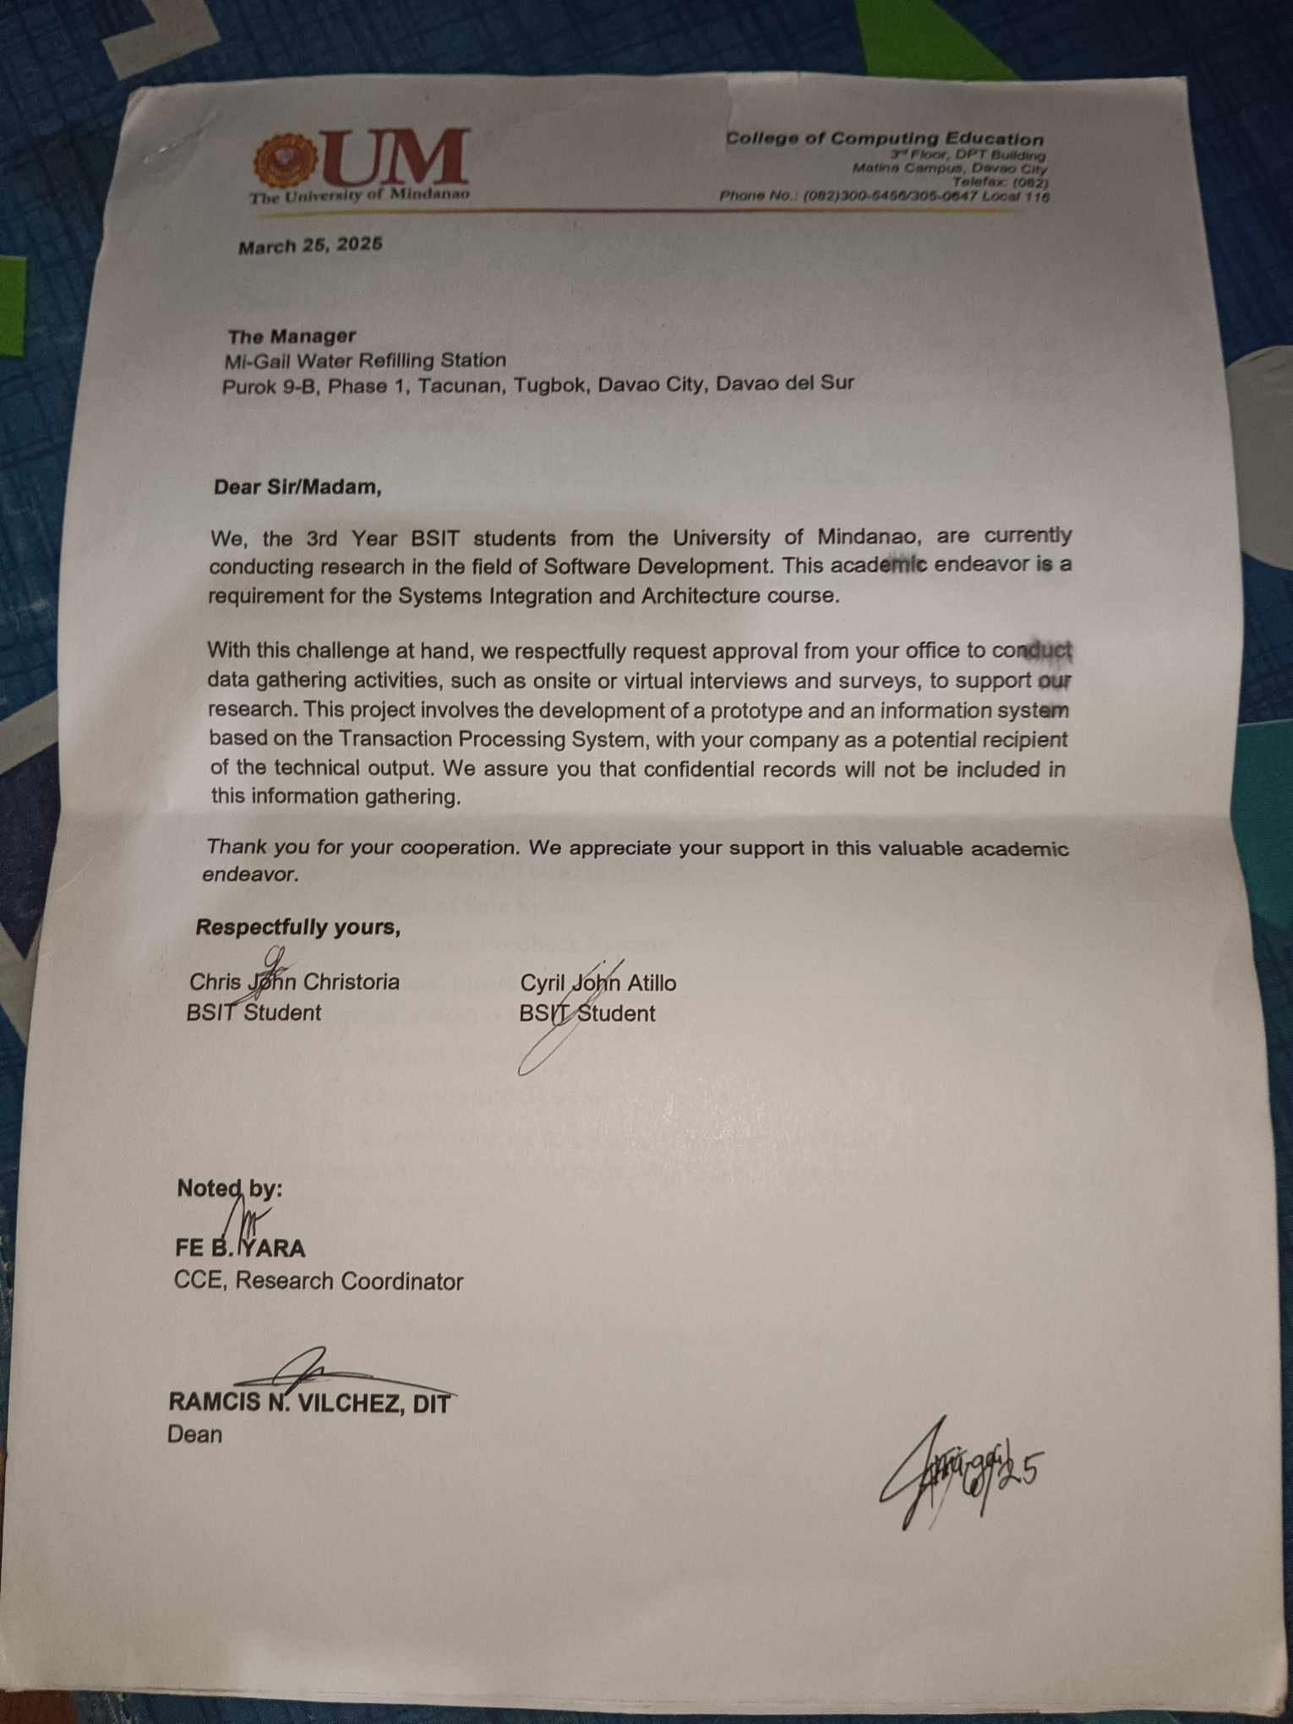

Appendix B (Company Forms)

Appendix C (Questionnaire)
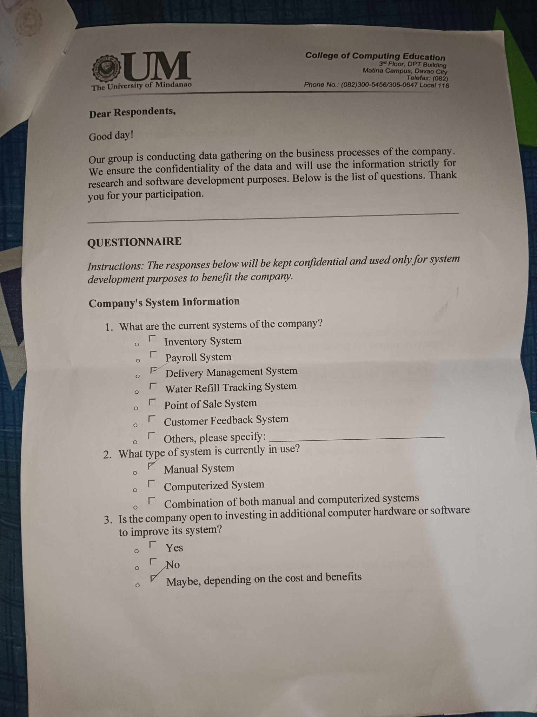

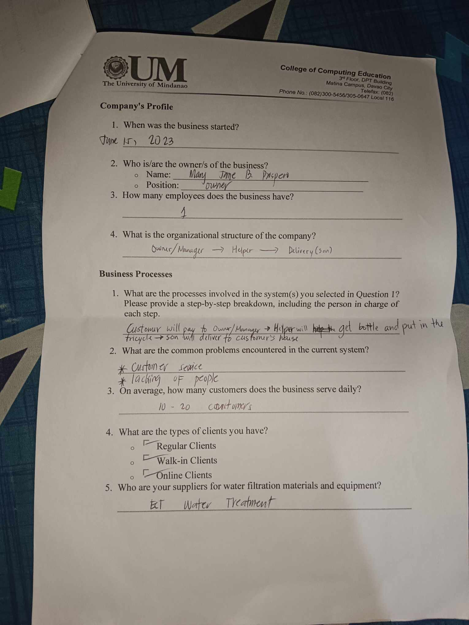

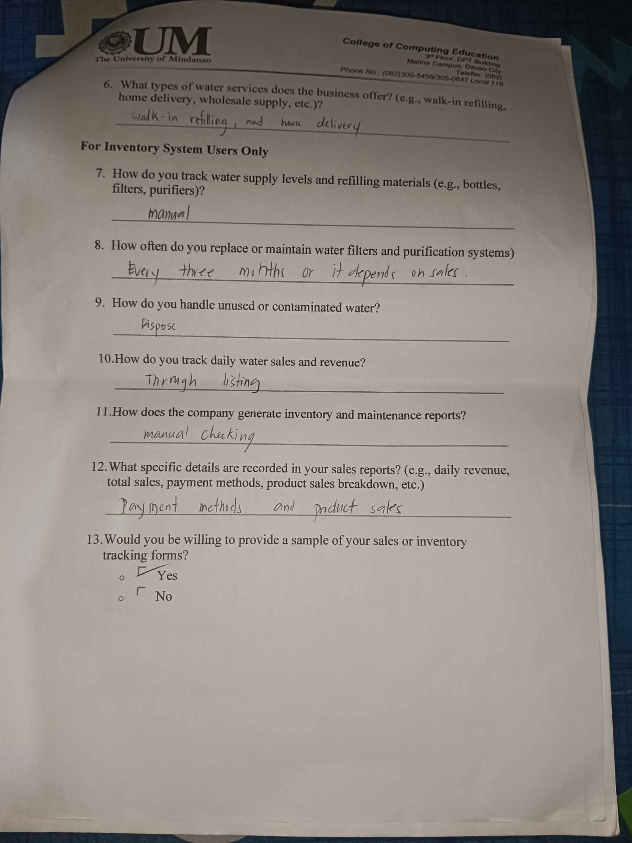

Appendix D: Rubric for Evaluating Software Project
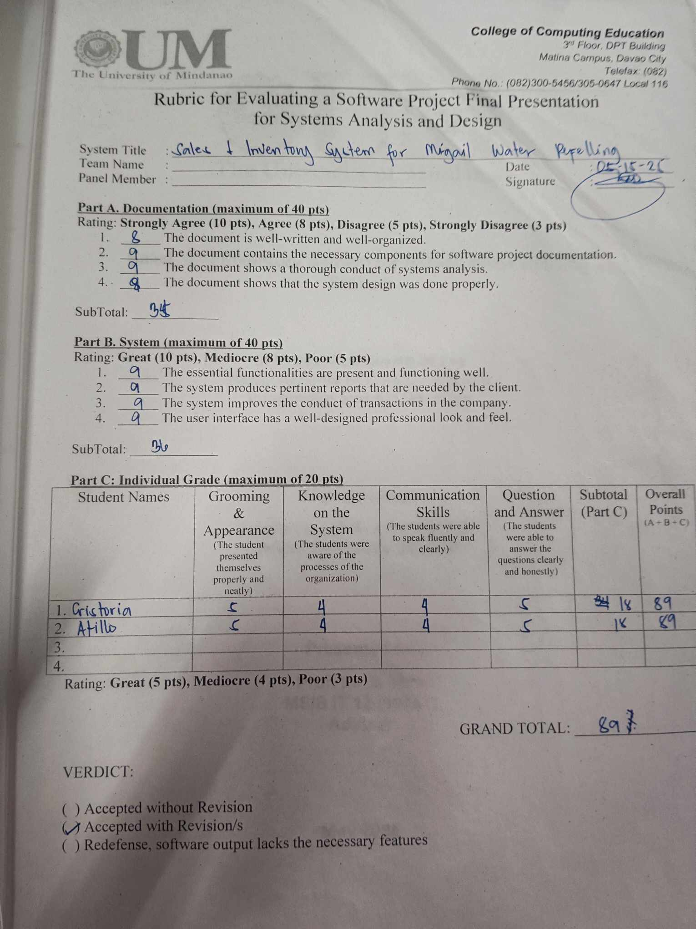

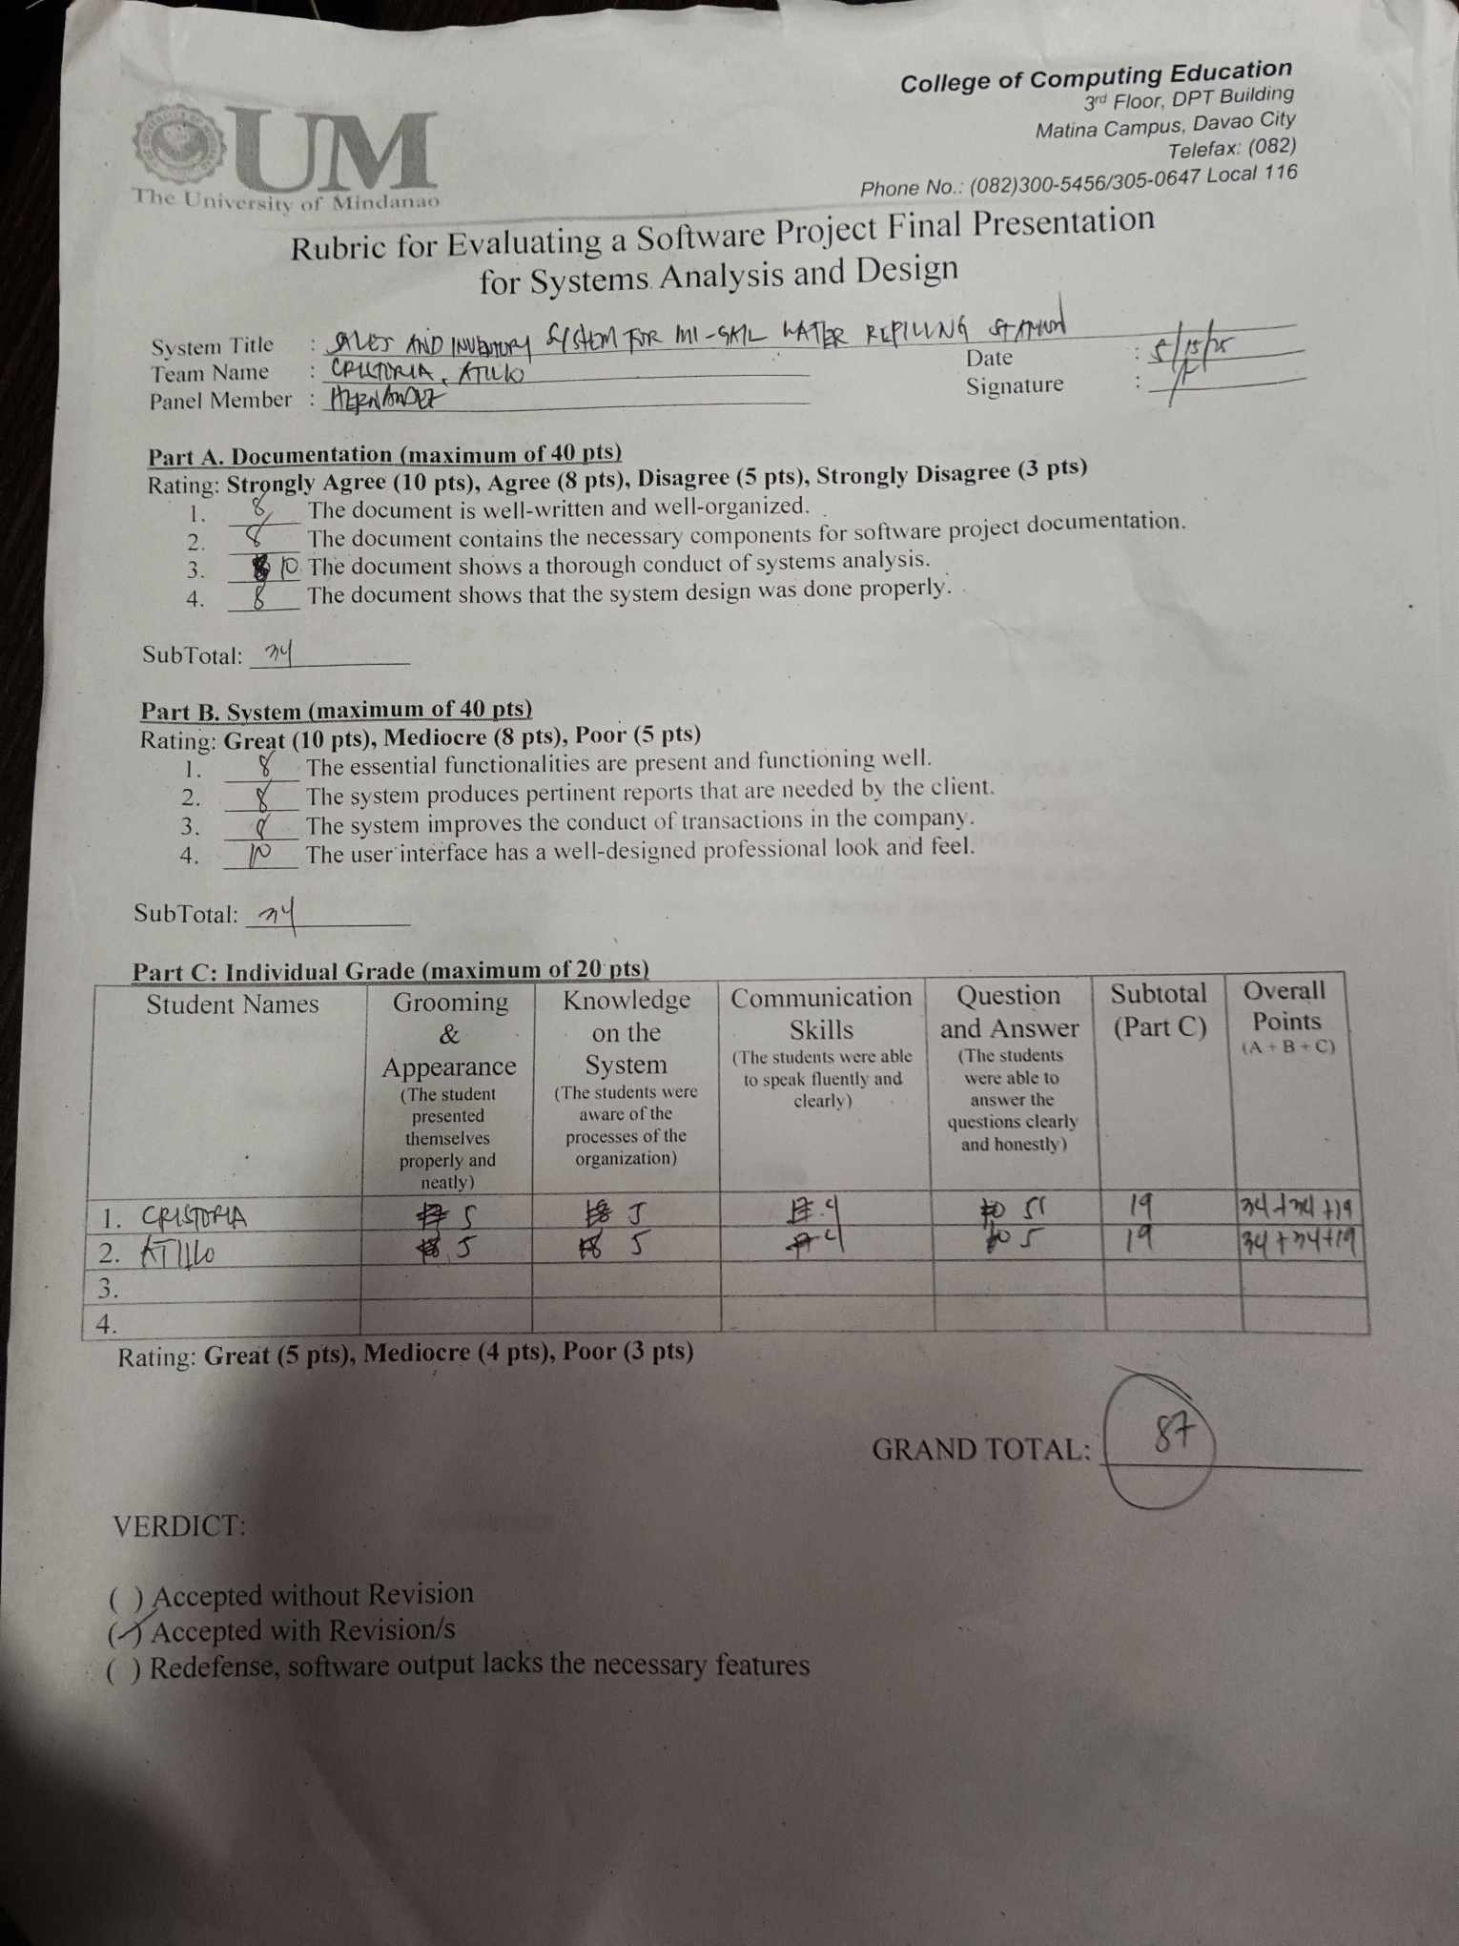


Appendix E (Curriculum Vitae)

Address: Tacunan, Tugbok District, Davao City
Contact #: 0945 106 7240
Email Address: c.atillo.537839@umindanao.edu.ph

PERSONAL BACKGROUND
Name: Cyril John S. Atillo
Civil Status: Single
Date of Birth: September 1, 2004
Place of Birth: SPMC Davao City
Citizenship: Filipino
Language Spoken: English, Tagalog, Cebuano

EDUCATIONAL BACKGROUND
Tertiary: University of Mindanao
Course: Bachelor of Science in Information Technology (2023-Present)
Address: Mc Arthur Highway, Matina, Davao City

Secondary: Tacunan National High School (2017-2022)
Address: Purok 2, Tacunan, Tugbok District, Davao City

Primary: Mintal Central Elementary School (2010-2016)
Addresss: Mintal, Tugbok District, Davao City



Address: Barangay 5-A, Purok 6-A, Gumamela St.
Bankerohan Davao City.
Contact #: 09058273693
Email Address: c.cristoria.531771@umindanao.edu.ph

PERSONAL BACKGROUND
Name: Chris John Cristoria
Civil Status: Single
Date of Birth: October 20, 2002
Place of Birth: SPMC Davao City
Citizenship: Filipino
Language Spoken: English, Tagalog, Cebuano

EDUCATIONAL BACKGROUND
Tertiary: University of Mindanao
Course: Bachelor of Science in Information Technology (2022-Present)
Address: Mc Arthur Highway, Matina, Davao City

Secondary: Davao City National High School(2015-2021)
Address: F. Torres St, Poblacion District, Davao City

Primary: Dona Pilar L. Malfori Elementary School (2009-2015)
Addresss: Madapu Hills, Barangay, Poblacion District, Davao City

